
Research & Vehicle Technology
“Infotainment Systems Product Development”

Feature – Visual Park Assist Graphic Client V2

APIM Infotainment Subsystem Part Specific Specification (SPSS)

Version 1.6
UNCONTROLLED COPY IF PRINTED

Version Date: December 8, 2017

FORD CONFIDENTIALF

Revision History

Date |  | Version | Notes
October 5, 2015 | 1.0 |  | Initial Release
December 18, 2015 | 1.1 |  | Updated Release
 | MD-REQ-014437/B-VisualParkAssist_St (TcSE ROIN-283917-1) |  |  | tmertiri: updated signal table.
 | CAMERA-FUR-REQ-197147/A-Infotainment Graphical Position Definition 11 |  |  | schapeki: added for blockage detection
 | CAMERA-FUR-REQ-130442/C-Visual Parking Aid Graphical Layout |  |  | Update for RPA_OL_3 and OR_3
 | CAMERA-FUR-REQ-196898/B-HMI Screen Logical Arbitration - Determine Dynamic Variables (PDC_Stat) |  |  | schapeki: Update signal states for PrkAidMsgTxt_D_Rq to match GMRDB
 | 201975/C-Base Park Aid Signal Interface |  |  | schapeki: structure update
 | CAMERA-FUR-REQ-130452/C-Park Distance Control (PDC) Signal list - [PrkAidMsgTxt_D_Rq]+ |  |  | schapeki: modified for blockage detection
 | CAMERA-FUR-REQ-130452/D-Park Distance Control (PDC) Signal list - [PrkAidMsgTxt_D_Rq] |  |  | schapeki: Update signal states for PrkAidMsgTxt_D_Rq to match GMRDB
 | CAMERA-FUR-REQ-130453/C-Park Distance Control (PDC) Signal list - [PrkAidSnsRlCrnr_D_Stat] |  |  | schapeki: update to add RPA_OL_3
 | CAMERA-FUR-REQ-131033/C-Park Distance Control (PDC) Signal list - [PrkAidSnsRrCrnr_D_Stat] |  |  | schapeki: update to add RPA_OR_3
 | CAMERA-FUR-REQ-130461/C-Park Distance Control (PDC) Signal Processing - Positionals RPA_OL_1, RPA_OL_2+ |  |  | schapeki: modified for blockage detection
 | CAMERA-FUR-REQ-130461/D-Park Distance Control (PDC) Signal Processing - Positionals RPA_OL_1, RPA_OL_2, RPA_OL_3 |  |  | schapeki: update to add RPA_OR_3, add state 0x8 to trailer
 | CAMERA-FUR-REQ-130463/C-Park Distance Control (PDC) Signal Processing - Positionals RPA_IL_1, RPA_IL_2, RPA_IL_3, RPA_IL_4, RPA_IL_5, RPA_IL_6+ |  |  | schapeki: modified for blockage detection
 | CAMERA-FUR-REQ-130463/D-Park Distance Control (PDC) Signal Processing - Positionals RPA_IL_1, RPA_IL_2, RPA_IL_3, RPA_IL_4, RPA_IL_5, RPA_IL_6 |  |  | schapeki: add state 0x8 to trailer
 | CAMERA-FUR-REQ-130464/C-Park Distance Control (PDC) Signal Processing - Positionals RPA_IR_1, RPA_IR_2, RPA_IR_3, RPA_IR_4, RPA_IR_5, RPA_IR_6+ |  |  | schapeki: modified for blockage detection
 | CAMERA-FUR-REQ-130464/D-Park Distance Control (PDC) Signal Processing - Positionals RPA_IR_1, RPA_IR_2, RPA_IR_3, RPA_IR_4, RPA_IR_5, RPA_IR_6 |  |  | schapeki: add state 0x8 to trailer
 | CAMERA-FUR-REQ-130467/C-Park Distance Control (PDC) Signal Processing - Positionals RPA_OR_1, RPA_OR_2+ |  |  | schapeki: modified for blockage detection
 | CAMERA-FUR-REQ-130467/D-Park Distance Control (PDC) Signal Processing - Positionals RPA_OR_1, RPA_OR_2, RPA_OR_3 |  |  | schapeki: update to add RPA_OL_3, add state 0x8 to trailer
 | CAMERA-FUR-REQ-130468/C-Park Distance Control (PDC) Signal Processing - Positionals FPA_OL_1, FPA_OL_2+ |  |  | schapeki: modified for blockage detection
 | CAMERA-FUR-REQ-130468/D-Park Distance Control (PDC) Signal Processing - Positionals FPA_OL_1, FPA_OL_2 |  |  | schapeki: add state 0x8 for PrkAidMsgTxt_D_Rq
 | CAMERA-FUR-REQ-130469/C-Park Distance Control (PDC) Signal Processing - Positionals FPA_IL_1, FPA_IL_2, FPA_IL_3+ |  |  | schapeki: modified for blockage detection
 | CAMERA-FUR-REQ-130469/D-Park Distance Control (PDC) Signal Processing - Positionals FPA_IL_1, FPA_IL_2, FPA_IL_3 |  |  | schapeki: add state 0x8 for PrkAidMsgTxt_D_Rq
 | CAMERA-FUR-REQ-130470/C-Park Distance Control (PDC) Signal Processing - Positionals FPA_IR_1, FPA_IR_2, FPA_IR_3+ |  |  | schapeki: modified for blockage detection
 | CAMERA-FUR-REQ-130470/D-Park Distance Control (PDC) Signal Processing - Positionals FPA_IR_1, FPA_IR_2, FPA_IR_3 |  |  | schapeki: add state 0x8 for PrkAidMsgTxt_D_Rq
 | CAMERA-FUR-REQ-130472/C-Park Distance Control (PDC) Signal Processing - Positionals FPA_OR_1, FPA_OR_2+ |  |  | schapeki: modified for blockage detection
 | CAMERA-FUR-REQ-130472/D-Park Distance Control (PDC) Signal Processing - Positionals FPA_OR_1, FPA_OR_2 |  |  | schapeki: add state 0x8 for PrkAidMsgTxt_D_Rq
 | CAMERA-FUR-REQ-130474/D-Park Distance Control (PDC) Signal Processing - Positionals SPA_L1_1, SPA_L1_2+ |  |  | schapeki: modified for blockage detection
 | CAMERA-FUR-REQ-130474/E-Park Distance Control (PDC) Signal Processing - Positionals SPA_L1_1, SPA_L1_2 |  |  | schapeki: correct zone transitions, add state 0x8 for PrkAidMsgTxt_D_Rq
 | CAMERA-FUR-REQ-130475/D-Park Distance Control (PDC) Signal Processing - Positionals SPA_R1_1, SPA_R1_2+ |  |  | schapeki: modified for blockage detection
 | CAMERA-FUR-REQ-130475/E-Park Distance Control (PDC) Signal Processing - Positionals SPA_R1_1, SPA_R1_2 |  |  | schapeki: correct zone transitions, add state 0x8 for PrkAidMsgTxt_D_Rq
 | CAMERA-FUR-REQ-130476/C-Park Distance Control (PDC) Signal Processing - Positionals SPA_L2_1, SPA_L2_2+ |  |  | schapeki: modified for blockage detection
 | CAMERA-FUR-REQ-130476/D-Park Distance Control (PDC) Signal Processing - Positionals SPA_L2_1, SPA_L2_2 |  |  | schapeki: correct zone transitions, add state 0x8 for PrkAidMsgTxt_D_Rq
 | CAMERA-FUR-REQ-130477/C-Park Distance Control (PDC) Signal Processing - Positionals SPA_R2_1, SPA_R2_2+ |  |  | schapeki: modified for blockage detection
 | CAMERA-FUR-REQ-130477/D-Park Distance Control (PDC) Signal Processing - Positionals SPA_R2_1, SPA_R2_2 |  |  | schapeki: correct zone transitions, add state 0x8 for PrkAidMsgTxt_D_Rq
 | CAMERA-FUR-REQ-130478/C-Park Distance Control (PDC) Signal Processing - Positionals SPA_L3_1, SPA_L3_2+ |  |  | schapeki: modified for blockage detection
 | CAMERA-FUR-REQ-130478/D-Park Distance Control (PDC) Signal Processing - Positionals SPA_L3_1, SPA_L3_2 |  |  | schapeki: correct zone transitions, add state 0x8 for PrkAidMsgTxt_D_Rq
 | CAMERA-FUR-REQ-130479/C-Park Distance Control (PDC) Signal Processing - Positionals SPA_R3_1, SPA_R3_2+ |  |  | schapeki: modified for blockage detection
 | CAMERA-FUR-REQ-130479/D-Park Distance Control (PDC) Signal Processing - Positionals SPA_R3_1, SPA_R3_2 |  |  | schapeki: correct zone transitions, add state 0x8 for PrkAidMsgTxt_D_Rq
 | CAMERA-FUR-REQ-130480/C-Park Distance Control (PDC) Signal Processing - Positionals SPA_L4_1, SPA_L4_2+ |  |  | schapeki: modified for blockage detection
 | CAMERA-FUR-REQ-130480/D-Park Distance Control (PDC) Signal Processing - Positionals SPA_L4_1, SPA_L4_2 |  |  | schapeki: correct zone transitions, add state 0x8 for PrkAidMsgTxt_D_Rq
 | CAMERA-FUR-REQ-130481/C-Park Distance Control (PDC) Signal Processing - Positionals SPA_R4_1, SPA_R4_2+ |  |  | schapeki: modified for blockage detection
 | CAMERA-FUR-REQ-130481/D-Park Distance Control (PDC) Signal Processing - Positionals SPA_R4_1, SPA_R4_2 |  |  | schapeki: correct zone transitions, add state 0x8 for PrkAidMsgTxt_D_Rq
 | CAMERA-FUR-REQ-130483/D-Park Distance Control (PDC) Signal Processing - Positional OUTLINE |  |  | schapeki: correct zone transitions, add state 0x8 for PrkAidMsgTxt_D_Rq
 | CAMERA-FUR-REQ-197149/A-Visual Park Aid Graphic - Visual Driving Tube General Requirements 1 |  |  | schapeki: added for visual driving tube.
 | CAMERA-FUR-REQ-197150/A-Visual Park Aid Graphic - Visual Driving Tube General Requirements 2 |  |  | schapeki: added for visual driving tube.
 | CAMERA-FUR-REQ-197151/A-Visual Park Aid Graphic - Visual Driving Tube General Requirements 3 |  |  | schapeki: added for visual driving tube.
 | CAMERA-FUR-REQ-197152/A-Visual Park Aid Graphic - Visual Driving Tube General Requirements 4 |  |  | schapeki: added for visual driving tube.
 | CAMERA-FUR-REQ-197153/A-Visual Park Aid Graphic - Visual Driving Tube General Requirements 5 |  |  | schapeki: added for visual driving tube.
 | CAMERA-FUR-REQ-197155/A-Visual Park Aid Graphic - Visual Driving Tube General Requirements 6 |  |  | schapeki: added for visual driving tube.
 | CAMERA-FUR-REQ-197156/A-Visual Park Aid Graphic - Visual Driving Tube General Requirements 7 |  |  | schapeki: added for visual driving tube.
 | CAMERA-FUR-REQ-197157/A-Visual Park Aid Graphic - Visual Driving Tube General Requirements 8 |  |  | schapeki: added for visual driving tube.
 | CAMERA-FUR-REQ-197158/A-Visual Park Aid Graphic - Visual Driving Tube General Requirements 9 |  |  | schapeki: added for visual driving tube.
 | CAMERA-FUR-REQ-197159/A-Visual Park Aid Graphic - Visual Driving Tube General Requirements 10 |  |  | schapeki: added for visual driving tube.
 | CAMERA-FUR-REQ-197160/A-Visual Park Aid Graphic - Visual Driving Tube General Requirements 11 |  |  | schapeki: added for visual driving tube.
 | CAMERA-FUR-REQ-197161/A-Visual Park Aid Graphic - Visual Driving Tube General Requirements 12 |  |  | schapeki: added for visual driving tube.
 | CAMERA-FUR-REQ-197162/A-Visual Park Aid Graphic - Visual Driving Tube General Requirements 13 |  |  | schapeki: added for visual driving tube.
 | CAMERA-FUR-REQ-197163/A-Visual Park Aid Graphic - Visual Driving Tube General Requirements 14 |  |  | schapeki: added for visual driving tube.
 | CAMERA-FUR-REQ-197164/A-Visual Park Aid Graphic - Visual Driving Tube General Requirements 15 |  |  | schapeki: added for visual driving tube.
 | CAMERA-FUR-REQ-197165/A-Visual Park Aid Graphic - Visual Driving Tube General Requirements 16 |  |  | schapeki: added for visual driving tube.
 | CAMERA-FUR-REQ-197166/A-Visual Park Aid Graphic - Visual Driving Tube General Requirements 17 |  |  | schapeki: added for visual driving tube.
 | CAMERA-FUR-REQ-197167/A-Visual Park Aid Graphic - Visual Driving Tube General Requirements 18 |  |  | schapeki: added for visual driving tube.
 | CAMERA-FUR-REQ-130503/E-Active Park Assist (APA) Signal Processing - Positional ParkPilot+ |  |  | schapeki: add column for new APA signal.
 | CAMERA-FUR-REQ-130503/F-Active Park Assist (APA) Signal Processing - Positional ParkPilot |  |  | schapeki: Update to add column for ApaDistToTrgt_D_Stat
March 18, 2016 | 1.2 |  | Updated Release
 | MD-REQ-014437/C-VisualParkAssist_St (TcSE ROIN-283917-1) |  |  | tmertiri:updated signals from notused1/2/3 to NotUsed
 | CAMERA-FUR-REQ-197147/B-Infotainment Graphical Position Definition 11 |  |  | schapeki: Update description to match implementation.
 | CAMERA-FUR-REQ-211758/A-Infotainment Graphical Position Definition 12 |  |  | schapeki: Added to enhance definition for sensor blockage.
 | CAMERA-FUR-REQ-211759/A-Infotainment Graphical Position Definition 13 |  |  | schapeki: Added to enhance definition for sensor blockage.
 | CAMERA-FUR-REQ-130779/C-Visual Parking Aid RPA Graphical Requirements 2 |  |  | schapeki: Update to correct number of sectors on rear outer.
 | CAMERA-FUR-REQ-130782/C-Visual Parking Aid FPA Graphical Requirements 3 |  |  | schapeki: Clarify front side sector definition (notes only).
 | 235042/D-Display HMI Arbitration General Requirements |  |  | schapeki: Structure update only.
 | CAMERA-FUR-REQ-131013/C-Display HMI Arbitration General Requirements 5 |  |  | schapeki: Clarify fault requirement for screen timeout.
 | CAMERA-FUR-REQ-211760/A-Display HMI Arbitration General Requirements 8 |  |  | schapeki: Added to specify fault screen design characteristics.
 | CAMERA-FUR-REQ-161327/D-Display HMI Arbitration Internal Variable Table (Timers and Debounce) |  |  | schapeki: Remove typical time recommendations and end-user control of exit delay.
 | CAMERA-FUR-REQ-131020/E-HMI Screen Logical Arbitration - Determine Dynamic Variables (GearPosHMI) |  |  | schapeki: Update tables to force reverse gear for RVC entry during SAC.
 | CAMERA-FUR-REQ-196898/C-HMI Screen Logical Arbitration - Determine Dynamic Variables (PDC_Stat) |  |  | schapeki: update states to match latest core direction for faults and blockage.
 | CAMERA-FUR-REQ-131023/D-HMI Screen Logical Arbitration - PDC Dedicated Display |  |  | schapeki: Update to allow fault display timeout while latched in fault state.
 | 201976/B-Park Distance Control (PDC) Signal list – Received by Infotainment ECU (from PAM) |  |  | schapeki: structure update
 | CAMERA-FUR-REQ-130452/E-Park Distance Control (PDC) Signal list - [PrkAidMsgTxt_D_Rq] |  |  | schapeki: match signals to CMDB exactly
 | CAMERA-FUR-REQ-130456/D-Park Distance Control (PDC) Signal list - [SidePrkSnsL1_D_Stat] |  |  | schapeki: Update notes to not reference enhanced FPA signal.
 | CAMERA-FUR-REQ-130457/D-Park Distance Control (PDC) Signal list - [SidePrkSnsR1_D_Stat] |  |  | schapeki: Update notes to not reference enhanced FPA signal.
 | 201979/C-Park Distance Control (PDC) Signal Processing |  |  | schapeki: Add note referencing arbitration section.
 | CAMERA-FUR-REQ-130461/E-Park Distance Control (PDC) Signal Processing - Positionals RPA_OL_1, RPA_OL_2, RPA_OL_3 |  |  | schapeki: Replace op.mode column with PDCDisp internal variable. Remove missing message comments. Update PrkAidMsgTxt_D_Rq to reflect sensor blockage only.
 | CAMERA-FUR-REQ-130463/E-Park Distance Control (PDC) Signal Processing - Positionals RPA_IL_1, RPA_IL_2, RPA_IL_3, RPA_IL_4, RPA_IL_5, RPA_IL_6 |  |  | schapeki: Replace op.mode column with PDCDisp internal variable. Remove missing message comments. Update PrkAidMsgTxt_D_Rq to reflect sensor blockage only.
 | CAMERA-FUR-REQ-130464/E-Park Distance Control (PDC) Signal Processing - Positionals RPA_IR_1, RPA_IR_2, RPA_IR_3, RPA_IR_4, RPA_IR_5, RPA_IR_6 |  |  | schapeki: Replace op.mode column with PDCDisp internal variable. Remove missing message comments. Update PrkAidMsgTxt_D_Rq to reflect sensor blockage only.
 | CAMERA-FUR-REQ-130467/E-Park Distance Control (PDC) Signal Processing - Positionals RPA_OR_1, RPA_OR_2, RPA_OR_3 |  |  | schapeki: Replace op.mode column with PDCDisp internal variable. Remove missing message comments. Update PrkAidMsgTxt_D_Rq to reflect sensor blockage only.
 | CAMERA-FUR-REQ-130468/E-Park Distance Control (PDC) Signal Processing - Positionals FPA_OL_1, FPA_OL_2 |  |  | schapeki: Replace op.mode column with PDCDisp internal variable. Remove missing message comments. Update PrkAidMsgTxt_D_Rq to reflect sensor blockage only.
 | CAMERA-FUR-REQ-130469/E-Park Distance Control (PDC) Signal Processing - Positionals FPA_IL_1, FPA_IL_2, FPA_IL_3 |  |  | schapeki: Replace op.mode column with PDCDisp internal variable. Remove missing message comments. Update PrkAidMsgTxt_D_Rq to reflect sensor blockage only.
 | CAMERA-FUR-REQ-130470/E-Park Distance Control (PDC) Signal Processing - Positionals FPA_IR_1, FPA_IR_2, FPA_IR_3 |  |  | schapeki: Replace op.mode column with PDCDisp internal variable. Remove missing message comments. Update PrkAidMsgTxt_D_Rq to reflect sensor blockage only.
 | CAMERA-FUR-REQ-130472/E-Park Distance Control (PDC) Signal Processing - Positionals FPA_OR_1, FPA_OR_2 |  |  | schapeki: Replace op.mode column with PDCDisp internal variable. Remove missing message comments. Update PrkAidMsgTxt_D_Rq to reflect sensor blockage only.
 | CAMERA-FUR-REQ-130474/F-Park Distance Control (PDC) Signal Processing - Positionals SPA_L1_1, SPA_L1_2 |  |  | schapeki: Replace op.mode column with PDCDisp internal variable. Remove missing message comments. Update PrkAidMsgTxt_D_Rq to reflect sensor blockage only. Remove usage of PrkAidSnsFlSide_D_Stat.
 | CAMERA-FUR-REQ-130475/F-Park Distance Control (PDC) Signal Processing - Positionals SPA_R1_1, SPA_R1_2 |  |  | schapeki: Replace op.mode column with PDCDisp internal variable. Remove missing message comments. Update PrkAidMsgTxt_D_Rq to reflect sensor blockage only. Remove usage of PrkAidSnsFrSide_D_Stat.
 | CAMERA-FUR-REQ-130476/E-Park Distance Control (PDC) Signal Processing - Positionals SPA_L2_1, SPA_L2_2 |  |  | schapeki: Replace op.mode column with PDCDisp internal variable. Remove missing message comments. Update PrkAidMsgTxt_D_Rq to reflect sensor blockage only.
 | CAMERA-FUR-REQ-130477/E-Park Distance Control (PDC) Signal Processing - Positionals SPA_R2_1, SPA_R2_2 |  |  | schapeki: Replace op.mode column with PDCDisp internal variable. Remove missing message comments. Update PrkAidMsgTxt_D_Rq to reflect sensor blockage only.
 | CAMERA-FUR-REQ-130478/E-Park Distance Control (PDC) Signal Processing - Positionals SPA_L3_1, SPA_L3_2 |  |  | schapeki: Replace op.mode column with PDCDisp internal variable. Remove missing message comments. Update PrkAidMsgTxt_D_Rq to reflect sensor blockage only.
 | CAMERA-FUR-REQ-130479/E-Park Distance Control (PDC) Signal Processing - Positionals SPA_R3_1, SPA_R3_2 |  |  | schapeki: Replace op.mode column with PDCDisp internal variable. Remove missing message comments. Update PrkAidMsgTxt_D_Rq to reflect sensor blockage only.
 | CAMERA-FUR-REQ-130480/E-Park Distance Control (PDC) Signal Processing - Positionals SPA_L4_1, SPA_L4_2 |  |  | schapeki: Replace op.mode column with PDCDisp internal variable. Remove missing message comments. Update PrkAidMsgTxt_D_Rq to reflect sensor blockage only. Fix column labels.
 | CAMERA-FUR-REQ-130481/E-Park Distance Control (PDC) Signal Processing - Positionals SPA_R4_1, SPA_R4_2 |  |  | schapeki: Replace op.mode column with PDCDisp internal variable. Remove missing message comments. Update PrkAidMsgTxt_D_Rq to reflect sensor blockage only.
 | CAMERA-FUR-REQ-130483/E-Park Distance Control (PDC) Signal Processing - Positional OUTLINE |  |  | schapeki: Replace op.mode column with PDCDisp internal variable. Remove missing message comments. Update PrkAidMsgTxt_D_Rq to reflect sensor blockage only.
June 29, 2016 | 1.3 |  | Updated Release
 | STR-300584/B-General Requirements |  |  | Delete MyKey requirement # 132682
 | CAMERA-FUR-REQ-157189/B-General Signal Interface 3 |  |  | schapeki: Clarify screen interaction with animations
 | CAMERA-FUR-REQ-197147/C-Infotainment Graphical Position Definition 11 |  |  | schapeki: no update, revised in error.
 | CAMERA-FUR-REQ-166820/C-HMI Screen Logical Arbitration - Camera |  |  | schapeki: update for fault handling bugfixes
 | CAMERA-FUR-REQ-166823/D-HMI Screen Logical Arbitration - APA Dedicated Display |  |  | schapeki: update for fault handling bugfixes
 | CAMERA-FUR-REQ-131023/E-HMI Screen Logical Arbitration - PDC Dedicated Display |  |  | schapeki: update for fault handling bugfixes
 | 235115/B-Base Parking Aid Display Deactivation Interface |  |  | schapeki: structure update only.
 | 201981/C-Base Parking Aid display Deactivation Function |  |  | schapeki: structure update to delete MyKey references.
 | CAMERA-FUR-REQ-131051/C-Base Parking Aid display Deactivation Function-BPA Close Option Logic |  |  | schapeki: bug fix to remove MyKey references.
 | CAMERA-FUR-REQ-130503/G-Active Park Assist (APA) Signal Processing - Positional ParkPilot |  |  | schapeki: bug fixes, table updates.
September 27, 2016 | 1.4 |  | Updated Release
 | 405481/A-HotKey Shortcut Menu General Requirements |  |  | schapeki: New general requirements for shortcut menu
 | CAMERA-FUR-REQ-236837/A-HotKey Shortcut Menu General Requirements 1 |  |  | schapeki: New functional requirement for Shortcut Menu
 | CAMERA-FUR-REQ-236838/A-HotKey Shortcut Menu General Requirements 2 |  |  | schapeki: New functional requirement for Shortcut Menu
 | CAMERA-FUR-REQ-236839/A-HotKey Shortcut Menu General Requirements 3 |  |  | schapeki: New functional requirement for Shortcut Menu
 | CAMERA-FUR-REQ-235899/A-HotKey Shortcut Menu General Requirements 4 |  |  | schapeki: New functional requirement for Shortcut Menu
 | CAMERA-FUR-REQ-235900/A-HotKey Shortcut Menu General Requirements 5 |  |  | schapeki: New functional requirement for Shortcut Menu
 | CAMERA-FUR-REQ-235901/A-HotKey Shortcut Menu General Requirements 6 |  |  | schapeki: New functional requirement for Shortcut Menu
 | CAMERA-FUR-REQ-236526/A-HotKey Shortcut Menu General Requirements 7 |  |  | schapeki: New functional requirement for Shortcut Menu
 | CAMERA-FUR-REQ-236527/A-HotKey Shortcut Menu General Requirements 8 |  |  | schapeki: New functional requirement for Shortcut Menu
 | CAMERA-FUR-REQ-236529/A-HotKey Shortcut Menu General Requirements 9 |  |  | schapeki: New functional requirement for Shortcut Menu
 | CAMERA-FUR-REQ-236530/A-HotKey Shortcut Menu General Requirements 10 |  |  | schapeki: New functional requirement for Shortcut Menu
 | CAMERA-FUR-REQ-236531/A-HotKey Shortcut Menu General Requirements 11 |  |  | schapeki: New functional requirement for Shortcut Menu
 | CAMERA-FUR-REQ-236532/A-HotKey Shortcut Menu General Requirements 12 |  |  | schapeki: New functional requirement for Shortcut Menu
 | CAMERA-FUR-REQ-236533/A-HotKey Shortcut Menu General Requirements 13 |  |  | schapeki: New functional requirement for Shortcut Menu
 | CAMERA-FUR-REQ-236534/A-HotKey Shortcut Menu General Requirements 14 |  |  | schapeki: New functional requirement for Shortcut Menu
 | CAMERA-FUR-REQ-236546/A-HotKey Shortcut Menu General Requirements 15 |  |  | schapeki: New functional requirement for Shortcut Menu
 | CAMERA-FUR-REQ-236829/A-HotKey Shortcut Menu General Requirements 16 |  |  | schapeki: New functional requirement for Shortcut Menu
 | CAMERA-FUR-REQ-236830/A-HotKey Shortcut Menu General Requirements 17 |  |  | schapeki: New functional requirement for Shortcut Menu
 | CAMERA-FUR-REQ-236831/A-HotKey Shortcut Menu General Requirements 18 |  |  | schapeki: New functional requirement for Shortcut Menu
 | CAMERA-FUR-REQ-236832/A-HotKey Shortcut Menu General Requirements 19 |  |  | schapeki: New functional requirement for Shortcut Menu
 | CAMERA-FUR-REQ-236833/A-HotKey Shortcut Menu General Requirements 20 |  |  | schapeki: New functional requirement for Shortcut Menu
 | CAMERA-FUR-REQ-236834/A-HotKey Shortcut Menu General Requirements 21 |  |  | schapeki: New functional requirement for Shortcut Menu
 | 405476/A-HotKey Shortcut Menu Signal List |  |  | schapeki: New signal list requirements
 | CAMERA-FUR-REQ-235902/A-HotKey Shortcut Menu Signal List - ApaMdeStat_D_RqDrv |  |  | schapeki: New signal list functional requirement
 | CAMERA-FUR-REQ-235903/A-HotKey Shortcut Menu Signal List - ApaSwtch_D_RqMnu |  |  | schapeki: New signal list functional requirement
 | CAMERA-FUR-REQ-235904/A-HotKey Shortcut Menu Signal List - PrkAidSwtch_D_RqMnu |  |  | schapeki: New signal list functional requirement
 | CAMERA-FUR-REQ-236835/A-HotKey Shortcut Menu Signal List - PrkAidFront_D_Stat |  |  | schapeki: New signal list functional requirement
 | CAMERA-FUR-REQ-236836/A-HotKey Shortcut Menu Signal List - PrkAidRear_D_Stat |  |  | schapeki: New signal list functional requirement
 | 405489/A-HotKey Shortcut Menu Signal Processing |  |  | schapeki: New signal processing requirements
 | CAMERA-FUR-REQ-235906/A-HotKey Shortcut Menu Signal Processing Requirements 1 |  |  | schapeki: New signal processing functional requirement
 | CAMERA-FUR-REQ-235908/A-HotKey Shortcut Menu Signal Processing Requirements 2 |  |  | schapeki: New signal processing functional requirement
 | CAMERA-FUR-REQ-235909/A-HotKey Shortcut Menu Signal Processing Requirements 3 |  |  | schapeki: New signal processing functional requirement
 | CAMERA-FUR-REQ-235910/A-HotKey Shortcut Menu Signal Processing Requirements 4 |  |  | schapeki: New signal processing functional requirement
 | CAMERA-FUR-REQ-235911/A-HotKey Shortcut Menu Signal Processing Requirements 5 |  |  | schapeki: New signal processing functional requirement
 | CAMERA-FUR-REQ-235912/A-HotKey Shortcut Menu Signal Processing Requirements 6 |  |  | schapeki: New signal processing functional requirement
 | CAMERA-FUR-REQ-235913/A-HotKey Shortcut Menu Signal Processing Requirements 7 |  |  | schapeki: New signal processing functional requirement
 | CAMERA-FUR-REQ-235914/A-HotKey Shortcut Menu Signal Processing Requirements 8 |  |  | schapeki: New signal processing functional requirement
 | CAMERA-FUR-REQ-235915/A-HotKey Shortcut Menu Signal Processing Requirements 9 |  |  | schapeki: New signal processing functional requirement
 | CAMERA-FUR-REQ-236842/A-HotKey Shortcut Menu Signal Processing Requirements 10 |  |  | schapeki: New signal processing functional requirement
 | CAMERA-FUR-REQ-236843/A-HotKey Shortcut Menu Signal Processing Requirements 11 |  |  | schapeki: New signal processing functional requirement
 | CAMERA-FUR-REQ-235916/A-HotKey Shortcut Menu Signal Processing Requirements 12 |  |  | schapeki: New signal processing functional requirement
 | CAMERA-FUR-REQ-236840/A-HotKey Shortcut Menu Signal Processing Requirements 13 |  |  | schapeki: New signal processing functional requirement
 | CAMERA-FUR-REQ-236841/A-HotKey Shortcut Menu Signal Processing Requirements 14 |  |  | schapeki: New signal processing functional requirement
 | CAMERA-FUR-REQ-237606/A-HotKey Shortcut Menu Signal Processing Requirements 15 |  |  | schapeki: New signal processing functional requirement
 | CAMERA-FUR-REQ-235917/A-HotKey Shortcut Menu Signal Processing Requirements 16 |  |  | schapeki: New signal processing functional requirement
 | CAMERA-FUR-REQ-235918/A-HotKey Shortcut Menu Signal Processing Requirements 17 |  |  | schapeki: New signal processing functional requirement
 | CAMERA-FUR-REQ-235920/A-HotKey Shortcut Menu Signal Processing Requirements 18 |  |  | schapeki: New signal processing functional requirement
 | CAMERA-FUR-REQ-130483/F-Park Distance Control (PDC) Signal Processing - Positional OUTLINE |  |  | schapeki: remove PrkAidSnsFlSide and FrSide, they should have been globally removed in previous revision of the specification.
 | CAMERA-FUR-REQ-130503/H-Active Park Assist (APA) Signal Processing - Positional ParkPilot |  |  | schapeki: add B479/C519 implementation notes.
March 10, 2017 | 1.5 |  | Updated Release
 | CAMERA-FUR-REQ-211758/B-Infotainment Graphical Position Definition 12 |  |  | schapeki: update reference drawing to match SDM4 concept.
 | CAMERA-FUR-REQ-211759/B-Infotainment Graphical Position Definition 13 |  |  | schapeki: update reference drawing to match SDM4 concept.
 | 405481/B-HotKey Shortcut Menu General Requirements |  |  | structure update, latest context diagram.
 | CAMERA-FUR-REQ-236837/B-HotKey Shortcut Menu General Requirements 1 |  |  | schapeki: Update to latest HotKey version Release_C.
 | CAMERA-FUR-REQ-236838/B-HotKey Shortcut Menu General Requirements 2 |  |  | schapeki: Update to latest HotKey version Release_C.
 | CAMERA-FUR-REQ-236839/B-HotKey Shortcut Menu General Requirements 3 |  |  | schapeki: Update to latest HotKey version Release_C.
 | CAMERA-FUR-REQ-235899/B-HotKey Shortcut Menu General Requirements 4 |  |  | schapeki: Update per subsystem HMI version -AB, update to latest HotKey version Release_C.
 | CAMERA-FUR-REQ-235900/B-HotKey Shortcut Menu General Requirements 5 |  |  | schapeki: Update per subsystem HMI version -AB, update to latest HotKey version Release_C.
 | CAMERA-FUR-REQ-235901/B-HotKey Shortcut Menu General Requirements 6 |  |  | schapeki: Update per subsystem HMI version -AB, update to latest HotKey version Release_C.
 | CAMERA-FUR-REQ-236526/B-HotKey Shortcut Menu General Requirements 7 |  |  | schapeki: Update to latest HotKey version Release_C.
 | CAMERA-FUR-REQ-236527/B-HotKey Shortcut Menu General Requirements 8 |  |  | schapeki: Update to latest HotKey version Release_C.
 | CAMERA-FUR-REQ-236529/B-HotKey Shortcut Menu General Requirements 9 |  |  | schapeki: Update to latest HotKey version Release_C.
 | CAMERA-FUR-REQ-236530/B-HotKey Shortcut Menu General Requirements 10 |  |  | schapeki: Update to latest HotKey version Release_C.
 | CAMERA-FUR-REQ-236531/B-HotKey Shortcut Menu General Requirements 11 |  |  | schapeki: Update to latest HotKey version Release_C.
 | CAMERA-FUR-REQ-236532/B-HotKey Shortcut Menu General Requirements 12 |  |  | schapeki: Update to latest HotKey version Release_C.
 | CAMERA-FUR-REQ-236533/B-HotKey Shortcut Menu General Requirements 13 |  |  | schapeki: Update to latest HotKey version Release_C.
 | CAMERA-FUR-REQ-236534/B-HotKey Shortcut Menu General Requirements 14 |  |  | schapeki: Update to latest HotKey version Release_C.
 | CAMERA-FUR-REQ-236546/B-HotKey Shortcut Menu General Requirements 15 |  |  | schapeki: Update to latest HotKey version Release_C.
 | CAMERA-FUR-REQ-236829/B-HotKey Shortcut Menu General Requirements 16 |  |  | schapeki: Update to latest HotKey version Release_C.
 | CAMERA-FUR-REQ-236830/B-HotKey Shortcut Menu General Requirements 17 |  |  | schapeki: Update to latest HotKey version Release_C.
 | CAMERA-FUR-REQ-236833/B-HotKey Shortcut Menu General Requirements 20 |  |  | schapeki: Update to latest HotKey version Release_C.
 | CAMERA-FUR-REQ-236834/B-HotKey Shortcut Menu General Requirements 21 |  |  | schapeki: Update to latest HotKey version Release_C.
 | CAMERA-FUR-REQ-250044/A-HotKey Shortcut Menu General Requirements 22 |  |  | schapeki: New HotKey requirement per version Release C.
 | CAMERA-FUR-REQ-250046/A-HotKey Shortcut Menu General Requirements 23 |  |  | schapeki: New HotKey requirement per version Release C.
 | CAMERA-FUR-REQ-250047/A-HotKey Shortcut Menu General Requirements 24 |  |  | schapeki: New HotKey requirement per version Release C.
 | CAMERA-FUR-REQ-250491/A-HotKey Shortcut Menu General Requirements 25 |  |  | schapeki: New HotKey requirement per version Release C.
 | CAMERA-FUR-REQ-235902/B-HotKey Shortcut Menu Signal List - ApaMdeStat_D_RqDrv |  |  | schapeki: Update to latest HotKey version Release_C.
 | CAMERA-FUR-REQ-235903/B-HotKey Shortcut Menu Signal List - ApaSwtch_D_RqMnu |  |  | schapeki: Update per subsystem HMI version -AB. Update to latest HotKey version Release_C.
 | CAMERA-FUR-REQ-235904/B-HotKey Shortcut Menu Signal List - PrkAidSwtch_D_RqMnu |  |  | schapeki: Update per subsystem HMI version -AB. Update to latest HotKey version Release_C.
 | CAMERA-FUR-REQ-236835/B-HotKey Shortcut Menu Signal List - PrkAidFront_D_Stat |  |  | schapeki: Update to latest HotKey version Release_C.
 | CAMERA-FUR-REQ-236836/B-HotKey Shortcut Menu Signal List - PrkAidRear_D_Stat |  |  | schapeki: Update to latest HotKey version Release_C.
 | CAMERA-FUR-REQ-235906/B-HotKey Shortcut Menu Signal Processing Requirements 1 |  |  | schapeki: Update to latest HotKey version Release_C.
 | CAMERA-FUR-REQ-235908/B-HotKey Shortcut Menu Signal Processing Requirements 2 |  |  | schapeki: Update to latest HotKey version Release_C.
 | CAMERA-FUR-REQ-235909/B-HotKey Shortcut Menu Signal Processing Requirements 3 |  |  | schapeki: Update to latest HotKey version Release_C.
 | CAMERA-FUR-REQ-235910/B-HotKey Shortcut Menu Signal Processing Requirements 4 |  |  | schapeki: Update per subsystem HMI version -AB. Update to latest HotKey version Release_C.
 | CAMERA-FUR-REQ-235911/B-HotKey Shortcut Menu Signal Processing Requirements 5 |  |  | schapeki: Update per subsystem HMI version -AB. Update to latest HotKey version Release_C.
 | CAMERA-FUR-REQ-235912/B-HotKey Shortcut Menu Signal Processing Requirements 6 |  |  | schapeki: Update per subsystem HMI version -AB. Update to latest HotKey version Release_C.
 | CAMERA-FUR-REQ-235913/B-HotKey Shortcut Menu Signal Processing Requirements 7 |  |  | schapeki: Update per subsystem HMI version -AB. Update to latest HotKey version Release_C.
 | CAMERA-FUR-REQ-235914/B-HotKey Shortcut Menu Signal Processing Requirements 8 |  |  | schapeki: Update per subsystem HMI version -AB. Update to latest HotKey version Release_C.
 | CAMERA-FUR-REQ-235915/B-HotKey Shortcut Menu Signal Processing Requirements 9 |  |  | schapeki: Update per subsystem HMI version -AB. Update to latest HotKey version Release_C.
 | CAMERA-FUR-REQ-236842/B-HotKey Shortcut Menu Signal Processing Requirements 10 |  |  | schapeki: Update to latest HotKey version Release_C.
 | CAMERA-FUR-REQ-236843/B-HotKey Shortcut Menu Signal Processing Requirements 11 |  |  | schapeki: Update per subsystem HMI version -AB. Update to latest HotKey version Release_C.
 | CAMERA-FUR-REQ-235916/B-HotKey Shortcut Menu Signal Processing Requirements 12 |  |  | schapeki: Update to latest HotKey version Release_C.
 | CAMERA-FUR-REQ-236840/B-HotKey Shortcut Menu Signal Processing Requirements 13 |  |  | schapeki: Update to latest HotKey version Release_C.
 | CAMERA-FUR-REQ-236841/B-HotKey Shortcut Menu Signal Processing Requirements 14 |  |  | schapeki: Update to latest HotKey version Release_C.
 | CAMERA-FUR-REQ-237606/B-HotKey Shortcut Menu Signal Processing Requirements 15 |  |  | schapeki: Update to latest HotKey version Release_C.
 | CAMERA-FUR-REQ-235917/B-HotKey Shortcut Menu Signal Processing Requirements 16 |  |  | schapeki: Update to latest HotKey version Release_C.
 | CAMERA-FUR-REQ-235918/B-HotKey Shortcut Menu Signal Processing Requirements 17 |  |  | schapeki: Update to latest HotKey version Release_C.
 | CAMERA-FUR-REQ-235920/B-HotKey Shortcut Menu Signal Processing Requirements 18 |  |  | schapeki: Update to latest HotKey version Release_C.
 | CAMERA-FUR-REQ-250026/A-HotKey Shortcut Menu Signal Processing Requirements 19 |  |  | schapeki: New HotKey requirement per version Release C.
 | CAMERA-FUR-REQ-250027/A-HotKey Shortcut Menu Signal Processing Requirements 20 |  |  | schapeki: New HotKey requirement per version Release C.
 | CAMERA-FUR-REQ-250028/A-HotKey Shortcut Menu Signal Processing Requirements 21 |  |  | schapeki: New HotKey requirement per version Release C.
 | CAMERA-FUR-REQ-250029/A-HotKey Shortcut Menu Signal Processing Requirements 22 |  |  | schapeki: New HotKey requirement per version Release C.
 | CAMERA-FUR-REQ-250030/A-HotKey Shortcut Menu Signal Processing Requirements 23 |  |  | schapeki: New HotKey requirement per version Release C.
 | CAMERA-FUR-REQ-250031/A-HotKey Shortcut Menu Signal Processing Requirements 25 |  |  | schapeki: New HotKey requirement per version Release C.
 | CAMERA-FUR-REQ-250032/A-HotKey Shortcut Menu Signal Processing Requirements 26 |  |  | schapeki: New HotKey requirement per version Release C.
 | CAMERA-FUR-REQ-250033/A-HotKey Shortcut Menu Signal Processing Requirements 27 |  |  | schapeki: New HotKey requirement per version Release C.
 | CAMERA-FUR-REQ-131020/F-HMI Screen Logical Arbitration - Determine Dynamic Variables (GearPosHMI) |  |  | schapeki: GearPosHMI expanded to include new gear signaling
 | CAMERA-FUR-REQ-196895/B-HMI Screen Logical Arbitration - Determine Dynamic Variables (APA_Mode) |  |  | schapeki: Update for new signal per core APA team feedback.
 | CAMERA-FUR-REQ-196898/D-HMI Screen Logical Arbitration - Determine Dynamic Variables (PDC_Stat) |  |  | schapeki: Correciton for fault input processing.
 | CAMERA-FUR-REQ-166820/D-HMI Screen Logical Arbitration - Camera+ |  |  | schapeki: update so that APA forces RVC exit delay.
 | CAMERA-FUR-REQ-166820/E-HMI Screen Logical Arbitration - Camera |  |  | schapeki: add clarificaiton note for symbol "=>"
 | CAMERA-FUR-REQ-166823/E-HMI Screen Logical Arbitration - APA Dedicated Display |  |  | schapeki: remove state 5 for "fault" which is already not in any use cases. Add anti-flicker timers transition into state 4, clear variable APADisp.
 | CAMERA-FUR-REQ-131023/F-HMI Screen Logical Arbitration - PDC Dedicated Display+ |  |  | schapeki: add anti-flicker timer to transition into states 4, 5; clear PDCDisp
 | CAMERA-FUR-REQ-131023/G-HMI Screen Logical Arbitration - PDC Dedicated Display |  |  | schapeki: Update transition state 1-2
 | CAMERA-FUR-REQ-130456/E-Park Distance Control (PDC) Signal list - [SidePrkSnsL1_D_Stat] |  |  | Update tables to correct copy and paste error.
 | CAMERA-FUR-REQ-130457/E-Park Distance Control (PDC) Signal list - [SidePrkSnsR1_D_Stat] |  |  | Update tables to correct copy and paste error.
 | CAMERA-FUR-REQ-130458/C-Park Distance Control (PDC) Signal list - [SidePrkSnsL2_D_Stat] |  |  | Update tables to correct copy and paste error.
 | CAMERA-FUR-REQ-131040/C-Park Distance Control (PDC) Signal list - [SidePrkSnsR2_D_Stat] |  |  | Update tables to correct copy and paste error.
 | CAMERA-FUR-REQ-131041/C-Park Distance Control (PDC) Signal list - [SidePrkSnsL3_D_Stat] |  |  | Update tables to correct copy and paste error.
 | CAMERA-FUR-REQ-131042/C-Park Distance Control (PDC) Signal list - [SidePrkSnsR3_D_Stat] |  |  | Update tables to correct copy and paste error.
 | CAMERA-FUR-REQ-131043/C-Park Distance Control (PDC) Signal list - [SidePrkSnsL4_D_Stat] |  |  | Update tables to correct copy and paste error.
 | CAMERA-FUR-REQ-131044/C-Park Distance Control (PDC) Signal list - [SidePrkSnsR4_D_Stat] |  |  | Update tables to correct copy and paste error.
 | CAMERA-FUR-REQ-130474/G-Park Distance Control (PDC) Signal Processing - Positionals SPA_L1_1, SPA_L1_2 |  |  | Update tables to correct copy and paste error.
 | CAMERA-FUR-REQ-130475/G-Park Distance Control (PDC) Signal Processing - Positionals SPA_R1_1, SPA_R1_2 |  |  | Update tables to correct copy and paste error.
 | CAMERA-FUR-REQ-130476/F-Park Distance Control (PDC) Signal Processing - Positionals SPA_L2_1, SPA_L2_2 |  |  | Update tables to correct copy and paste error.
 | CAMERA-FUR-REQ-130477/F-Park Distance Control (PDC) Signal Processing - Positionals SPA_R2_1, SPA_R2_2 |  |  | Update tables to correct copy and paste error.
 | CAMERA-FUR-REQ-130478/F-Park Distance Control (PDC) Signal Processing - Positionals SPA_L3_1, SPA_L3_2 |  |  | Update tables to correct copy and paste error.
 | CAMERA-FUR-REQ-130479/F-Park Distance Control (PDC) Signal Processing - Positionals SPA_R3_1, SPA_R3_2 |  |  | Update tables to correct copy and paste error.
 | CAMERA-FUR-REQ-130480/F-Park Distance Control (PDC) Signal Processing - Positionals SPA_L4_1, SPA_L4_2 |  |  | Update tables to correct copy and paste error.
 | CAMERA-FUR-REQ-130481/F-Park Distance Control (PDC) Signal Processing - Positionals SPA_R4_1, SPA_R4_2 |  |  | Update tables to correct copy and paste error.
 | CAMERA-FUR-REQ-197151/B-Visual Park Aid Graphic - Visual Driving Tube General Requirements 3 |  |  | schapeki: Update for latest visual driving tube.
 | CAMERA-FUR-REQ-197152/B-Visual Park Aid Graphic - Visual Driving Tube General Requirements 4 |  |  | schapeki: Update for latest visual driving tube.
 | CAMERA-FUR-REQ-250050/A-Visual Park Aid Graphic - Visual Driving Tube General Requirements 4.1 |  |  | schapeki: New for latest visual driving tube.
 | CAMERA-FUR-REQ-250051/A-Visual Park Aid Graphic - Visual Driving Tube General Requirements 4.2 |  |  | schapeki: New for latest visual driving tube.
 | CAMERA-FUR-REQ-250052/A-Visual Park Aid Graphic - Visual Driving Tube General Requirements 4.3 |  |  | schapeki: New for latest visual driving tube.
 | CAMERA-FUR-REQ-197155/B-Visual Park Aid Graphic - Visual Driving Tube General Requirements 6 |  |  | schapeki: Update for latest visual driving tube.
 | CAMERA-FUR-REQ-197156/B-Visual Park Aid Graphic - Visual Driving Tube General Requirements 7 |  |  | schapeki: Update for latest visual driving tube.
 | CAMERA-FUR-REQ-197157/B-Visual Park Aid Graphic - Visual Driving Tube General Requirements 8 |  |  | schapeki: Update for latest visual driving tube.
 | CAMERA-FUR-REQ-197158/B-Visual Park Aid Graphic - Visual Driving Tube General Requirements 9 |  |  | schapeki: Update for latest visual driving tube.
 | CAMERA-FUR-REQ-197159/B-Visual Park Aid Graphic - Visual Driving Tube General Requirements 10 |  |  | schapeki: Update for latest visual driving tube.
 | CAMERA-FUR-REQ-197160/B-Visual Park Aid Graphic - Visual Driving Tube General Requirements 11 |  |  | schapeki: Update for latest visual driving tube.
 | CAMERA-FUR-REQ-197161/B-Visual Park Aid Graphic - Visual Driving Tube General Requirements 12 |  |  | schapeki: Update for latest visual driving tube.
 | CAMERA-FUR-REQ-197162/B-Visual Park Aid Graphic - Visual Driving Tube General Requirements 13 |  |  | schapeki: Update for latest visual driving tube.
 | CAMERA-FUR-REQ-130487/C-Base Parking Aid display Deactivation General Requirements 1 |  |  | schapeki: clarification for soft button close option
 | CAMERA-FUR-REQ-131051/D-Base Parking Aid display Deactivation Function-BPA Close Option Logic |  |  | schapeki: update an outdated variable name to PDCDisp.
 | CAMERA-FUR-REQ-130503/I-Active Park Assist (APA) Signal Processing - Positional ParkPilot+ |  |  | schapeki: show both tables, one for 8" and one for 4"
 | CAMERA-FUR-REQ-130503/J-Active Park Assist (APA) Signal Processing - Positional ParkPilot |  |  | schapeki: add Parking Assistance_Cfg per ApaCsi document
December 8, 2017 | 1.6 |  | Updated Release
 | 405481/C-HotKey Shortcut Menu General Requirements |  |  | schapeki: structure update, add mykey requirements
 | CAMERA-FUR-REQ-236837/C-HotKey Shortcut Menu General Requirements 1 |  |  | schapeki: Description updates per latest VDOC059291
 | CAMERA-FUR-REQ-236839/C-HotKey Shortcut Menu General Requirements 3 |  |  | schapeki: Description updates per latest VDOC059291
 | CAMERA-FUR-REQ-236533/C-HotKey Shortcut Menu General Requirements 13 |  |  | schapeki: Description updates per latest VDOC059291
 | CAMERA-FUR-REQ-250491/B-HotKey Shortcut Menu General Requirements 25 |  |  | schapeki: Remove duplicate table per latest VDOC059291
 | CAMERA-FUR-REQ-272559/A-HotKey Shortcut Menu General Requirements 26 |  |  | schapeki: Add for MyKey interdependence per latest VDOC059291
 | CAMERA-FUR-REQ-272563/A-HotKey Shortcut Menu General Requirements 27 |  |  | schapeki: Add per latest VDOC059291
 | CAMERA-FUR-REQ-235910/C-HotKey Shortcut Menu Signal Processing Requirements 4 |  |  | schapeki: Update per latest VDOC059291
 | CAMERA-FUR-REQ-235912/C-HotKey Shortcut Menu Signal Processing Requirements 6 |  |  | schapeki: fix broken references per latest VDOC059291
 | CAMERA-FUR-REQ-235914/C-HotKey Shortcut Menu Signal Processing Requirements 8 |  |  | schapeki: Update table per latest VDOC059291
 | CAMERA-FUR-REQ-236840/C-HotKey Shortcut Menu Signal Processing Requirements 13 |  |  | schapeki: Updates per latest VDOC059291
 | CAMERA-FUR-REQ-237606/C-HotKey Shortcut Menu Signal Processing Requirements 15 |  |  | schapeki: fix broken references per latest VDOC059291
 | CAMERA-FUR-REQ-250492/B-HotKey Shortcut Menu Signal Processing Requirements 24 |  |  | schapeki: Description updates per latest VDOC059291
 | CAMERA-FUR-REQ-250031/B-HotKey Shortcut Menu Signal Processing Requirements 25 |  |  | schapeki: Delete text, this was a incorrectly shown as a duplicate requirement.
 | CAMERA-FUR-REQ-272598/A-HotKey Shortcut Menu Signal Processing Requirements 28 |  |  | schapeki: Create new anti-race requirement per latest VDOC059291
 | CAMERA-FUR-REQ-161327/E-Display HMI Arbitration Internal Variable Table (Timers and Debounce) |  |  | schapeki: Clarification-add notes for choosing program-specific timeouts (per F. Krins feedback)
 | CAMERA-FUR-REQ-196898/E-HMI Screen Logical Arbitration - Determine Dynamic Variables (PDC_Stat) |  |  | schapeki: Add note for how to handle RVC exit delay mode
 | CAMERA-FUR-REQ-131023/H-HMI Screen Logical Arbitration - PDC Dedicated Display |  |  | schapeki: Remove redundant variable setting on exit from states 4 and 5
 | CAMERA-FUR-REQ-130487/D-Base Parking Aid display Deactivation General Requirements 1 |  |  | schapeki: text description clarification
 | CAMERA-FUR-REQ-130503/K-Active Park Assist (APA) Signal Processing - Positional ParkPilot |  |  | schapeki: clerical: have ApaTrgtDist_D_Stat refer to 0x0 instead of 0xF

Table of Contents
Revision History 2
1 Overview 14
2 Architectural Design 15
2.1 VPAv1-CLD-REQ-014434/A-Visual Park Assist Graphic Client (TcSE ROIN-283948-1) 15
2.2 VisualParkAssistGraphicClient Interface 15
2.2.1 VPAv1-IIR-REQ-130705/B-VisualParkAssistGraphicClient_Rx 15
3 General Requirements 22
3.1 General Signal Interface 22
3.1.1 CAMERA-FUR-REQ-130570/B-General Signal Interface 1 22
3.1.2 CAMERA-FUR-REQ-130571/B-General Signal Interface 2 22
3.1.3 CAMERA-FUR-REQ-157189/B-General Signal Interface 3 22
3.2 Operational Modes and Voltage Range Definition 22
3.2.1 CAMERA-FUR-REQ-130572/A-Ignition Status Handling 22
3.2.2 CAMERA-FUR-REQ-130573/A-Voltage Range Definition 23
3.3 Graphical Position Definition 23
3.3.1 CAMERA-FUR-REQ-130574/B-Infotainment Graphical Position Definition 1 23
3.3.2 CAMERA-FUR-REQ-130575/B-Infotainment Graphical Position Definition 2 23
3.3.3 CAMERA-FUR-REQ-130576/B-Infotainment Graphical Position Definition 3 23
3.3.4 CAMERA-FUR-REQ-130577/B-Infotainment Graphical Position Definition 4 23
3.3.5 CAMERA-FUR-REQ-130578/B-Infotainment Graphical Position Definition 5 23
3.3.6 CAMERA-FUR-REQ-130579/B-Infotainment Graphical Position Definition 6 23
3.3.7 CAMERA-FUR-REQ-130580/B-Infotainment Graphical Position Definition 7 23
3.3.8 CAMERA-FUR-REQ-130581/B-Infotainment Graphical Position Definition 8 23
3.3.9 CAMERA-FUR-REQ-130582/B-Infotainment Graphical Position Definition 9 23
3.3.10 CAMERA-FUR-REQ-130583/B-Infotainment Graphical Position Definition 10 23
3.3.11 CAMERA-FUR-REQ-197147/C-Infotainment Graphical Position Definition 11 23
3.3.12 CAMERA-FUR-REQ-211758/B-Infotainment Graphical Position Definition 12 24
3.3.13 CAMERA-FUR-REQ-211759/B-Infotainment Graphical Position Definition 13 24
3.4 Visual Park Aid Graphical Requirements 25
3.4.1 CAMERA-FUR-REQ-130442/C-Visual Parking Aid Graphical Layout 25
3.4.2 CAMERA-FUR-REQ-130775/B-Visual Parking Aid General Graphical Requirements 1 27
3.4.3 CAMERA-FUR-REQ-130776/B-Visual Parking Aid General Graphical Requirements 2 27
3.4.4 CAMERA-FUR-REQ-130777/B-Visual Parking Aid General Graphical Requirements 3 27
3.4.5 Visual Parking Aid RPA Graphical Requirements 27
3.4.6 Visual Parking Aid FPA Graphical Requirements 27
3.4.7 Visual Parking Aid SPA Graphical Requirements 27
3.5 Active Park Assist (APA) and Park Distance Control (PDC) during Rear Video Camera (RVC) Graphical Requirements 28
3.5.1 CAMERA-FUR-REQ-161276/B-Active Park Assist (APA) and Park Distance Control (PDC) during Rear Video Camera (RVC) Graphical Layout 28
3.5.2 CAMERA-FUR-REQ-161271/B-Active Park Assist (APA) and Park Distance Control (PDC) during Rear Video Camera (RVC) Graphical Requirements 1 28
3.5.3 CAMERA-FUR-REQ-161272/B-Active Park Assist (APA) and Park Distance Control (PDC) during Rear Video Camera (RVC) Graphical Requirements 2 28
3.5.4 CAMERA-FUR-REQ-161273/B-Active Park Assist (APA) and Park Distance Control (PDC) during Rear Video Camera (RVC) Graphical Requirements 3 29
3.5.5 CAMERA-FUR-REQ-161274/B-Active Park Assist (APA) and Park Distance Control (PDC) during Rear Video Camera (RVC) Graphical Requirements 4 29
3.5.6 CAMERA-FUR-REQ-161275/B-Active Park Assist (APA) and Park Distance Control (PDC) during Rear Video Camera (RVC) Graphical Requirements 5 29
3.5.7 CAMERA-FUR-REQ-165415/A-Active Park Assist (APA) and Park Distance Control (PDC) during Rear Video Camera (RVC) Graphical Requirements 6 29
3.6 HotKey Shortcut Menu Interface 29
3.6.1 HotKey Shortcut Menu General Requirements 29
3.6.2 HotKey Shortcut Menu Signal List 34
3.6.3 HotKey Shortcut Menu Signal Processing 35
3.7 Display HMI Arbitration 43
3.7.1 Display HMI Arbitration General Requirements 43
3.7.2 Display HMI Arbitration Internal Arbitration Variables 44
3.7.3 CAMERA-FUR-REQ-131018/D-HMI Screen Logical Arbitration - Determine Static Variables (Camra_Cfg) 48
3.7.4 CAMERA-FUR-REQ-131019/C-HMI Screen Logical Arbitration - Determine Static Variables (APA_Cfg, PDC_Cfg) 48
3.7.5 CAMERA-FUR-REQ-131020/F-HMI Screen Logical Arbitration - Determine Dynamic Variables (GearPosHMI) 49
3.7.6 CAMERA-FUR-REQ-161328/B-HMI Screen Logical Arbitration - Determine Dynamic Variables (FVCScrRq) 52
3.7.7 CAMERA-FUR-REQ-196894/A-HMI Screen Logical Arbitration - Determine Dynamic Variables (RVC_OverSpd_Thres) 52
3.7.8 CAMERA-FUR-REQ-196895/B-HMI Screen Logical Arbitration - Determine Dynamic Variables (APA_Mode) 52
3.7.9 CAMERA-FUR-REQ-196896/A-HMI Screen Logical Arbitration - Determine Dynamic Variables (APA_Sys_Stat) 53
3.7.10 CAMERA-FUR-REQ-196897/A-HMI Screen Logical Arbitration - Determine Dynamic Variables (APA_Gear_Shif) 53
3.7.11 CAMERA-FUR-REQ-196898/E-HMI Screen Logical Arbitration - Determine Dynamic Variables (PDC_Stat) 54
3.7.12 CAMERA-FUR-REQ-166820/E-HMI Screen Logical Arbitration - Camera 56
3.7.13 CAMERA-FUR-REQ-166823/E-HMI Screen Logical Arbitration - APA Dedicated Display 57
3.7.14 CAMERA-FUR-REQ-131023/H-HMI Screen Logical Arbitration - PDC Dedicated Display 58
3.7.15 CAMERA-FUR-REQ-196899/A-HMI Screen Logical Arbitration - Screen Controller 58
3.8 Base Park Aid Signal Interface 59
3.8.1 Park Distance Control (PDC) Signal list – Received by Infotainment ECU (from PAM) 59
3.8.2 Park Distance Control (PDC) Signal Processing 68
3.8.3 Visual Park Aid Graphic - Visual Driving tube 80
3.8.4 Base Parking Aid Display Deactivation Interface 89
3.9 CAMERA-FUR-REQ-161354/A-Reverse Video Camera with Active Park Assist (APA) and Park Distance Control (PDC) - Positional ParkPilot 91
3.10 CAMERA-FUR-REQ-130503/K-Active Park Assist (APA) Signal Processing - Positional ParkPilot 91
4 Functional Definition 93
4.1 VPAv1-FUN-REQ-130706/A-Enable/Disable Visual Park Assist 93
4.1.1 Use Cases 93
4.1.2 White Box View 93
4.2 VPAv1-FUN-REQ-130707/B-Display Visual Park Assist 95
4.2.1 Requirements 95
4.2.2 Use Cases 96
4.2.3 White Box View 97
5 Appendix: Reference Documents 99

Overview
The Visual Park Assist (VPA) system will provide a display to the user that shows colored bars around a vehicle icon. The bars represent a visualization of the audible chimes that occur in response to objects in close proximity of the vehicle. Visual Park Assist (VPA) is the next generation of the Park Distance Control (PDC) feature and incorporates new parking scenarios for vehicle side object avoidance (Side Parking Assist). A given vehicle configuration will implement the spec content for only one feature, either Visual Park Assist (VPA) or Park Distance Control (PDC), but not both.

Architectural Design

VPAv1-CLD-REQ-014434/A-Visual Park Assist Graphic Client (TcSE ROIN-283948-1)
Responsibility: The Visual Park Assist Graphic Client is the visual interface of the Visual Park Assist function. It displays information to the user relative to objects detected near the exterior of the vehicle.

VisualParkAssistGraphicClient Interface

VPAv1-IIR-REQ-130705/B-VisualParkAssistGraphicClient_Rx

MD-REQ-014247/B-ParkAidSensorFront_St (TcSE ROIN-264265-1)
Message Type: Status

Indicates the distance between front sensors and obstacles.

Name | Literals | Value | Description
FrontLeftCenter | - | - | Distance to front-left-center sensor
 | Off | 0x0
 | Zone1 | 0x1
 | Zone2 | 0x2
 | Zone3 | 0x3
 | Zone4 | 0x4
 | Zone5 | 0x5
 | Zone6 | 0x6
 | Zone7 | 0x7
 | Zone8 | 0x8
 | Zone9 | 0x9
 | Zone10 | 0xA
 | Zone11 | 0xB
 | Zone12 | 0xC
 | Zone13 | 0xD
 | Zone14 | 0xE
 | Zone15 | 0xF
FrontRightCenter | - | - | Distance to front-right-center sensor
 | Off | 0x0
 | Zone1 | 0x1
 | Zone2 | 0x2
 | Zone3 | 0x3
 | Zone4 | 0x4
 | Zone5 | 0x5
 | Zone6 | 0x6
 | Zone7 | 0x7
 | Zone8 | 0x8
 | Zone9 | 0x9
 | Zone10 | 0xA
 | Zone11 | 0xB
 | Zone12 | 0xC
 | Zone13 | 0xD
 | Zone14 | 0xE
 | Zone15 | 0xF
FrontLeftCorner | - | - | Distance to front-left-corner sensor
 | Off | 0x0
 | Zone1 | 0x1
 | Zone2 | 0x2
 | Zone3 | 0x3
 | Zone4 | 0x4
 | Zone5 | 0x5
 | Zone6 | 0x6
 | Zone7 | 0x7
 | Zone8 | 0x8
 | Zone9 | 0x9
 | Zone10 | 0xA
 | Zone11 | 0xB
 | Zone12 | 0xC
 | Zone13 | 0xD
 | Zone14 | 0xE
 | Zone15 | 0xF
FrontRightCorner | - | - | Distance to front-right-corner sensor
 | Off | 0x0
 | Zone1 | 0x1
 | Zone2 | 0x2
 | Zone3 | 0x3
 | Zone4 | 0x4
 | Zone5 | 0x5
 | Zone6 | 0x6
 | Zone7 | 0x7
 | Zone8 | 0x8
 | Zone9 | 0x9
 | Zone10 | 0xA
 | Zone11 | 0xB
 | Zone12 | 0xC
 | Zone13 | 0xD
 | Zone14 | 0xE
 | Zone15 | 0xF

MD-REQ-014248/B-ParkAidSensorRear_St (TcSE ROIN-264340-2)
Message Type: Status

Indicates the distance between rear sensors and obstacles.

Name | Literals | Value | Description
RearLeftCenter | - | - | Distance to rear-left-center sensor
 | Off | 0x0
 | Zone1 | 0x1
 | Zone2 | 0x2
 | Zone3 | 0x3
 | Zone4 | 0x4
 | Zone5 | 0x5
 | Zone6 | 0x6
 | Zone7 | 0x7
 | Zone8 | 0x8
 | Zone9 | 0x9
 | Zone10 | 0xA
 | Zone11 | 0xB
 | Zone12 | 0xC
 | Zone13 | 0xD
 | Zone14 | 0xE
 | Zone15 | 0xF
RearRightCenter | - | - | Distance to rear-right-center sensor
 | Off | 0x0
 | Zone1 | 0x1
 | Zone2 | 0x2
 | Zone3 | 0x3
 | Zone4 | 0x4
 | Zone5 | 0x5
 | Zone6 | 0x6
 | Zone7 | 0x7
 | Zone8 | 0x8
 | Zone9 | 0x9
 | Zone10 | 0xA
 | Zone11 | 0xB
 | Zone12 | 0xC
 | Zone13 | 0xD
 | Zone14 | 0xE
 | Zone15 | 0xF
RearLeftCorner | - | - | Distance to rear-left-corner sensor
 | Off | 0x0
 | Zone1 | 0x1
 | Zone2 | 0x2
 | Zone3 | 0x3
 | Zone4 | 0x4
 | Zone5 | 0x5
 | Zone6 | 0x6
 | Zone7 | 0x7
 | Zone8 | 0x8
 | Zone9 | 0x9
 | Zone10 | 0xA
 | Zone11 | 0xB
 | Zone12 | 0xC
 | Zone13 | 0xD
 | Zone14 | 0xE
 | Zone15 | 0xF
RearRightCorner | - | - | Distance to rear-right-corner sensor
 | Off | 0x0
 | Zone1 | 0x1
 | Zone2 | 0x2
 | Zone3 | 0x3
 | Zone4 | 0x4
 | Zone5 | 0x5
 | Zone6 | 0x6
 | Zone7 | 0x7
 | Zone8 | 0x8
 | Zone9 | 0x9
 | Zone10 | 0xA
 | Zone11 | 0xB
 | Zone12 | 0xC
 | Zone13 | 0xD
 | Zone14 | 0xE
 | Zone15 | 0xF

MD-REQ-014436/A-ParkAidSensorSide_St (TcSE ROIN-283922-2)
Message Type: Status
Indicates when objects are detected on the side of the vehicle.

Name | Literals | Value | Description
RightSideSector1 | - | - | Determines when an object is detected in the front-most, right-side sector with respect to the visual park assist vehicle icon.
 | Off | 0x0
 | Zone1 | 0x1
 | Zone2 | 0x2
 | Zone3 | 0x3
 | Zone4 | 0x4
 | Zone5 | 0x5
 | Zone6 | 0x6
 | Zone7 | 0x7
 | Zone8 | 0x8
 | Zone9 | 0x9
 | Zone10 | 0xA
 | Zone11 | 0XB
 | Zone12 | 0XC
 | NoObjectInSector | 0xD
 | SectorNotFullyScannedYet | 0xE
 | Reserved | 0xF
RightSideSector2 | - | - | Determines when an object is detected in the front-middle, right-side sector with respect to the visual park assist vehicle icon.
 | Off | 0x0
 | Zone1 | 0x1
 | Zone2 | 0x2
 | Zone3 | 0x3
 | Zone4 | 0x4
 | Zone5 | 0x5
 | Zone6 | 0x6
 | Zone7 | 0x7
 | Zone8 | 0x8
 | Zone9 | 0x9
 | Zone10 | 0xA
 | Zone11 | 0XB
 | Zone12 | 0XC
 | NoObjectInSector | 0xD
 | SectorNotFullyScannedYet | 0xE
 | Reserved | 0xF
RightSideSector3 | - | - | Determines when an object is detected in the rear-middle, right-side sector with respect to the visual park assist vehicle icon.
 | Off | 0x0
 | Zone1 | 0x1
 | Zone2 | 0x2
 | Zone3 | 0x3
 | Zone4 | 0x4
 | Zone5 | 0x5
 | Zone6 | 0x6
 | Zone7 | 0x7
 | Zone8 | 0x8
 | Zone9 | 0x9
 | Zone10 | 0xA
 | Zone11 | 0XB
 | Zone12 | 0XC
 | NoObjectInSector | 0xD
 | SectorNotFullyScannedYet | 0xE
 | Reserved | 0xF
RightSideSector4 | - | - | Determines when an object is detected in the rear-most, right-side sector with respect to the visual park assist vehicle icon.
 | Off | 0x0
 | Zone1 | 0x1
 | Zone2 | 0x2
 | Zone3 | 0x3
 | Zone4 | 0x4
 | Zone5 | 0x5
 | Zone6 | 0x6
 | Zone7 | 0x7
 | Zone8 | 0x8
 | Zone9 | 0x9
 | Zone10 | 0xA
 | Zone11 | 0XB
 | Zone12 | 0XC
 | NoObjectInSector | 0xD
 | SectorNotFullyScannedYet | 0xE
 | Reserved | 0xF
LeftSideSector1 | - | - | Determines when an object is detected in the front-most, left-side sector with respect to the visual park assist vehicle icon.
 | Off | 0x0
 | Zone1 | 0x1
 | Zone2 | 0x2
 | Zone3 | 0x3
 | Zone4 | 0x4
 | Zone5 | 0x5
 | Zone6 | 0x6
 | Zone7 | 0x7
 | Zone8 | 0x8
 | Zone9 | 0x9
 | Zone10 | 0xA
 | Zone11 | 0XB
 | Zone12 | 0XC
 | NoObjectInSector | 0xD
 | SectorNotFullyScannedYet | 0xE
 | Reserved | 0xF
LeftSideSector2 | - | - | Determines when an object is detected in the front-middle, left-side sector with respect to the visual park assist vehicle icon.
 | Off | 0x0
 | Zone1 | 0x1
 | Zone2 | 0x2
 | Zone3 | 0x3
 | Zone4 | 0x4
 | Zone5 | 0x5
 | Zone6 | 0x6
 | Zone7 | 0x7
 | Zone8 | 0x8
 | Zone9 | 0x9
 | Zone10 | 0xA
 | Zone11 | 0XB
 | Zone12 | 0XC
 | NoObjectInSector | 0xD
 | SectorNotFullyScannedYet | 0xE
 | Reserved | 0xF
LeftSideSector3 | - | - | Determines when an object is detected in the rear-middle, left-side sector with respect to the visual park assist vehicle icon.
 | Off | 0x0
 | Zone1 | 0x1
 | Zone2 | 0x2
 | Zone3 | 0x3
 | Zone4 | 0x4
 | Zone5 | 0x5
 | Zone6 | 0x6
 | Zone7 | 0x7
 | Zone8 | 0x8
 | Zone9 | 0x9
 | Zone10 | 0xA
 | Zone11 | 0XB
 | Zone12 | 0XC
 | NoObjectInSector | 0xD
 | SectorNotFullyScannedYet | 0xE
 | Reserved | 0xF
LeftSideSector4 | - | - | Determines when an object is detected in the rear-most, left-side sector with respect to the visual park assist vehicle icon.
 | Off | 0x0
 | Zone1 | 0x1
 | Zone2 | 0x2
 | Zone3 | 0x3
 | Zone4 | 0x4
 | Zone5 | 0x5
 | Zone6 | 0x6
 | Zone7 | 0x7
 | Zone8 | 0x8
 | Zone9 | 0x9
 | Zone10 | 0xA
 | Zone11 | 0XB
 | Zone12 | 0XC
 | NoObjectInSector | 0xD
 | SectorNotFullyScannedYet | 0xE
 | Reserved | 0xF

MD-REQ-014437/C-VisualParkAssist_St (TcSE ROIN-283917-1)
Message Type: Status

Indicates the state of the park aid system relative to sensor activity.

Name | Literals | Value | Description
Type | - | - | -
 | AllSensorsOff | 0x0 | Rear and Front park assist disabled
 | RsensorsOnFsensorsOff | 0x1 | Rear park assist enabled, Front park assist disabled
 | RsensorsOffFsensorsOn | 0x2 | Rear park assist disabled, Front park assist enabled
 | NotUsed | 0x3
 | NotUsed | 0x4
 | RsensorsOnFsensorsOn | 0x5 | Rear and Front park assist enabled
 | ParkSysAlternateMode | 0x6
 | NotUsed | 0x7
 | R_Sns_Trlr_F_Sns_Blk | 0x8 | Trailer attached and front sensor blocked.
 | FailWithChime | 0x9
 | FailNoChime | 0xA | Rear or Front park assist malfunction
 | NotAvailTrailerAtchd | 0xB | Trailer connected when only Rear park assist is enabled or available
 | RsensorsOffTrailerAtchd | 0xC | Trailer connected when Front park assist is enabled (includes Front & Rear both enabled)
 | R_Sns_Blk_F_Sns_ON | 0xD | Rear sensor blocked front sensor on.
 | R_Sns_ON_F_Sns_Blk | 0xE | Rear sensor on front sensor blocked.
 | All_Sns_Blk | 0xF | All sensor blocked.

General Requirements

General Signal Interface

CAMERA-FUR-REQ-130570/B-General Signal Interface 1
Any signals received or sent as part of a message defined by the CMDB but NOT listed in the following requirements shall be disregarded by the infotainment display system.
Note:
Examples: At the time of release of this document, the signals [PrkAidSnsRlSide_D_Stat] and [PrkAidSnsRrSide_D_Stat] are not functionally supported by the PAM for any configuration. They are, however, included in the message ParkAid_Aud_Warn_Stat2 which is sent out by the PAM. Similarly, the signals [PrkAidFront_D_Stat] and [PrkAidFront_D_RqDrv] need not be supported by the cluster even if they are still sent by the PAM with messages ParkAid_Aud_Warn_Stat2 and Cluster_Info4_HS1 (see Y2013_CGEA1.3_CMDB_v13.09_Export).

CAMERA-FUR-REQ-130571/B-General Signal Interface 2
If the infotainment display is not a direct receiver of the signals described in this section, the signals shall be transmitted by a gateway module. While uncommon, some gateways may change the signal names; the infotainment display shall map the signals accordingly.
Note:
In general, gateway specifications are beyond the scope of this document. In case signal names are changed by the gateway, the gateway spec owner shall respect the requirements of this specification.

CAMERA-FUR-REQ-157189/B-General Signal Interface 3
Unless otherwise specified, the Infotainment ECU shall respond to a signal state change by updating the display within 100ms of receipt.

Note: If the display system is in process of showing “non-functional” startup screens but functionally fully initialized and receives APA, BPA or camera requests other than “off” or “initialize” (so any of the features requests a screen), the display system shall show the requested screen. This is so that interruption of any screen animations is consistent across features.

Operational Modes and Voltage Range Definition

Throughout this document, ignition status references shall correspond to the debounced system operational mode as prescribed by the ignition status CAN message.

CAMERA-FUR-REQ-130572/A-Ignition Status Handling

Signal Received By Infotainment | Signal Parameters | Notes
Ignition_Status | State Encoded:  $0: Unknown  $1: Off  $2: Accessory  $4: Run  $8: Start  $F: Invalid | Ignition Status is determined individually by each ECU.  Within this document, Ignition Status = RUN shall be defined as the debounced power mode that the subject ECU self-determines using signal Ignition_Status = $4 (Run).

CAMERA-FUR-REQ-130573/A-Voltage Range Definition
Throughout this specification, operating voltages shall be assumed to be within normal operational range. Exceptions shall apply only when a requirement addresses specific voltage ranges.

Graphical Position Definition

CAMERA-FUR-REQ-130574/B-Infotainment Graphical Position Definition 1
The HMI system shall provide graphics with fixed assignments for each dedicated display area per HMI program-specific graphical specifications.

CAMERA-FUR-REQ-130575/B-Infotainment Graphical Position Definition 2
The infotainment system shall only show sectors/ execute the below requirements if a screen has been requested as per the HMI arbitration defined in this specification.

CAMERA-FUR-REQ-130576/B-Infotainment Graphical Position Definition 3
Specific graphical display locations and content per program shall be provided by HMI and concurred upon by VE and E/ESE Parking Assistance Engineering.
Note:
The above requirement means that the graphical examples provided in this specification are for functional direction only and are not to be implemented exactly as they have been drawn herein.

CAMERA-FUR-REQ-130577/B-Infotainment Graphical Position Definition 4
All defined graphics shall always be supported. Should HMI deem a particular graphic not applicable, it shall achieve this appearance by defining the various states of that graphic as identical to the background.

CAMERA-FUR-REQ-130578/B-Infotainment Graphical Position Definition 5
Segment counting shall always start with the innermost segment: innermost segment is Segment_1; outermost segment is Segment_(1+n).

CAMERA-FUR-REQ-130579/B-Infotainment Graphical Position Definition 6
The term On-Warn means: an object is present in the respective segment and it is lit in its HMI-defined “on color” (e.g. red, yellow or green) or shown with its HMI-defined “on design” (if no colors available).

CAMERA-FUR-REQ-130580/B-Infotainment Graphical Position Definition 7
The term On-Idle means: no object is present in the respective segment and it is shown in the HMI-defined color associated to this state (e.g. gray) or with the corresponding HMI-defined design (if no color available).

CAMERA-FUR-REQ-130581/B-Infotainment Graphical Position Definition 8
The term On-Nostat means: the park aid module is unable to determine status for the respective segment and it is shown in the HMI-defined no-status condition (e.g. background, crosshatch or gray).
Note: an example is when an object is detected in the closest (zone 1) range, the status of the farther sectors in that range (zones 2, 3, 4, et.al.) will be On-Nostat.

CAMERA-FUR-REQ-130582/B-Infotainment Graphical Position Definition 9
The term inactive means: the respective segment is not shown and the graphics shall display as the HMI-defined background.

CAMERA-FUR-REQ-130583/B-Infotainment Graphical Position Definition 10
The term On-Trailer means: the portion of the trailer graphic that is contained within the respective segment area. When all defined RPA segments are set to “On-Trailer,” the totality of the HMI-defined trailer graphic shall be represented.

CAMERA-FUR-REQ-197147/C-Infotainment Graphical Position Definition 11
The term On-Blkd means: The respective segment is replaced with an HMI-defined graphic representing a blocked sensor (e.g. white dot or crossed out sector).

CAMERA-FUR-REQ-211758/B-Infotainment Graphical Position Definition 12
When the status of any front sensor is On-Blkd, in addition to the graphic defined for the individual positional, an HMI-defined graphic shall be displayed which indicates that all front indication sectors are disabled.

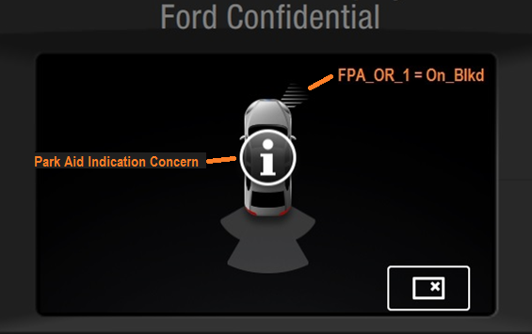

CAMERA-FUR-REQ-211759/B-Infotainment Graphical Position Definition 13
When the status of any rear sensor is On-Blkd, in addition to the graphic defined for the individual positional, an HMI-defined graphic shall be displayed which indicates that all rear indication sectors are disabled.

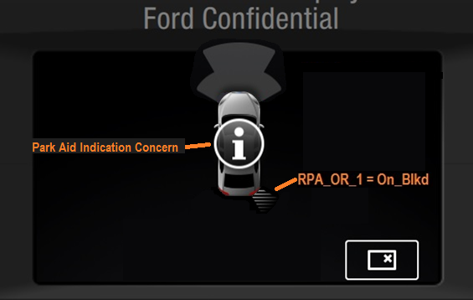

Visual Park Aid Graphical Requirements

CAMERA-FUR-REQ-130442/C-Visual Parking Aid Graphical Layout
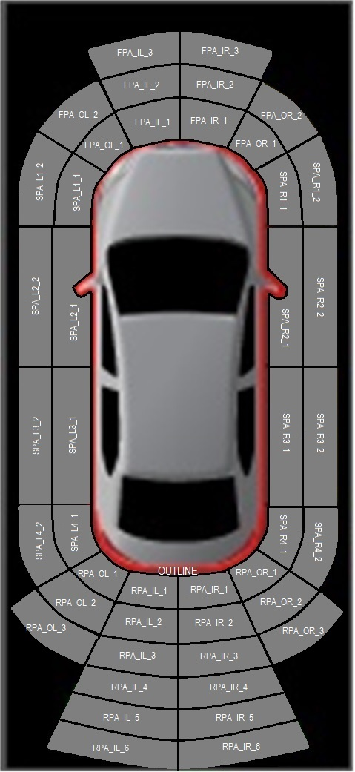
Actual HMI graphics will be application specific

Position | Abbreviation
RPA_OuterLeft_1 | RPA_OL_1
RPA_OuterLeft_2 | RPA_OL_2
RPA_OuterLeft_3 | RPA_OL_3
RPA_InnerLeft_1 | RPA_IL_1
RPA_InnerLeft_2 | RPA_IL_2
RPA_InnerLeft_3 | RPA_IL_3
RPA_InnerLeft_4 | RPA_IL_4
RPA_InnerLeft_5 | RPA_IL_5
RPA_InnerLeft_6 | RPA_IL_6
RPA_InnerRight_1 | RPA_IR_1
RPA_InnerRight_2 | RPA_IR_2
RPA_InnerRight_3 | RPA_IR_3
RPA_InnerRight_4 | RPA_IR_4
RPA_InnerRight_5 | RPA_IR_5
RPA_InnerRight_6 | RPA_IR_6
RPA_OuterRight_1 | RPA_OR_1
RPA_OuterRight_2 | RPA_OR_2
RPA_OuterRight_3 | RPA_OR_3
FPA_OuterLeft_1 | FPA_OL_1
FPA_OuterLeft_2 | FPA_OL_2
FPA_InnerLeft_1 | FPA_IL_1
FPA_InnerLeft_2 | FPA_IL_2
FPA_InnerLeft_3 | FPA_IL_3
FPA_InnerRight_1 | FPA_IR_1
FPA_InnerRight_2 | FPA_IR_2
FPA_InnerRight_3 | FPA_IR_3
FPA_OuterRight_1 | FPA_OR_1
FPA_OuterRight_2 | FPA_OR_2
SPA_Left1_1 | SPA_L1_1
SPA_Left1_2 | SPA_L1_2
SPA_Right1_1 | SPA_R1_1
SPA_Right1_2 | SPA_R1_2
SPA_Left2_1 | SPA_L2_1
SPA_Left2_2 | SPA_L2_2
SPA_Right2_1 | SPA_R2_1
SPA_Right2_2 | SPA_R2_2
SPA_Left3_1 | SPA_L3_1
SPA_Left3_2 | SPA_L3_2
SPA_Right3_1 | SPA_R3_1
SPA_Right3_2 | SPA_R3_2
SPA_Left4_1 | SPA_L4_1
SPA_Left4_2 | SPA_L4_2
SPA_Right4_1 | SPA_R4_1
SPA_Right4_2 | SPA_R4_2
HMI Zone Assignment for PDC

CAMERA-FUR-REQ-130775/B-Visual Parking Aid General Graphical Requirements 1
The HMI system screen designer shall align the size and position of the Base Park Aid (BPA) sectors area such that they reflect as closely as possible to the BPA system sector area definitions.
Note:
This requirement aims to assure that the parking aid and HMI engineers are in agreement. The indication of object position must be (as closely as possible) in line with the true object position per tests #27, #28 of CETP: 13.13-R-4171.

CAMERA-FUR-REQ-130776/B-Visual Parking Aid General Graphical Requirements 2
All sectors of Park Distance Control (PDC) shall be supported.
Note:
Which sectors are shown shall be controlled directly by the CAN signaling; PAM configuration shall ensure that the commanded display matches the number of channels available in the vehicle.

CAMERA-FUR-REQ-130777/B-Visual Parking Aid General Graphical Requirements 3
Positional nomenclature follows HMI zone assignment for PDC table. The positional OUTLINE shall consist of an HMI-defined outline of the vehicle that can be activated independent of other segments.
Note:
Typical execution aligns the warning color of the vehicle outline with any segment 1 warning.

Visual Parking Aid RPA Graphical Requirements

CAMERA-FUR-REQ-130778/B-Visual Parking Aid RPA Graphical Requirements 1
The two inner/ center RPA sectors RPA_IL, RPA_IR shall consist of six (6) independent bars or segments.

CAMERA-FUR-REQ-130779/C-Visual Parking Aid RPA Graphical Requirements 2
The two outer/ corner RPA sectors RPA_OL, RPA_OR shall consist of three (3) independent bars or segments.

Visual Parking Aid FPA Graphical Requirements

CAMERA-FUR-REQ-130780/B-Visual Parking Aid FPA Graphical Requirements 1
The two inner/ center FPA sectors FPA_IL, FPA_IR shall consist of three (3) independent bars or segments.

CAMERA-FUR-REQ-130781/B-Visual Parking Aid FPA Graphical Requirements 2
The two outer/ corner FPA sectors FPA_OL, FPA_OR shall consist of two (2) independent bars or segments.

CAMERA-FUR-REQ-130782/C-Visual Parking Aid FPA Graphical Requirements 3
The two side FPA sectors SPA_L1, SPA_L2 shall consist of two (2) independent bars or segments.
Note:
These side sectors are functionally handled as if they are part of SPA. This is why the nomenclature uses “SPA” here instead of “FPA.”

Visual Parking Aid SPA Graphical Requirements

CAMERA-FUR-REQ-130783/B-Visual Parking Aid SPA Graphical Requirements 1
All SPA sectors SPA_L2, SPA_R2, SPA_L3, SPA_R3, SPA_L4 and SPA_L4 shall consist of two (2) independent bars or segments.

CAMERA-FUR-REQ-130784/B-Visual Parking Aid SPA Graphical Requirements 2
The SPA sectors SPA_L2 and SPA_R2 shall start at a position at which the driver – when looking at the vehicle symbol - would expect the front axle of the vehicle.

CAMERA-FUR-REQ-130785/B-Visual Parking Aid SPA Graphical Requirements 3
The SPA sectors SPA_L3 and SPA_R3 shall end at a position at which the driver – when looking at the vehicle symbol - would expect the rear axle of the vehicle.

CAMERA-FUR-REQ-130786/B-Visual Parking Aid SPA Graphical Requirements 4
SPA sectors SPA_L2, SPA_L3 and SPA_R2, SPA_R3 shall have the same length.

CAMERA-FUR-REQ-130787/B-Visual Parking Aid SPA Graphical Requirements 5
SPA sectors SPA_L1 and SPA_R1 shall start at the end of the FPA corner sectors.

CAMERA-FUR-REQ-130788/B-Visual Parking Aid SPA Graphical Requirements 6
SPA sectors SPA_L4 and SPA_R4 shall end at the start of the RPA corner sectors.

Active Park Assist (APA) and Park Distance Control (PDC) during Rear Video Camera (RVC) Graphical Requirements

CAMERA-FUR-REQ-161276/B-Active Park Assist (APA) and Park Distance Control (PDC) during Rear Video Camera (RVC) Graphical Layout
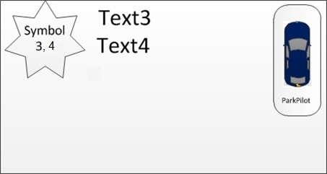

Actual HMI graphics will be application specific.

Position | Abbreviation
Driver Instruction/Information | Symbol 3
Driver Instruction/Information | Symbol 4
Driver Instruction/Information | Text3
Driver Instruction/Information | Text4
Visual Park Aid Zone Graphic | ParkPilot
HMI Zone Assignment for APA and PDC during RVC

CAMERA-FUR-REQ-161271/B-Active Park Assist (APA) and Park Distance Control (PDC) during Rear Video Camera (RVC) Graphical Requirements 1
The APA and PDC during RVC screen content shall be developed in close cooperation between the APA function owner, HMI and VE.

CAMERA-FUR-REQ-161272/B-Active Park Assist (APA) and Park Distance Control (PDC) during Rear Video Camera (RVC) Graphical Requirements 2
The HMI team shall design the screens such that they reflect the detailed instructions that the driver must follow.

CAMERA-FUR-REQ-161273/B-Active Park Assist (APA) and Park Distance Control (PDC) during Rear Video Camera (RVC) Graphical Requirements 3
The HMI system screen designer shall meet the functional direction of this interface specification (e.g. a graphic shall be provided for each functional block) however the actual graphic and its position shall be placed per HMI team direction.

CAMERA-FUR-REQ-161274/B-Active Park Assist (APA) and Park Distance Control (PDC) during Rear Video Camera (RVC) Graphical Requirements 4
It is acceptable for the HMI design to overlap positionals as deemed necessary. Should this be required, all overlaps shall be reviewed with parking assistance engineering to ensure proper foreground/background priority has been assigned to the overlapping positionals.

CAMERA-FUR-REQ-161275/B-Active Park Assist (APA) and Park Distance Control (PDC) during Rear Video Camera (RVC) Graphical Requirements 5
Each logical value of the simplified signals shall determine the display of each positional as defined in section Active Park Assist (APA) and Park Distance Control (PDC) during Rear Video Camera (RVC) Signal Processing.

CAMERA-FUR-REQ-165415/A-Active Park Assist (APA) and Park Distance Control (PDC) during Rear Video Camera (RVC) Graphical Requirements 6
Upon transition into or out of “Active Park Assist (APA) and Park Distance Control (PDC) during Rear Video Camera (RVC),” active park positionals shall not be displayed until the state of the active park input signals has changed.
Note: this is for flicker prevention. The HMI ECU memorizes the state of the APA signals at RVC screen transition and does not overlay any APA positionals until there is a state change of the input sign

HotKey Shortcut Menu Interface
The interface requirements of this section shall be met by the HMI in order to support the HotKey shortcut menu high level functional requirements.

HotKey Shortcut Menu General Requirements
A high level sketch of the functional distribution that is the baseline of the hotkey logic is depicted below. Note that the signal interface for triggering visual APA and BPA indication is intentionally excluded from the sketch.

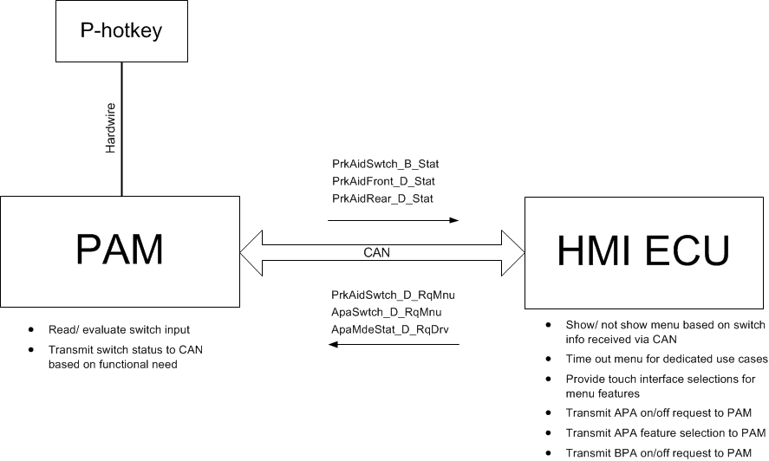

High level functional distribution for hotkey logic (visual indication excluded)

CAMERA-FUR-REQ-236837/C-HotKey Shortcut Menu General Requirements 1
The P-hotkey menu shall offer to select the active park assist feature (“APA-option”), de-activate or activate the BPA feature (“BPA-option”) or select “other features” (“Other-option”).
Note:
This specification is established by the APA/BPA feature owners. Hence, the “other features” are not within author’s responsibility. Still, the way they are presented has an impact on the APA/BPA feature activation and deactivation. The detailed layout is of course the HMI design/ ergo team’s responsibility. The sketch deliberately does not provide any details with respect to the MyKey use case and the BPA option. It is expected that the HMI team decides what the menu should look like, e.g. greyed out not-selectable option or not shown at all. (P-HotkeyReq014)

CAMERA-FUR-REQ-236838/B-HotKey Shortcut Menu General Requirements 2
The P-hotkey menu shall only be accessible via the hotkey.
Note:
For the FAP feature we expect to always see a button press before we go active. If the menu would be available via any kind of SYNC menu (thus avoiding use of the hotkey) this concept would no longer work. So it must be guaranteed that the menu (and thus FAP) can only be called when the button is pressed.

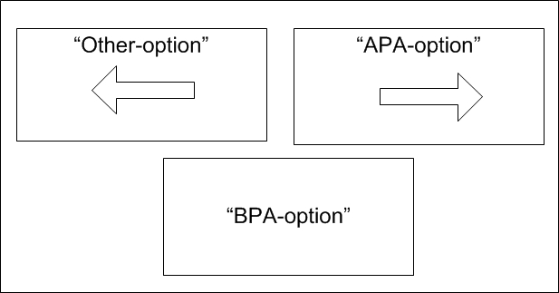
High level sketch of possible hotkey menu design
(P-HotkeyReq015)

CAMERA-FUR-REQ-236839/C-HotKey Shortcut Menu General Requirements 3
If the P-hotkey is concept is applied, all APA full screen scanning screens shall show the feature selection menu bar.
Note:
This requirement needs to be respected by the HMI system. As we lose the possibility to toggle features via the hard button, availability of the feature selection menu must be guaranteed.
(P-HotkeyReq067)

CAMERA-FUR-REQ-235899/B-HotKey Shortcut Menu General Requirements 4
If the p-hotkey menu is currently shown when reverse gear is engaged, the HMI system shall close the p-hotkey menu and show the RVC view as defined by requirements from the reverse camera team.
Note:
Requirements applicable for RVC indication as applicable at the time of release of this specification remain in place.
(P-HotkeyReq104)

CAMERA-FUR-REQ-235900/B-HotKey Shortcut Menu General Requirements 5
If the p-hotkey menu is closed due to reverse gear being engaged, the HMI system shall not show APA information on the RVC screen.
Note:
We need to avoid race conditions. Imagine that the APA feature may be slower to change from the mode it is in if the hotkey menu is shown to the mode it is in when the menu is off. Mind that both systems use reverse gear and have to process it to change states. In this case the HMI could then still receive APA information that was sent to adapt the appearance of the APA selection option because the PAM may be slower processing/ receiving reverse gear. We do not want this information to appear on the RVC screen.
(P-HotkeyReq105)

CAMERA-FUR-REQ-235901/B-HotKey Shortcut Menu General Requirements 6
The HMI system shall never change from a non p-hotkey screen to full screen APA.
Note:
We need to make sure we avoid flicker. When the button is pressed the PAM goes into a dedicated operational mode associated to showing information while the menu is shown. Now imagine we have an overspeed use case. This means when the PAM goes into this “menu mode” it provides the ApaCsi signals that in non-hotkey variants trigger the APA overspeed screen. Imagine now that the HMI would interpret the ApaCsi signals for overspeed first and only afterwards consider the signal from the switch (which should be send by the PAM simultaneously, but there are multiple messages to read). When pressing the switch we could then have a brief flicker of today’s APA overspeed screen followed by the p-hotkey menu. And this is something we surely don’t want. So the HMI system needs to make sure all signals/ messages are evaluated, before it reacts. If the switch signal is received as pressed simultaneously with the ApaCsi signals for e.g. APA overspeed, then we want to see “just” the p-hotkey menu with the APA option shown for the overspeed condition.
(P-HotkeyReq100)

CAMERA-FUR-REQ-236526/B-HotKey Shortcut Menu General Requirements 7
The BPA feature activation status shall be clearly reflected in the P-hotkey menu.
(P-HotkeyReq068)

CAMERA-FUR-REQ-236527/B-HotKey Shortcut Menu General Requirements 8
If the driver has called up the P-hotkey menu and has selected the “BPA-option”, the p-hotkey menu shall time out after [tCloseConfirm].
Note:
It should be safe to assume that when the driver has opened the menu to activate or deactivate the BPA option this was the only action they wanted to perform. Thus the menu can be automatically closed. We add the delay [tCloseConfirm], though, to make sure the driver sees the confirmation of his/her action by a change of state of the BPA ON/Off menu.
(P-HotkeyReq051)

CAMERA-FUR-REQ-236529/B-HotKey Shortcut Menu General Requirements 9
If the driver has called up the P-hotkey menu and successfully selected the “APA-option”, the hotkey menu shall be closed and the APA feature shall be shown full screen.
Note:
The driver can of course only “successfully” select the “APA-option” if it is selectable.
(P-HotkeyReq069)

CAMERA-FUR-REQ-236530/B-HotKey Shortcut Menu General Requirements 10
The “BPA-option” of the P-hotkey menu shall have an “ON/ ENABLED” and “OFF/ DISABLED” state.
Note:
The design of this interface is the responsibility of HMI, but the BPA feature owner needs to sign off.
(P-HotkeyReq064)

CAMERA-FUR-REQ-236531/B-HotKey Shortcut Menu General Requirements 11
The “APA-option” of the P-hotkey menu shall have a “normal” state, an “overspeed” state, an “unavalaible” state and a “fault” state.
(P-HotkeyReq019)

CAMERA-FUR-REQ-236532/B-HotKey Shortcut Menu General Requirements 12
When in “normal” state the “APA-option” shall be designed to indicate that the feature is selectable.
(P-HotkeyReq020)

CAMERA-FUR-REQ-236533/C-HotKey Shortcut Menu General Requirements 13
When in “overspeed” state, the “APA-option” shall provide additional symbols or text to indicate that the vehicle is operated outside of the APA feature’s speed envelope, but the “APA-option” shall be shown as selectable.
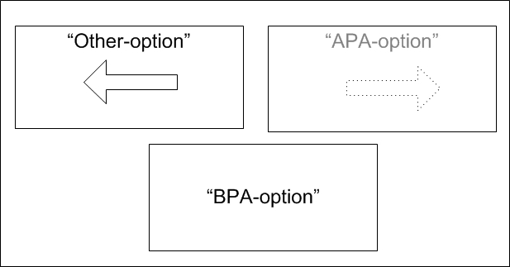

Sketch for possible design of APA feature selection during overspeed
(P-HotkeyReq021)

CAMERA-FUR-REQ-236534/B-HotKey Shortcut Menu General Requirements 14
When in “unavailable” state, the “APA-option” shall be “greyed out” or provide additional symbols or text to indicate that (and why) the APA feature is not available and cannot be selected.
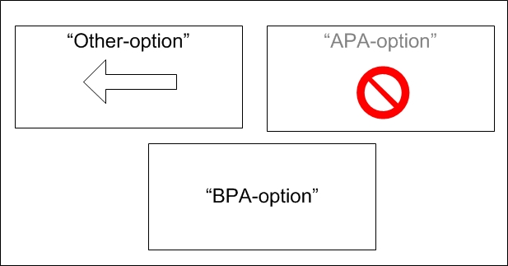

Sketch for possible design of APA feature selection when APA is not available.
(P-HotkeyReq022)

CAMERA-FUR-REQ-236546/B-HotKey Shortcut Menu General Requirements 15
When in “fault” state, the “APA-option” shall be “greyed out” or provide additional symbols or text to indicate that the APA feature is faulted and cannot be selected.
(P-HotkeyReq023)

CAMERA-FUR-REQ-236829/B-HotKey Shortcut Menu General Requirements 16
When the “APA.-option” is in “overspeed” state, feature selection and thus a change to full screen APA mode shall remain available.
Note:
We here consider that the vehicle may be driven just slightly outside of the APA feature’s speed envelope. So we do allow selecting the feature. Note that when activated in overspeed condition the APA feature controls the screen time out. This is the same behavior as for APA implementations with a hard button directly communicating with the APA feature. This is supported by PAM signals.
(P-HotkeyReq024)

CAMERA-FUR-REQ-236830/B-HotKey Shortcut Menu General Requirements 17
When the “APA-option” is in “fault” or “unavailable” state, feature selection shall not be available and a change to full screen APA mode shall not be possible.
(P-HotkeyReq025)

CAMERA-FUR-REQ-236833/B-HotKey Shortcut Menu General Requirements 20
All APA screens shall feature an “APA off” option.
Note:
The “off option” is today already part of the scanning screens. This requirement extends its availability to the screens for active steering. This is necessary as we no longer have the hardbutton to deactivate active steering.
(P-HotkeyReq046)

CAMERA-FUR-REQ-236834/B-HotKey Shortcut Menu General Requirements 21
The RVC screen shall provide an interface to activate/ deactivate BPA.
Note:
With the introduction with the p-hotkey we lose the standalone BPA switch. And as the p-hotkey is not available in reverse gear, we do need another possibility to deactivate BPA.
(P-HotkeyReq099)

CAMERA-FUR-REQ-250044/A-HotKey Shortcut Menu General Requirements 22
If the driver has called up the P-hotkey menu and selects the “Other-option”, the p-hotkey menu shall be immediately closed and the “Other-option” shall be shown full screen.
(P-Hotkey126)

CAMERA-FUR-REQ-250046/A-HotKey Shortcut Menu General Requirements 23
If the p-hotkey menu has been shown without interruption for [tCloseNoSelection], the hotkey menu shall be closed.

Note;
An interruption in this context could e.g. be the indication of the BPA “full screen” overlay on top of the p-hotkey menu or selection of any of the p-hotkey menu’s options.
(P-HotkeyReq129)

CAMERA-FUR-REQ-250047/A-HotKey Shortcut Menu General Requirements 24
If the hotkey concept is applied, all “full screen” BPA overlays shall include a BPA “ON/OFF” option as symbolically shown by the Figure.
Note:
The final design fulfilling all ergo and BPA requirements has to be defined by the HMI design team and signed off by the BPA feature owner.
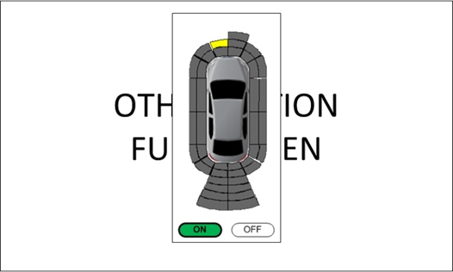
sketch of BPA overlay with ON/OFF (HMI to decide on final design)
(P-HotkeyReq159)

CAMERA-FUR-REQ-250491/B-HotKey Shortcut Menu General Requirements 25
If the hotkey menu offers any “on-screen close option” that can be used to deactivate the P-hotkey menu;
If the P-hotkey menu closes due to activation of the on-screen deactivation option, the operational table for [ApaMdeStat_D_RqDrv] shall be respected.

This requirement covers the possibility that the generic hotkey menu design includes a “Cancel” or “Close” option on the touch screen. This option is not part of the APA/ BPA feature specifications, but seems to be a generic design. So it is important to respect this requirement as when the menu closes, the PAM/ APA feature always needs to be informed.
(P-HotKeyReq170)

CAMERA-FUR-REQ-272559/A-HotKey Shortcut Menu General Requirements 26
If MyKey is present the BPA on/off selection of the BPA overlay shall not be shown.

Note:
In case of the BPA overlay it does not make much sense to show the On/Off option, but make it not selectable. This might confuse people more than it helps. With the On/Off option simply not being there, the message that BPA cannot be deactivated in case of MyKey is clear.
(P-HotkeyReq173)

CAMERA-FUR-REQ-272563/A-HotKey Shortcut Menu General Requirements 27
If the P-hotkey menu closes due to [tCloseConfirm] timeout, [tCloseNoSelection] timeout or any on-screen deactivation option: The P-Hotkey menu shall be closed without any discernable flicker.
(P-HotkeyReq171)

HotKey Shortcut Menu Signal List

CAMERA-FUR-REQ-235902/B-HotKey Shortcut Menu Signal List - ApaMdeStat_D_RqDrv
The HMI system shall transmit the signal [ApaMdeStat_D_RqDrv] to the PAM.
Note:
This signal already exists today. It is used for feature selection via the APA feature menu. The associated functional logic is a little expanded to support the hotkey concept.
(P-HotkeyReq033)

CAMERA-FUR-REQ-235903/B-HotKey Shortcut Menu Signal List - ApaSwtch_D_RqMnu
The HMI system shall transmit the signal [ApaSwtch_D_RqMnu] to the PAM.
Note:
The signal is used to activate/ deactivate APA active scanning. See requirements of this section.
(P-HotkeyReq058)

CAMERA-FUR-REQ-235904/B-HotKey Shortcut Menu Signal List - PrkAidSwtch_D_RqMnu
The HMI system shall transmit the signal [PrkAidSwtch_D_RqMnu] to the PAM.
Note:
The signal is used to activate/ deactivate BPA. See requirements of this section.
(P-HotkeyReq059)

CAMERA-FUR-REQ-236835/B-HotKey Shortcut Menu Signal List - PrkAidFront_D_Stat
The HMI system shall receive the signal PrkAidFront_D_Stat from the PAM.
Note:
We don’t know today if the Hotkey logic will be used only with park aid variants >4channel. In theory, if that’s the case we could use a single signal. For timing reasons and to protect potential later usage with 4channel/ RPA-only variants we here take two existing signals.
(P-HotkeyReq111)

CAMERA-FUR-REQ-236836/B-HotKey Shortcut Menu Signal List - PrkAidRear_D_Stat
The HMI system shall receive the signal PrkAidRear_D_Stat from the PAM.
Note:
We don’t know today if the Hotkey logic will be used only with park aid variants >4channel. In theory, if that’s the case we could use a single signal. For timing reasons and to protect potential later usage with 4channel/ RPA-only variants we here take two existing signals.
(P-HotkeyReq111)

HotKey Shortcut Menu Signal Processing

CAMERA-FUR-REQ-235906/B-HotKey Shortcut Menu Signal Processing Requirements 1
When the HMI system initializes, the default of the signal [ApaMdeStat_D_RqDrv] shall be “0x0 – Inactive”.
(P-HotkeyReq034)

CAMERA-FUR-REQ-235908/B-HotKey Shortcut Menu Signal Processing Requirements 2
When the HMI system initializes, the default of the signal [ApaSwtch_D_RqMnu] shall be “0x0 – Not pressed”.
(P-HotkeyReq060)

CAMERA-FUR-REQ-235909/B-HotKey Shortcut Menu Signal Processing Requirements 3
When the HMI system initializes, the default of the signal [PrkAidSwtch_D_RqMnu] shall be “0x0 – Not pressed”.
(P-HotkeyReq061)

CAMERA-FUR-REQ-235910/C-HotKey Shortcut Menu Signal Processing Requirements 4
The HMI system shall react on [PrkAidSwtch_B_Stat] (received from the PAM) as defined by the following table.

Initial HMI p-hotkey menu status |  | Status of [PrkAidSwtch_B_Stat] |  | Resulting p-hotkey menu status
p-hotkey menu not shown | AND | 0x0 “Not pressed” |  | p-hotkey menu not shown, any other screen remains shown
p-hotkey menu not shown * | AND | Transition from 0x0 “Not pressed” to 0x1 “Pressed” |  | Show p-hotkey menu
p-hotkey menu shown | AND | Transitionfrom 0x0 “Not pressed”  to 0x1 “Pressed” |  | Close p-hotkey menu  (Return to active screen prior to activation of p-hotkey menu)
* Note that this state includes full screen APA mode and the BPA “full screen” overlay on top of the menu screen.

HMI system reaction to PrkAidSwtch_B_Stat
(P-HotkeyReq056)

CAMERA-FUR-REQ-235911/B-HotKey Shortcut Menu Signal Processing Requirements 5
The HMI system shall change the state of the signal [ApaSwtch_D_RqMnu] as per the following table.

p-hotkey menu state | AND | driver action |  | State of [ApaSwtch_D_RqMnu]
p-hotkey menu not shown | - | don’t care |  | “0x0 Not pressed”
p-hotkey menu shown | AND | None |  | “0x0 Not pressed”
p-hotkey menu shown | AND | driver selects “BPA-option” of p-hotkey menu |  | “0x0 Not pressed”
p-hotkey menu shown | AND | driver selects “Other-option” of p-hotkey menu |  | “0x0 Not pressed”
p-hotkey menu shown | AND | driver selects “APA-option” of p-hotkey menu |  | Cycle
HMI system logic for ApaSwtch_D_RqMnu – Change from 0x0 to “other”
(P-HotkeyReq036)

CAMERA-FUR-REQ-235912/C-HotKey Shortcut Menu Signal Processing Requirements 6
The HMI system shall change the state of the signal [ApaMdeStat_D_RqDrv] as per the following tables.
Note:
The logic with respect to the state of [ApaMdeStat_D_RqDrv] and [ApaMde_D_Stat] is already in place today. This table should not be in conflict with that existing logic, but is added here to complete this specification.
 | HMI screen |  | driver action / menu state |  | State of [ApaMdeStat_D_RqDrv]
1 | any screen shown but not the p-hotkey menu | AND | don’t care |  | “0x0 Inactive”
2 | p-hotkey menu shown | AND | None |  | “0x0 Inactive”
3 | p-hotkey menu shown | AND | driver selects “BPA-option” of p-hotkey menu |  | “0x0 Inactive”
4 | p-hotkey menu shown | AND | driver selects “Other-option” of p-hotkey menu |  | “0x0 Off”
5 | p-hotkey menu shown | AND | driver selects “APA-option” of p-hotkey menu |  | “0x0 Inactive”
6 | APA menu bar shown on full APA screen | AND | None |  | “0x0 Inactive”
7 | APA menu bar shown on full APA screen | AND | driver selects “IPa” option |  | “0x1 SAPP”
8 | APA menu bar shown on full APA screen | AND | driver selects “IPe” option |  | “0x2 PPA”
9 | APA menu bar shown on full APA screen | AND | driver selects “OPa” option |  | “0x3 POA”
10 | APA menu bar shown on full APA screen | AND | driver selects “Off” option |  | “0x6 Off”
11 | APA “off” option shown on full APA screen | AND | driver selects “Off” option |  | “0x6 Off”
12 | p-hotkey menu shown | AND | p-hotkey menu closes due to [tCloseConfirm] timeout, [tCloseNoSelection] timeout or any other on-screen deactivation option |  | “0x6 Off”
HMI system logic for [ApaMdeStat_D_RqDrv] – Change from 0x0 to “other”

Initial state of [ApaMdeStat_D_RqDrv] |  | State of [ApaMde_D_Stat]  (received from PAM) |  | Resulting state of [ApaMdeStat_D_RqDrv]
0x0 “Inactive” | AND | Any change |  | “0x0 Inactive”
0x1 “SAPP” | AND | Changes from “Any” to “0x2 SAPP” |  | “0x0 Inactive”
0x1 “SAPP” | AND | Is/remains “0x2 SAPP” |  | “0x0 Inactive”
0x2 “PPA” | AND | Changes from “Any” to “0x3 PPA” |  | “0x0 Inactive”
0x2 “PPA” | AND | Is/remains “0x3 PPA” |  | “0x0 Inactive”
0x3 “POA” | AND | Changes from “Any” to “0x4 POA” |  | “0x0 Inactive”
0x3 “POA” | AND | Is/remains “0x4 POA” |  | “0x0 Inactive”
0x6 “Off” | AND | Changes from “Any” to “0x1 OFF” |  | “0x0 Inactive”
HMI system logic for [ApaMdeStat_D_RqDrv] – Change from “other “to 0x0
(P-HotkeyReq057)

CAMERA-FUR-REQ-235913/B-HotKey Shortcut Menu Signal Processing Requirements 7
When the trigger conditions for cycling are fulfilled, the HMI system shall change [ApaSwtch_D_RqMnu] from state “0x0” to state “0x1”, hold this state for at least [tHoldPressed] and end the cycle with the transition back to state “0x0”.
Note:
See figure. The requirement to keep the pressed state set at least [tHoldPressed] aims at assuring the PAM detects the change. You may consider this requirement fulfilled if the minimum SeperationTime as defined per applicable CAN specifications for event periodic signals or if the message rate of the signal [ApaSwtch_D_RqMnu] is the same or bigger than [tHoldPressed].

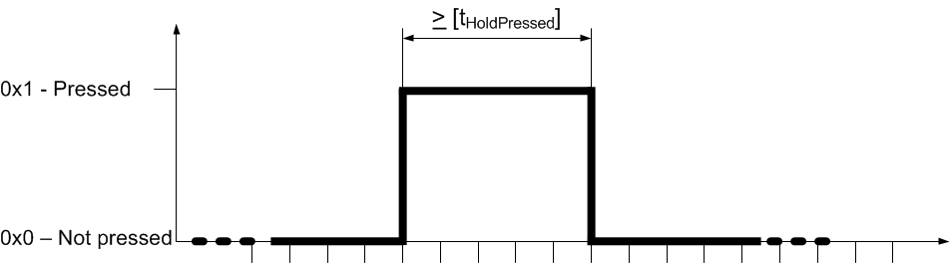

Cycle for [ApaSwtch_D_RqMnu] and [PrkAidSwtch_D_RqMnu]
(P-HotkeyReq038)

CAMERA-FUR-REQ-235914/C-HotKey Shortcut Menu Signal Processing Requirements 8
If the hotkey menu is shown, the APA feature selection interface shall depend on the signal [ApaSys_D_Stat] as detailed by the following table.

[ApaSys_D_Stat] |  | If hotkey menu is shown, APA feature selection option shall show that:
State | Description
0x0 | Null | APA option is selectable: No  APA option additional info: None  Note:  When this state is set the APA system is initializing. So this is a theoretical case as it should be assumed that during initialization the p-hotkey does not work and hence the menu
0x1 | Off | APA option is selectable: Yes  APA option additional info: None  Note:  This is a standard use case that occurs every time the p-hotkey calls up the menu and speed is within range and APA is available.
0x2 | On | n/a – in this case the full APA screen is shown, no hotkey menu available  Note:  When [ApaSys_D_Stat] is “On”, APA must be in full screen mode. Therefore this state cannot coincide with the menu being shown. Mind that changes from full screen APA to the P-hotkey menu can only be achieved by pressing the P-hotkey. As the P-hotkey is controlled by the PAM/ APA feature, however, the PAM can control that [ApaSys_D_Stat] is set to “Off” simultaneously with the change of [PrkAidSwtch_B_Stat].
0x3 | Overspeed | APA option is selectable: Yes  APA option additional info: Overspeed condition (show symbol or text)  Note:  This is a standard use case if the vehicle is driven above scanning speed. So the HMI does not need to look at speed. It can use this state from the PAM.
0x4 | ApaCancelled | APA option is selectable: Yes  APA option additional info: None  Note:  The states “ApaCancelled” and “Finished” can only occur during APA full screen mode. The only way to change from APA full screen mode back to showing the menu is via a press of the P_Hotkey. Imagine that the customer pushes the p-hotkey while the APA system is triggering a message for cancellation or has just finished and is still triggering the finish screen. As per the overall architecture, the P-hotkey is connected to the APA module. So the APA module can then always reset [ApaSys_D_Stat to “Off”] simultaneously with sending the signal for switch pressed [PrkAidSwtch_B_Stat]. Therefore, for the architecture in place the APA feature can prevent these states from appearing when the menu is shown. We still do define HMI system reaction for these states. Just in case.
0x5 | NotAccessible | APA option is selectable: No  APA option additional info: Read additional signals to show info:  if [ApaMsgTxt_D_Rq] == 0x3 “TcsDisabled”  Indicate TCS needs to be enabled to use APA (wording or symbol tbd)  elseif [ApaMsgTxt_D_Rq] ~= 0x3 “TcsDisabled” (includes signal n/a)  check [TrlrLampCnnct_B_Actl]  end  if [TrlrLampCnnct_B_Actl] == 0x1  Indicate APA cannot be used with a trailer attached (wording or symbol tbd)  else  Don’t show additional info  end  Note:  This logic considers that the driver could have hooked up a trailer or disabled traction control prior to pressing the P-hotkey or while the menu was shown. In both cases the APA feature is not available. The reason for the unavailability can easily be derived from existing signals. Showing additional information aims at reducing TGW in case of users that are unaware of these limitations.
0x6 | Finished | APA option is selectable: Yes⁴  APA option additional info: No  Note:  See note to 0x4.
0x7 | Faulty | APA option is selectable: No  APA option additional info: APA is faulted (show symbol or text)

APA feature selection option with regard to ApaSys_D_Stat
(P-HotkeyReq044)

CAMERA-FUR-REQ-235915/B-HotKey Shortcut Menu Signal Processing Requirements 9
If [ApaSys_D_Stat] changes from any state to “0x2 – On”, the HMI system shall show APA screens in full screen mode according to the ApaCsi interface specifications.
Note:
Remember that when the APA feature option is selected, the HMI system cycles the signal [ApaSwtch_D_RqMnu] and this makes the PAM change from its menu mode to full screen mode. We intentionally wait for the PAM response before the full screen mode is launched. While this could produce “slow reaction”, it should reduce the risk of undefined states. These undefined states would occur if the HMI immediately jumped to full screen mode with the APA feature initially being still in menu mode.
(P-HotkeyReq096)

CAMERA-FUR-REQ-236842/B-HotKey Shortcut Menu Signal Processing Requirements 10

If the p-hotkey menu is shown | AND
[ApaSys_D_Stat] has any state other than (“0x0 – Null”) or (“0x2 – On”) or (“0x5 – NotAccessible”) or (“0x7 – Faulty”), | AND
the driver selects the APA option in the p-hotkey menu,
the HMI system shall cycle the signal [ApaSwtch_D_RqMnu].
(P-HotKeyReq097)

CAMERA-FUR-REQ-236843/B-HotKey Shortcut Menu Signal Processing Requirements 11

If the p-hotkey menu is shown |  | AND
[ApaSys_D_Stat] has the state (“0x0 – Null”) or (“0x2 – On”) or (“0x5 – NotAccessible”) or (“0x7 – Faulty”),
the driver shall not be able to select the APA option in the p-hotkey menu.
Note:
The state “0x2 – On” here is only mentioned for completeness. Per overall system interface design [ApaSys_D_Stat] can never be “0x2 – On” when the menu is shown. For this state we will always have the full screen APA mode.
(P-HotKeyReq048)

CAMERA-FUR-REQ-235916/B-HotKey Shortcut Menu Signal Processing Requirements 12
If the p-hotkey menu is shown and the “BPA-option” is selectable and the driver selects the “BPA-option”, the HMI system shall cycle the signal [PrkAidSwtch_D_RqMnu] as defined by the following figure.
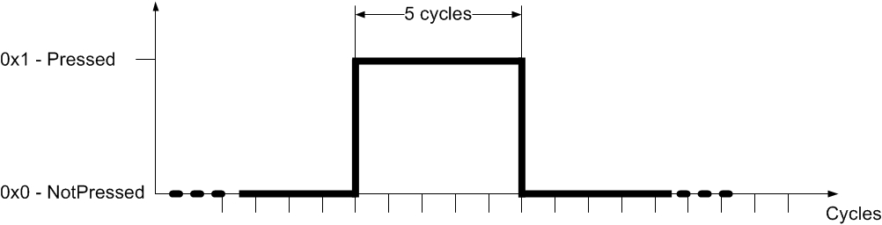
Cycle for [PrkAidSwtch_D_RqMnu]
(P-HotkeyReq106)

CAMERA-FUR-REQ-236840/C-HotKey Shortcut Menu Signal Processing Requirements 13
The status of the “BPA-option” shall be set as per the table.

 |  |  |  |  |  | “BPA-option”
HMI p-hotkey menu status |  | PrkAidFront_D_Stat |  | PrkAidRear_D_Stat |  | Style | Selectability
not shown | - | Don’t’ care | - | Don’t’ care |  | Don’t care | None
Shown | AND | 0x1 “Enabled” | OR | 0x1 “Enabled” |  | BPA enabled | Selectable
Shown | AND | 0x0 “Disabled” | AND | 0x0 “Disabled” |  | BPA disabled | Selectable
Shown | AND | 0x2 “Not used” OR  0x3 “Faulty” | OR | 0x2 “Not used” OR  0x3 “Faulty” |  | BPA disabled | Not Selectable
Note:
As per PAM specification the combinations “Faulty” and “Enabled” for front/rear (or vice versa) are not possible. Whenever any of the two signals assumes the state “Faulty” while the menu is shown, the HMI system shall apply the last requirement line of the above table.

State of BPA selection option as a function of ParkAidFront_D_Stat / ParkAidRear_D_Stat

BPA selection interface | [IgnKeyType_D_Actl] |  | Style / consequence
Hotkey menu | Is  0x2 “Key In Ignition MyKey” |  | Either show current state of BPA option with the BPA option being not selectable or do not show BPA option at all. The HMI team shall decide from one of these alternatives based on the different possible Hotkey menu content.
On/Off interface on top of/ as part of the BPA overlay. | Is not  0x2 “Key In Ignition MyKey” |  | Do not show On/Off interface on top of BPA overlay,

State of BPA selection option as a function of MyKey

(P-HotkeyReq110)

CAMERA-FUR-REQ-236841/B-HotKey Shortcut Menu Signal Processing Requirements 14

If the p-hotkey menu or any other screen is currently shown | AND
the signal [PrkAidMsgTxt_D_Rq] cycles from any state for which no BPA overlay is requested to any state for which a BPA overlay is requested,
the BPA “full screen” visual indication shall be shown on top of the p-hotkey menu or other currently shown screen (as per existing requirements for BPA ).
Note:
The requirements for activation of the BPA warning remain unaffected. Compared to the first release of this specification the above requirements changed such that the p-hotkey menu remains active in the back and the BPA overlay is shown full screen on top of the p-hotkey menu. This enables the driver to turn BPA off via the option built into the BPA overlay and then continue selecting an option from the p-hotkey menu. The underlying use case is that the driver called the menu, a BPA event “intervened” and upon closing the BPA overlay the menu is immediately available again. Make sure to respect that we specifically want the screen to be shown only when a signal transition/ cycle occurs!
(P-HotKeyReq052)

CAMERA-FUR-REQ-237606/C-HotKey Shortcut Menu Signal Processing Requirements 15
If [PrkAidMsgTxt_D_Rq] requests to show the BPA “full screen” overlay AND
the p-hotkey menu is triggered AND
the state of [PrkAidMsgTxt_D_Rq] remains “steady”/ does not cycle;

the BPA full screen overlay shall be closed AND
the p-hotkey menu shall be shown AND
the p-hotkey menu shall remain shown until another requirement to close the p-hotkey menu applies.
Note:
This requirement primarily aims at assuring that the hotkey menu remains shown when it has been called while a BPA warning is requested and BPA continues to request the visual warning. A potential use case is that a BPA warning is requested and shown and the driver presses the P-hotkey. Pressing the hotkey makes the APA system cycle the signal [PrkAidSwtch_B_Stat] which in turn triggers the menu. The driver could that while BPA still requested the BPA full screen overlay, but we here follow the driver’s wish to see the menu as long as we have “the same” warning from BPA. “The same” is derived from [PrkAidMsgTxt_D_Rq] being steady.
(P-HotkeyReq114)

CAMERA-FUR-REQ-235917/B-HotKey Shortcut Menu Signal Processing Requirements 16
If the RVC screen is shown and the driver selects the “BPA-option”, the HMI system shall cycle the signal [PrkAidSwtch_D_RqMnu] as defined by the figure.
Cycle for [PrkAidSwtch_D_RqMnu]
(P-HotkeyReq107)

CAMERA-FUR-REQ-235918/B-HotKey Shortcut Menu Signal Processing Requirements 17
If the p-hotkey menu is shown and the driver selects any option other than the “BPA-option”, the HMI system shall keep the signal [PrkAidSwtch_D_RqMnu] set to “0x0 – Not pressed”.
(P-HotkeyReq108)

CAMERA-FUR-REQ-235920/B-HotKey Shortcut Menu Signal Processing Requirements 18
If the RVC screen is shown and the driver selects any option other than the “BPA-option”, the HMI system shall keep the signal [PrkAidSwtch_D_RqMnu] set to “0x0 – Not pressed”.
Note:
This should be clear as only the “BPA-option” can change BPA status. Still this requirement was added for completeness.
(P-HotkeyReq109)

CAMERA-FUR-REQ-250026/A-HotKey Shortcut Menu Signal Processing Requirements 19
If [ApaSys_D_Stat] is “0x3 – Overspeed”, AND
the driver selects the APA option
the HMI system shall show APA screens in full screen mode according to the ApaCsi interface specifications.
Note:
If the vehicle is driven above the APA operational speed the APA system sets the signal [ApaSys_D_Stat] to “ox3” so that the HMI system can already show overspeed information in the P-Hotkey menu. However, that means we cannot use the state of [ApaSys_D_Stat] to determine when to change to full screen mode. Because the state in case of overspeed is the same regardless of menu or full screen mode. Therefore, in this case we allow the system to go the full screen mode just based on the APA option selection.
(P-HotkeyReq165)

CAMERA-FUR-REQ-250027/A-HotKey Shortcut Menu Signal Processing Requirements 20
If the p-hotkey menu is closed and the signal [PrkAidMsgTxt_D_Rq] requests a BPA warning, the HMI system shall immediately show the appropriate BPA visual indication as per existing requirements for BPA visual indication.
Note:
Imagine a use case for which the menu is requested to be shown while the BPA overlay is shown. If the menu is then closed again either by the timeout or via driver action (i.e. CAN signal), and a request to show the BPA overlay is still present, the BPA overlay shall be shown. Mind that the BPA overlay is shown on top of the screen that was shown before the hotkey menu was called.
(P-HotkeyReq130)

CAMERA-FUR-REQ-250028/A-HotKey Shortcut Menu Signal Processing Requirements 21
The transition from the P-hotkey menu w/o BPA “full screen” overlay to the BPA overlay shown on top of the screen active before the hotkey menu was shown shall occur seamless and w/o any discernible flicker.
Note:
Imagine that prior to the hotkey menu being shown the HMI was showing the “home screen” or the “home screen” with the BPA overlay. Now, at the time the p-hotkey menu is closed either by the CAN signal or by the timeout condition, the HMI system needs to check if a BPA request for an overlay is present. This check has to be performed before the new screen is build. If the request to show a BPA overlay is present, the HMI system must then immediately show the BPA overlay on top of the “home screen”. We could consider it to be “flicker” if first the “home screen” would be shown and then the BPA overlay on top of it.
(P-HotkeyReq160)

CAMERA-FUR-REQ-250029/A-HotKey Shortcut Menu Signal Processing Requirements 22
If the BPA “full screen” overlay is shown AND
[PrkAidMsgTxt_D_Rq] no longer requests to show the BPA “full screen” overlay
the BPA “full screen” overlay shall be closed as per existing BPA interface requirements.
Note:
This is not a new requirement. The existing BPA requirements do apply. The requirement is still added for completeness of the hotkey requirement set.
(P-HotkeyReq164)

CAMERA-FUR-REQ-250030/A-HotKey Shortcut Menu Signal Processing Requirements 23
If the BPA overlay is shown on top of the p-hotkey menu, the timer [t_{CloseNoSelection}] shall be stopped and reset.
Note:
We want to avoid that while the BPA overlay is shown, the background image changes. This could create flicker. Therefore we freeze the p-hotkey menu in the background of the BPA warning overlay as long as the BPA warning is shown.
(P-hotkey168)

CAMERA-FUR-REQ-250492/B-HotKey Shortcut Menu Signal Processing Requirements 24
If the [PrkAidMsgTxt_D_Rq] changes to “0x0 - All Park Sensors OFF” when the BPA overlay is shown on top of the p-hotkey menu), the timer [t_{CloseNoSelection}] shall again be applied.
Note:
So we restart the timer from zero and the driver has again the [t_{CloseNoSelection}] until the menu closes.
(P-HotKeyReq169)

CAMERA-FUR-REQ-250031/B-HotKey Shortcut Menu Signal Processing Requirements 25
Deleted: was a duplicate of CAMERA-FUR-REQ-250492/A-HotKey Shortcut Menu Signal Processing Requirements 24.

CAMERA-FUR-REQ-250032/A-HotKey Shortcut Menu Signal Processing Requirements 26
If the BPA “full screen” overlay is shown and the driver selects the “OFF” option, the HMI system shall cycle the signal [PrkAidSwtch_D_RqMnu].
Note:
This signal transition is used by the PAM to disable the BPA request. If the PAM disable the BPA request, the signal [PrkAidMsgTxt_D_Rq] will change states. The change of state of [PrkAidMsgTxt_D_Rq] finally terminates the BPA “full screen” overlay.
(P-HotkeyReq161)

CAMERA-FUR-REQ-250033/A-HotKey Shortcut Menu Signal Processing Requirements 27
If the BPA “full screen” overlay is shown (compare Figure 2 2) and the driver selects the “ON” option, the HMI system shall keep the signal [PrkAidSwtch_D_RqMnu] set to “0x0 – Not pressed”.
(P-HotkeyReq162)

CAMERA-FUR-REQ-272598/A-HotKey Shortcut Menu Signal Processing Requirements 28

If the P-hotkey menu is shown | AND
[tCloseConfirm] timer has expired OR [tCloseNoSelection] timer has expired OR on-screen deactivation option selected | AND
[ApaSys_D_Stat] has any state other than “0x1 – Off”;

the HMI system shall (temporarily) ignore any APA screen request until [ApaSys_D_Stat] changes to a state other than “0x1 – Off”.
Note:
We need to avoid race conditions. For the above cases, the P-hotkey menu is closed based on HMI logic. Closing is communicated by the HMI system via the signal [ApaMde_D_RqDrv]. This potentially creates a race condition as the APA feature needs to receive the signal and change its status. So for a brief period of time, the signal [ApaSys_D_Stat] may unintentionally be set to a value other than “Off” (as APA needs to leave the “preview”/ n”menu” mode). If we don’t take care this may lead to brief indication of the respective APA (full) screen, so flicker. The most robust solution to fulfill the above requirement appears to monitor the state of the signal [ApaSys_D_Stat] at the time the HMI logic decides the menu needs to be closed.
(P-HotkeyReq172)

Display HMI Arbitration

It is essential that the Infotainment ECU seamlessly integrates the Visual Park Aid and Active Park Assist screens into the overall display arbitration.

Display HMI Arbitration General Requirements
Display HMI Arbitration Use Diagram

CAMERA-FUR-REQ-131009/C-Display HMI Arbitration General Requirements 1
The HMI system shall arbitrate between screens with no discernable flicker as per HMI arbitration state machines.

CAMERA-FUR-REQ-131010/B-Display HMI Arbitration General Requirements 2
Within the Infotainment ECU overall display arbitration, the Camera, Active Park Assist and Visual Park Assist screens shall have the highest priority. No provision has been made in the screen arbitration to allow for higher priority displays, so any deviations require review and sign-off by Parking Assistance Core Engineering.
Note:
A legal requirement for APA exists. This states, the driver needs to be informed if the function is active and when it has been finished. In some legacy projects an indicator in the APA button has supported this requirement. However, the current design approach is to not use an indicator in the APA switch. The second part of the above requirement respects that (today) “Emergency Assist” has a higher priority than APA.

CAMERA-FUR-REQ-131011/C-Display HMI Arbitration General Requirements 3
Static Variables (e.g. configuration checks) shall be determined at transition to stable RUN operating mode, power-on initialization or ECU reset as per the arbitration tables.

CAMERA-FUR-REQ-131012/B-Display HMI Arbitration General Requirements 4
Static variables shall hold their state in KAM at key OFF. This is to provide a prior value during key RUN initialization.

CAMERA-FUR-REQ-131013/C-Display HMI Arbitration General Requirements 5
If a Park Aid fault screen is shown, the infotainment display system shall time out after a HMI-defined time. In addition to this time out, HMI may also allow a user input to acknowledge the fault and then close the screen.

CAMERA-FUR-REQ-131014/B-Display HMI Arbitration General Requirements 6
The HMI display client shall provide for internal timers. Operational value of the non-customer-selectable timers shall be programmable via direct memory write to EEPROM OR via a constant change in flash ROM (Individual vehicle applications may adjust the timers as program requirements dictate). At initialization (entry into stabilized RUN mode, power on reset, ECU reset), all timers shall initialize into state STOPPED AND RESET.

CAMERA-FUR-REQ-131015/C-Display HMI Arbitration General Requirements 7
Customer-selectable settings shall store the customer preference in KAM within a key cycle. At key OFF, if the customer-selected value is different than the stored value, the KAM location shall be committed to EEPROM or flash ROM appropriately.

CAMERA-FUR-REQ-211760/A-Display HMI Arbitration General Requirements 8
Fault screen appearance shall be approved by the camera, active park and park aid core teams respectively.

Display HMI Arbitration Internal Arbitration Variables

CAMERA-FUR-REQ-131016/D-Display HMI Arbitration Internal Variable Table (Static)

Variable Name | Value at initialization (battery connect) | Value at transition into RUN state | Notes
APA_Cfg | False | Use prior value | This looks at method II variables in the HMI ECU to determine whether or not to show the APA screens
Camra_Cfg | False | Use prior value | This looks at method II variables in the HMI ECU to determine whether or not to show the camera screens
FVC_Cfg | False | Use prior value | This looks at method II variables in the HMI ECU to determine maximum allowable speed limit for RVC exit
PDC_Cfg | False | Use prior value | This looks at method II variables in the HMI ECU to determine whether or not to show the PDC screens
OffRoadCamera_Cfg | False | Use prior value | This looks at method II variables in the HMI ECU to determine the speed thresholds for FVC screen deactivation
CamraDisable_Cfg | Use stored value | Use stored value | This is a internal parameter (not method 2 configurable) representing the vehicle speed at which the camera delay is overridden. Typical setting is 10kph.
CamraOffRoadDisable_Cfg | Use stored value | Use stored value | This is a internal parameter (not method 2 configurable) representing the vehicle speed at which the front camera delay is overridden when off-road capability has been enabled by the user. Typical setting is 24kph.

CAMERA-FUR-REQ-161326/C-Display HMI Arbitration Internal Variable Table (Dynamic)

Variable Name | Value at initialization (battery connect) | Value at transition into RUN state | Notes
APADisp | FALSE | FALSE | Internal parameter that represents the real-time state of the APA screen request. Used by the screen controller.
APA_Mode | NOT_APA | NOT_APA | Real-time (not debounced) variable used by the APA state machine. Debounce is handled on the PAM side.
APA_Sys_Stat | OFF | OFF | Real-time (not debounced) variable used by the APA state machine. Debounce is handled on the PAM side.
APA_Gear_Shif | NO_REQUEST | NO_REQUEST | Real-time (not debounced) variable used by the APA state machine. Debounce is handled on the PAM side.
FVCDisp | FALSE | FALSE | Internal parameter that represents the real-time state of the FVC screen request. Used by the screen controller.
FVC_OverSpd_Thres | CamraDisable_Cfg | CamraDisable_Cfg | Used as speed threshold for FVC screen deactivation
FVCScrRq | FALSE | FALSE | Internal parameter that is used to represent the real-time state of the Front Video Camera (FVC) user request status
GearPosHMI | PARK | PARK | Debounced internal parameter (see timer section for debounce characteristics) that is set and used within the arbitration state machines
Park_Brake_Merged | NOT_APPLIED | NOT_APPLIED | Real-time (not debounced) variable used in the gear input processing table – park brake status is required in order to determine PARK on manual transmission variants
PDC_Stat | INACTIVE | INACTIVE
PDCDisp | FALSE | FALSE | Internal parameter that represents the real-time state of the PDC screen request. Used by the screen controller.
RVC_OverSpd_Thres | CamraDisable_Cfg | CamraDisable_Cfg | Used as speed threshold for RVC screen deactivation
RVCDisp | FALSE | FALSE | Internal parameter that represents the real-time state of the RVC screen request. Used by the screen controller.

CAMERA-FUR-REQ-161327/E-Display HMI Arbitration Internal Variable Table (Timers and Debounce)

Variable Name | Minimum Programmable Value | Maximum Programmable Value | Initial (default, not program specific) Value | Notes†
APA_Actv_MM_Timr_Cfg | 0 | 5000ms | 250ms | Time to missing message fault while APA is actively displaying
APA_Mode_Timr_Cfg | 0 | 2000ms | 0ms | Timer for debouncing active park input data  Note: should already be debounced by source.
Camra_Actv_MM_Timer_Cfg | 0 | 5000ms | 1000ms | Time to missing message fault while camera is actively displaying
Camra_Exit_Timr_Cfg | 0 | 5000ms | 2000 | Minimum RVC camera screen display time when exiting using Camera Exit Delay.
GearPosHMI_Timr_Cfg | 0 | 2000ms | 250ms | Camera screen entry time  Note: 2000ms is the FMVSS111 maximum time.  Ford maximum per Rqt131305-007773 is 750ms for the entire system.
Camra_Fault_Timr_Cfg | 0 | 5000ms | 1000ms | Timer for debouncing data “faulty”
Park_Brake_Timr_Cfg | 0 | 2000ms | 0ms | Timer for debouncing park brake input data  Note: should already be debounced by source.
PDC_Stat_Timr_Cfg | 0 | 2000ms | 0ms | Timer for debouncing park aid input data  Note: should already be debounced by source.
PDC_Actv_MM_Timr_Cfg | 0 | 5000ms | 250ms | Time to missing message fault while PDC is actively displaying
PDC_Fault_Timr_Cfg | 0 | 5000ms | 250ms | Timer for debouncing data “faulty”
†Initial values must be reviewed for application on each specific program. Typical example of this would be for a missing message timeout, e.g. if a default timeout in this table is 250ms but the gateway messaging rate of the signal to HS3 is 500ms, then that timer should be set to 1500-2500ms (3-5x messaging rate is typical as long as it falls within the min/max definition). The applications D&R and feature owner shall direct the final value for each program.

CAMERA-FUR-REQ-131018/D-HMI Screen Logical Arbitration - Determine Static Variables (Camra_Cfg)
The following decision table creates Camra_Cfg based on Method II camera configuration values.
Method 2  “Rear Camera” | Method 2  ”RVC Split View” | Method 2  “DAFVC Split View” | Method 2  “360 Camera View” | “Camra_Cfg”
NOT_  AVAILABLE | NOT_  AVAILABLE | NOT_  AVAILABLE | NOT_  AVAILABLE | FALSE
All Other Cases |  |  |  | TRUE

Screen Arbitration Configuration Variables: Camera

CAMERA-FUR-REQ-131019/C-HMI Screen Logical Arbitration - Determine Static Variables (APA_Cfg, PDC_Cfg)

HMI Configuration for Parking Assistance | APA_Cfg | PDC_Cfg
NO_PDC_PSM_SAPP (or NOT_USED) | FALSE | FALSE
REAR_PDC | REARFRONT_PDC | FALSE | TRUE
REARFRONT_PDC_SAPP_NA |  REAR_SAPP_NA |  REARFRONT_PDC_EU |  REAR_SAPP_EU |  REARFRONT_PDC_APA |  APALITE |  APALITE_PLUS | TRUE | TRUE

Screen Arbitration Configuration Variables: Active Park Assist (APA) & Park Distance Control (PDC)

CAMERA-FUR-REQ-131020/F-HMI Screen Logical Arbitration - Determine Dynamic Variables (GearPosHMI)
The following decision table determines the parking brake status for use in the gear input processing table associated with manual transmissions. The parking brake may be mechanical or electronic-based, and there are separate CAN signals for each.
PrkBrkStatus is a CAN signal that contains numerous states such as REAR_CALIPER_CLOSED and REAR_CALIPER_TRANSITION. The table below assumes a simplified mapping of the signal into ACTIVE and INACTIVE.

PrkBrkActv_B_Actl | PrkBrkStatus | Park_Brake_Merged
DON’T CARE | ACTIVE  consecutive samples for  (T>= Park_Brake_Timr_Cfg) | APPLIED
DON’T CARE | INACTIVE  consecutive samples for  (T>= Park_Brake_Timr_Cfg) | NOT_APPLIED
ACTIVE  consecutive samples for  (T>= Park_Brake_Timr_Cfg) | DON’T CARE | APPLIED
INACTIVE  consecutive samples for  (T>= Park_Brake_Timr_Cfg) | DON’T CARE | NOT_APPLIED

The following decision tables take the Gear Lever Position and Gear Reverse CAN input signals that are used for automatic and manual transmissions, respectively, and produce GearPosHMI.

Note that per the tables, ApaSteScanMde_D_Stat can prohibit transitions into PARK or NOT_PARK_REVERSE while actively steering (ApaSteScanMde_D_Stat=STEERING). This feature allows GearPosHMI to hold the RVC during active park maneuvering.

TrnType | GearRvrse_  D_Actl_  ComStat | GearRvrse_D_Actl | Park_Brake_  Merged | ApaSteScanMde_D_Stat | GearPosHMI
MANUAL | MISSING for  >=Camra_Actv_  MM_Timr_Cfg | DON'T CARE | DON’T CARE | DON'T CARE | MISSING
MANUAL | PRESENT | ACTIVE_CONFIRMED | ACTIVE_NOT_  CONFIRMED  consecutive samples for (T>=GearPosHMI_Timr_Cfg) | DON’T CARE | DON’T CARE | REVERSE
MANUAL | PRESENT | INACTIVE_  NOT_CONFIRMED |  INACTIVE_  CONFIRMED  After consecutive samples for (T>=GearPosHMI_Timr_Cfg) | APPLIED | NULL |  NOT_SCANNING | SCANNING  (No debounce) | PARK
MANUAL | PRESENT | INACTIVE_  NOT_CONFIRMED |  INACTIVE_  CONFIRMED  After consecutive samples for (T>=GearPosHMI_Timr_Cfg) | NOT_  APPLIED | NULL |  NOT_SCANNING | SCANNING  (No debounce) | NOT_PARK_  REVERSE
MANUAL | PRESENT | FAULT for >= Camra_Fault_Timr_Cfg | DON’T CARE | DON'T CARE | GEAR_FAULT

For programs using OLD transmission gear signals
TrnType | Reverse Gear* | GearLvrPos_  D_Actl_ComStat | GearLvrPos_D_Actl | ApaSteScanMde_  D_Stat | GearPosHMI
AUTO | 0 | MISSING for  >= Camra_Actv_  MM_Timr_Cfg | DON'T CARE | DON'T CARE | MISSING
AUTO | 0 | PRESENT | REVERSE  After consecutive samples for (T>=GearPosHMI_Timr_Cfg) | NULL | NOT_SCANNING | SCANNING  (No debounce) | REVERSE
AUTO | 0 | PRESENT | DON’T CARE | STEERING  (No debounce) | REVERSE
AUTO | 0 | PRESENT | FAULT for >= Camra_Fault_Timr_Cfg | DON'T CARE | GEAR_FAULT
AUTO | 0 | PRESENT | PARK  After consecutive samples for (T>=GearPosHMI_Timr_Cfg) | NULL | NOT_SCANNING | SCANNING  (No debounce) | PARK
AUTO | 0 | PRESENT | NEUTRAL |  DRIVE |  SPORT_DRIVESPORT |  LOW |  FIRST |  SECOND |  THIRD |  FOURTH |  FIFTH | SIXTH |  UNKNOWN_POSITION  After consecutive samples for (T>=GearPosHMI_Timr_Cfg) | NULL | NOT_SCANNING | SCANNING  (No debounce) | NOT_PARK_  REVERSE

General Screen Arbitration: Gear Position Determination for programs using old gear signaling
*This is an existing configuration (DE05 byte 1 bit 4 on APIM) which points to old or new messaging

For programs using NEW transmission gear signals
TrnType | Reverse Gear* | TrnRng_D_Rq_ComStat | TrnRng_D_Rq | ApaSteScanMde_  D_Stat | GearPosHMI
AUTO | 1 | MISSING for  >= Camra_Actv_  MM_Timr_Cfg | DON'T CARE | DON'T CARE | MISSING
AUTO | 1 | PRESENT | REVERSE  After consecutive samples for (T>=GearPosHMI_Timr_Cfg) | NULL | NOT_SCANNING | SCANNING  (No debounce) | REVERSE
AUTO | 1 | PRESENT | DON’T CARE | STEERING  (No debounce) | REVERSE
AUTO | 1 | PRESENT | FAULT | DON'T CARE | GEAR_FAULT
AUTO | 1 | PRESENT | PARK | NULL | NOT_SCANNING | SCANNING  (No debounce) | PARK
AUTO | 1 | PRESENT | NEUTRAL | DRIVE | SPORT_DRIVESPORT_MPOSITION | LOW | RANGE1_M1_L1 | RANGE2_M2_L2 | RANGE3_M3_L3 | RANGE4 | RANGE5 | RANGE6 | NOTUSED_1 | NOTUSED_2 | UNKNOWN POSITION  After consecutive samples for (T>=GearPosHMI_Timr_Cfg) | NULL | NOT_SCANNING | SCANNING  (No debounce) | NOT_PARK_  REVERSE

General Screen Arbitration: Gear Position Determination for programs using new gear signaling
*This is an existing configuration (DE05 byte 1 bit 4 on APIM) which points to old or new messaging

CAMERA-FUR-REQ-161328/B-HMI Screen Logical Arbitration - Determine Dynamic Variables (FVCScrRq)

CtrStkFeatNoActl (FeatConfig for 0x081B) | FVCScrRq
OFF | OFF
FRONT360 | FRONTNORMAL | FRONTSPLIT  (feature number coded; no debounce) | FRONT
REAR | REAR360 | REARNORMAL |  REARSPLIT | REARZOOM | CHMSL |  CHMSLZOOM | AUX | TRG |  TRGREARNORMAL |  STRAIGHTBACKUP MODE  (feature number coded; no debounce) | REAR

General Screen Arbitration: Front Camera Status Determination

CAMERA-FUR-REQ-196894/A-HMI Screen Logical Arbitration - Determine Dynamic Variables (RVC_OverSpd_Thres)
The following decision table creates FVC_OverSpd_Thres based on the Off Road status and mode. RVC_OverSpd_Thres is set to CamraDisable_Cfg (only one speed threshold applies to rear camera).
OffRoad  Camera_Cfg | AWDStat_D_RqDsply | FVC_OverSpd_Thres | RVC_OverSpd_Thres
TRUE | _4x4_Off_Road_Mode |  _4x4_Exiting_Off_Road |  _4x4_Extreme_Off_Road_Mode |  _4x4_Off_Road_Speed  (No debounce) | Value of  CamraOffRoadDisable_Cfg  (24 KPH) | Value of  CamraDisable_Cfg  (10 KPH)
TRUE | !=(_4x4_Off_Road_Mode |  _4x4_Exiting_Off_Road |  _4x4_Extreme_Off_Road_Mode |  _4x4_Off_Road_Speed)  (No debounce) | Value of  CamraDisable_Cfg  (10 KPH) | Value of  CamraDisable_Cfg  (10 KPH)
FALSE | DON’T CARE | Value of  CamraDisable_Cfg  (10 KPH) | Value of  CamraDisable_Cfg  (10 KPH)
FALSE | DON’T CARE | Value of  CamraDisable_Cfg  (10 KPH) | Value of  CamraDisable_Cfg  (10 KPH)
Front & Rear Camera Overspeed Threshold Input Processing Table

CAMERA-FUR-REQ-196895/B-HMI Screen Logical Arbitration - Determine Dynamic Variables (APA_Mode)
The following decision table creates APA_Mode from the ApaSys_D_Stat CAN signal.

ApaSys_D_Stat_ComStat | ApaSys_D_Stat | APA_Mode
MISSING for >= APA_Actv_MM_Timr_Cfg | DON’T CARE | MISSING
PRESENT | On | Overspeed | ApaCancelled | NotAccessible | Finished | Faulty  After consecutive samples for (T>=APA_Mode_Timr_Cfg) | APA
PRESENT | NULL | OFF  After consecutive samples for (T>=APA_Mode_Timr_Cfg) | NOT_APA
APA Mode Input Processing Table

CAMERA-FUR-REQ-196896/A-HMI Screen Logical Arbitration - Determine Dynamic Variables (APA_Sys_Stat)

ApaSys_D_Stat | APA_Sys_Stat
NULL  (No Debounce) | NULL
OFF  (No Debounce) | OFF
ON  (No Debounce) | ON
OVERSPEED  (No Debounce) | OVERSPEED
APA_CANCELLED  (No Debounce) | APA_CANCELLED
NOT_ACCESSIBLE  (No Debounce) | NOT_ACCESSIBLE
FINISHED  (No Debounce) | FINISHED
FAULTY for >=APA_Fault_Timr_Cfg | APA_SYS_FAULT
APA System Status Input Processing Table

CAMERA-FUR-REQ-196897/A-HMI Screen Logical Arbitration - Determine Dynamic Variables (APA_Gear_Shif)

ApaGearShif_D_RqDrv | APA_Gear_Shif
NULL  (No Debounce) | NULL
NO_REQUEST  (No Debounce) | NO_REQUEST
SHIFT_TO_R  (No Debounce) | SHIFT_TO_R
SHIFT_TO_D  (No Debounce) | SHIFT_TO_D
SHIFT_TO_N  (No Debounce) | SHIFT_TO_N
SHIFT_TO_P  (No Debounce) | SHIFT_TO_P
APA Gear Shift Input Processing Table

CAMERA-FUR-REQ-196898/E-HMI Screen Logical Arbitration - Determine Dynamic Variables (PDC_Stat)

PrkAidMsgTxt_D_Rq_ComStat | PrkAidMsgTxt_D_Rq | PDC_Stat
MISSING for >= PDC_ Actv_MM_Timr_Cfg | DON'T CARE | MISSING
PRESENT | R_SNSRS_ON_F_SNSRS_OFF |  R_SNSRS_OFF_F_SNSRS_ON |  R_SNSRS_ON_F_SNSRS_ON |  |R_SNS_INACTIVE_TRLR_ATCH |  R_Sns_Trlr_F_Sns_Blk |  R_Sns_Blk_F_Sns_On |  R_Sns_On_F_Sns_Blk |  All_Sns_Blk  After consecutive samples for (T>=PDC_Stat_Timr_Cfg) | ACTIVE
PRESENT | ALL_PARK_SENSORS_OFF |  PARK_SYS_ALTERNATE_MODE |  NOT_USED |  NOT_AVAIL_TRLR_ATTCHD  After consecutive samples for (T>=PDC_Stat_Timr_Cfg) | INACTIVE*
PRESENT | FAIL_MODE_NO_CHIME  for >= PDC_Fault_Timr_Cfg | FAIL_MODE_WITH_CHIME for >= PDC_Fault_Timr_Cfg | PDC_STAT_  FAULT
*PDC_Stat shall only transition into INACTIVE if RVC is not in delay mode (RVC_Exit_Dly=OFF)
This is so that the PDC image, if displayed, remains on RVC until the RVC is closed.

Park Aid Message Text Input Processing Table

CAMERA-FUR-REQ-166820/E-HMI Screen Logical Arbitration - Camera
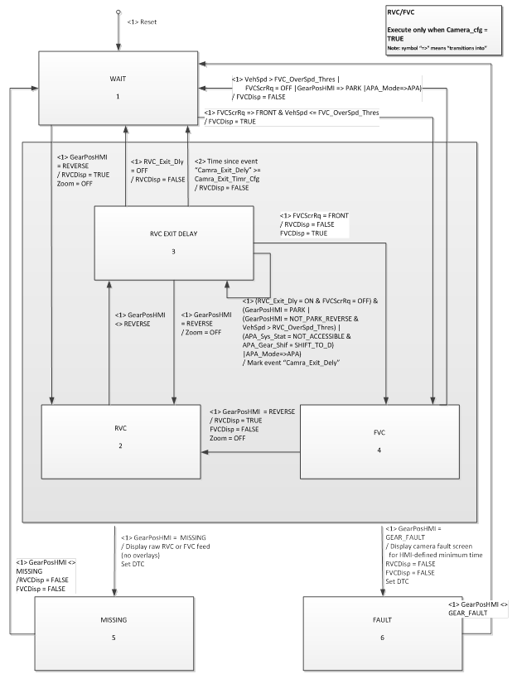
General Screen Arbitration: Step #1 Camera

CAMERA-FUR-REQ-166823/E-HMI Screen Logical Arbitration - APA Dedicated Display
General Screen Arbitration: Active Park Assist (APA)

CAMERA-FUR-REQ-131023/H-HMI Screen Logical Arbitration - PDC Dedicated Display
General Screen Arbitration: Park Distance Control (PDC)

CAMERA-FUR-REQ-196899/A-HMI Screen Logical Arbitration - Screen Controller
Screens shall be assigned real time as per the following state table
FVCDisp | RVCDisp | APADisp | PDCDisp | Screen displayed | Reference:  Sample Screen
0 | 0 | 0 | 0 | No display (release control to HMI ECU) | 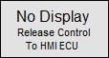
0 | 0 | 0 | 1 | Dedicated PDC | 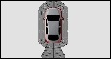
0 | 0 | 1 | 0 | APA (PDC will not be shown) | 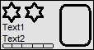
0 | 0 | 1 | 1 | APA (PDC will be shown) | 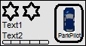
0 | 1 | 0 | 0 | RVC (APA instructions not shown, PDC will not be shown) | 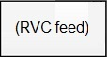
0 | 1 | 0 | 1 | RVC (APA instructions not shown, PDC will be shown) | 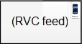
0 | 1 | 1 | 0 | RVC (APA instructions will be shown, PDC will not be shown) | 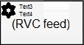
0 | 1 | 1 | 1 | RVC (APA instructions will be shown, PDC will be shown) | 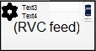
1 | 0 | 0 | 0 | FVC (APA instructions not shown, PDC will not be shown) | 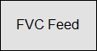
1 | 0 | 0 | 1 | FVC (APA instructions not shown, PDC will be shown) | 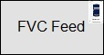
1 | 0 | 1 | 0 | FVC (APA instructions will be shown, PDC will not be shown) | 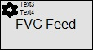
1 | 0 | 1 | 1 | FVC (APA instructions will be shown, PDC will be shown) | 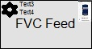
1 | 1 | 0 | 0 | Combination prohibited by the RVC/FVC state machine  (FVC & RVC images not displayed simultaneously) | N/A
1 | 1 | 0 | 1 |  | N/A
1 | 1 | 1 | 0 |  | N/A
1 | 1 | 1 | 1 |  | N/A
Screen Arbitration Controller

Base Park Aid Signal Interface
This section lists all the signals that shall be used by the infotainment display to show the Park Distance Control (PDC) graphic. The action that the display needs to take for each signal will be provided in following sections.

Park Distance Control (PDC) Signal list – Received by Infotainment ECU (from PAM)

CAMERA-FUR-REQ-130452/E-Park Distance Control (PDC) Signal list - [PrkAidMsgTxt_D_Rq]

Signal Received By Infotainment | Signal Parameters | Affected Display Position | Sample HMI  (Reference Only)
[PrkAidMsgTxt_D_Rq] | State Encoded:  $0: All_Park_Sensors_Off  $1: R_Snsrs_On_F_Snsrs_Off  $2: R_Snsrs_Off_F_Snsrs_On  $3: NotUsed  $4: NotUsed  $5: R_Snsrs_On_F_Snsrs_On  $6: Park_Sys_Alternate_Mode  $7: NotUsed  $8: R_Sns_Trlr_F_Sns_Blk  $9: Fail_Mode_with_Chime  $A: Fail_Mode_no_Chime  $B: Not_Avail_Trlr_attchd  $C: R_Sns_Inactive_Trlr_atch  360 Display  $D: R_Sns_Blk_F_Sns_ON  $E: R_Sns_ON_F_Sns_Blk  $F: All_Sns_Blk | All PDC | 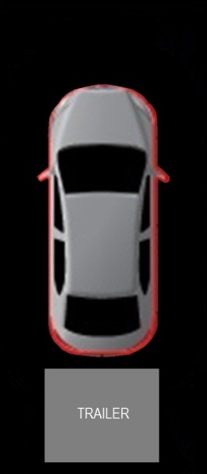
-Note: this is the only signal that can cause display of the trailer; this is why it is shown as the HMI sample.

CAMERA-FUR-REQ-130453/C-Park Distance Control (PDC) Signal list - [PrkAidSnsRlCrnr_D_Stat]

Signal Received By Infotainment | Signal Parameters | Affected Display Position | Sample HMI  (Reference Only)
[PrkAidSnsRlCrnr_D_Stat] | State Encoded:  $0: Off  $1: Zone_1  $2: Zone_2  $3: Zone_3  $4: Zone_4  $5: Zone_5  $6: Zone_6  $7: Zone_7  $8: Zone_8  $9: Zone_9  $A: Zone_10  $B: Zone_11  $C: Zone_12  $D: Zone_13  $E: Zone_14  $F: Zone_15 | RPA_OL_1  RPA_OL_2  RPA_OL_3  OUTLINE | 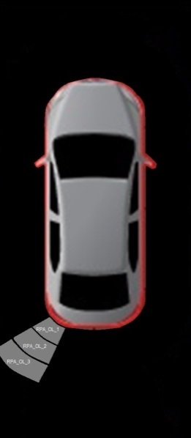

CAMERA-FUR-REQ-131031/B-Park Distance Control (PDC) Signal list - [PrkAidSnsRlCntr_D_Stat]

Signal Received By Infotainment | Signal Parameters | Affected Display Position | Sample HMI  (Reference Only)
[PrkAidSnsRlCntr_D_Stat] | State Encoded:  $0: Off  $1: Zone_1  $2: Zone_2  $3: Zone_3  $4: Zone_4  $5: Zone_5  $6: Zone_6  $7: Zone_7  $8: Zone_8  $9: Zone_9  $A: Zone_10  $B: Zone_11  $C: Zone_12  $D: Zone_13  $E: Zone_14  $F: Zone_15 | RPA_IL_1  RPA_IL_2  RPA_IL_3  RPA_IL_4  RPA_IL_5  RPA_IL_6  OUTLINE | 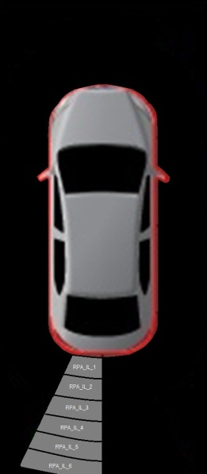

CAMERA-FUR-REQ-131032/B-Park Distance Control (PDC) Signal list - [PrkAidSnsRrCntr_D_Stat]

Signal Received By Infotainment | Signal Parameters | Affected Display Position | Sample HMI  (Reference Only)
[PrkAidSnsRrCntr_D_Stat] | State Encoded:  $0: Off  $1: Zone_1  $2: Zone_2  $3: Zone_3  $4: Zone_4  $5: Zone_5  $6: Zone_6  $7: Zone_7  $8: Zone_8  $9: Zone_9  $A: Zone_10  $B: Zone_11  $C: Zone_12  $D: Zone_13  $E: Zone_14  $F: Zone_15 | RPA_IR_1  RPA_IR_2  RPA_IR_3  RPA_IR_4  RPA_IR_5  RPA_IR_6  OUTLINE | 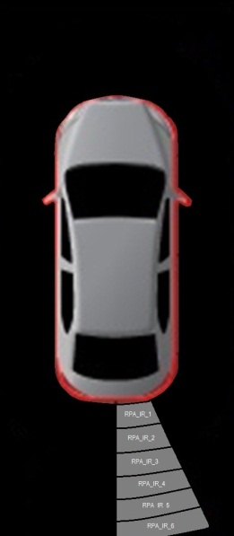

CAMERA-FUR-REQ-131033/C-Park Distance Control (PDC) Signal list - [PrkAidSnsRrCrnr_D_Stat]

Signal Received By Infotainment | Signal Parameters | Affected Display Position | Sample HMI  (Reference Only)
[PrkAidSnsRrCrnr_D_Stat] | State Encoded:  $0: Off  $1: Zone_1  $2: Zone_2  $3: Zone_3  $4: Zone_4  $5: Zone_5  $6: Zone_6  $7: Zone_7  $8: Zone_8  $9: Zone_9  $A: Zone_10  $B: Zone_11  $C: Zone_12  $D: Zone_13  $E: Zone_14  $F: Zone_15 | RPA_OR_1  RPA_OR_2  RPA_OR_3  OUTLINE | 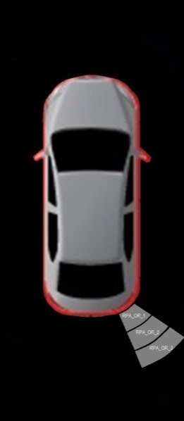

CAMERA-FUR-REQ-130454/B-Park Distance Control (PDC) Signal list - [PrkAidSnsFlCrnr_D_Stat]

Signal Received By Infotainment | Signal Parameters | Affected Display Position | Sample HMI  (Reference Only)
[PrkAidSnsFlCrnr_D_Stat] | State Encoded:  $0: Off  $1: Zone_1  $2: Zone_2  $3: Zone_3  $4: Zone_4  $5: Zone_5  $6: Zone_6  $7: Zone_7  $8: Zone_8  $9: Zone_9  $A: Zone_10  $B: Zone_11  $C: Zone_12  $D: Zone_13  $E: Zone_14  $F: Zone_15 | FPA_OL_1  FPA_OL_2  OUTLINE | 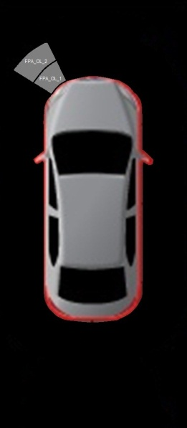

CAMERA-FUR-REQ-131034/B-Park Distance Control (PDC) Signal list - [PrkAidSnsFlCntr_D_Stat]

Signal Received By Infotainment | Signal Parameters | Affected Display Position | Sample HMI  (Reference Only)
[PrkAidSnsFlCntr_D_Stat] | State Encoded:  $0: Off  $1: Zone_1  $2: Zone_2  $3: Zone_3  $4: Zone_4  $5: Zone_5  $6: Zone_6  $7: Zone_7  $8: Zone_8  $9: Zone_9  $A: Zone_10  $B: Zone_11  $C: Zone_12  $D: Zone_13  $E: Zone_14  $F: Zone_15 | FPA_IL_1  FPA_IL_2  FPA_IL_3  OUTLINE | 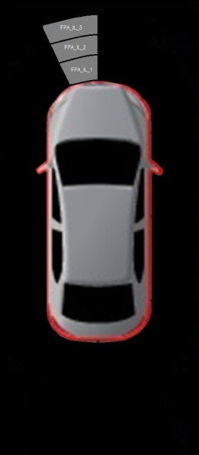

CAMERA-FUR-REQ-131035/B-Park Distance Control (PDC) Signal list - [PrkAidSnsFrCntr_D_Stat]

Signal Received By Infotainment | Signal Parameters | Affected Display Position | Sample HMI  (Reference Only)
[PrkAidSnsFrCntr_D_Stat] | State Encoded:  $0: Off  $1: Zone_1  $2: Zone_2  $3: Zone_3  $4: Zone_4  $5: Zone_5  $6: Zone_6  $7: Zone_7  $8: Zone_8  $9: Zone_9  $A: Zone_10  $B: Zone_11  $C: Zone_12  $D: Zone_13  $E: Zone_14  $F: Zone_15 | FPA_IR_1  FPA_IR_2  FPA_IR_3  OUTLINE | 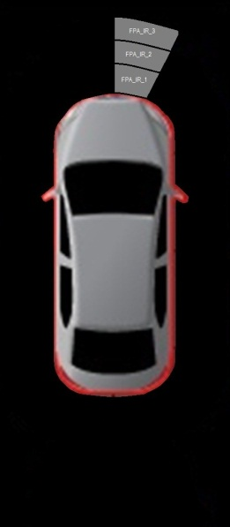

CAMERA-FUR-REQ-131036/B-Park Distance Control (PDC) Signal list - [PrkAidSnsFrCrnr_D_Stat]

Signal Received By Infotainment | Signal Parameters | Affected Display Position | Sample HMI  (Reference Only)
[PrkAidSnsFrCrnr_D_Stat] | State Encoded:  $0: Off  $1: Zone_1  $2: Zone_2  $3: Zone_3  $4: Zone_4  $5: Zone_5  $6: Zone_6  $7: Zone_7  $8: Zone_8  $9: Zone_9  $A: Zone_10  $B: Zone_11  $C: Zone_12  $D: Zone_13  $E: Zone_14  $F: Zone_15 | FPA_OR_1  FPA_OR_2  OUTLINE | 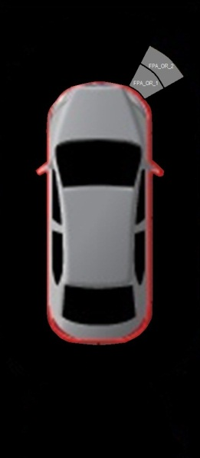

CAMERA-FUR-REQ-130456/E-Park Distance Control (PDC) Signal list - [SidePrkSnsL1_D_Stat]

Signal Received By Infotainment | Signal Parameters | Affected Display Position | Sample HMI  (Reference Only)
[SidePrkSnsL1_D_Stat] | State Encoded:  $0: Off  $1: Zone1  $2: Zone2  $3: Zone3  $4: Zone4  $5: Zone5  $6: Zone6  $7: Zone7  $8: Zone8  $9: Zone9  $A: Zone10  $B: Zone11  $C: Zone12  $D: NoObjectInSector  $E: NotFullyScannedYet  $F: NotUsed | SPA_L1_1  SPA_L1_2  OUTLINE | 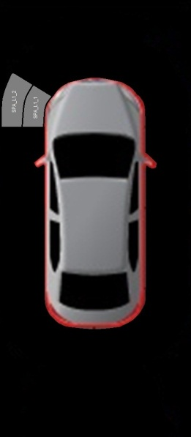

CAMERA-FUR-REQ-130457/E-Park Distance Control (PDC) Signal list - [SidePrkSnsR1_D_Stat]

Signal Received By Infotainment | Signal Parameters | Affected Display Position | Sample HMI  (Reference Only)
[SidePrkSnsR1_D_Stat] | State Encoded:  $0: Off  $1: Zone1  $2: Zone2  $3: Zone3  $4: Zone4  $5: Zone5  $6: Zone6  $7: Zone7  $8: Zone8  $9: Zone9  $A: Zone10  $B: Zone11  $C: Zone12  $D: NoObjectInSector  $E: NotFullyScannedYet  $F: NotUsed | SPA_R1_1  SPA_R1_2  OUTLINE | 0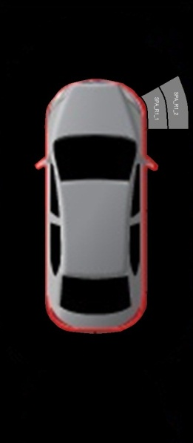

CAMERA-FUR-REQ-130458/C-Park Distance Control (PDC) Signal list - [SidePrkSnsL2_D_Stat]

Signal Received By Infotainment | Signal Parameters | Affected Display Position | Sample HMI  (Reference Only)
[SidePrkSnsL2_D_Stat] | State Encoded:  $0: Off  $1: Zone1  $2: Zone2  $3: Zone3  $4: Zone4  $5: Zone5  $6: Zone6  $7: Zone7  $8: Zone8  $9: Zone9  $A: Zone10  $B: Zone11  $C: Zone12  $D: NoObjectInSector  $E: NotFullyScannedYet  $F: NotUsed | SPA_L2_1  SPA_L2_2  OUTLINE | 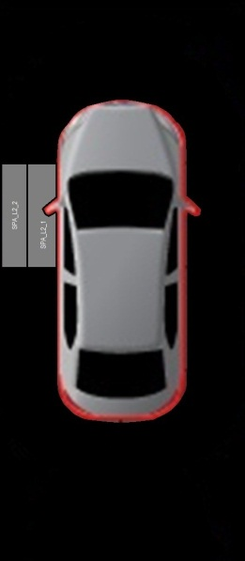

CAMERA-FUR-REQ-131040/C-Park Distance Control (PDC) Signal list - [SidePrkSnsR2_D_Stat]

Signal Received By Infotainment | Signal Parameters | Affected Display Position | Sample HMI  (Reference Only)
[SidePrkSnsR2_D_Stat] | State Encoded:  $0: Off  $1: Zone1  $2: Zone2  $3: Zone3  $4: Zone4  $5: Zone5  $6: Zone6  $7: Zone7  $8: Zone8  $9: Zone9  $A: Zone10  $B: Zone11  $C: Zone12  $D: NoObjectInSector  $E: NotFullyScannedYet  $F: NotUsed | SPA_R2_1  SPA_R2_2  OUTLINE | 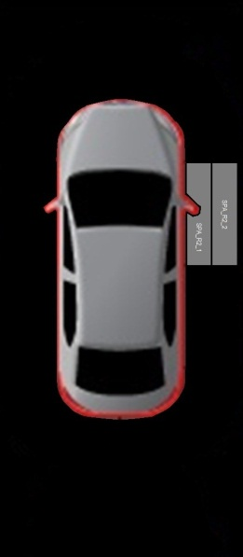

CAMERA-FUR-REQ-131041/C-Park Distance Control (PDC) Signal list - [SidePrkSnsL3_D_Stat]

Signal Received By Infotainment | Signal Parameters | Affected Display Position | Sample HMI  (Reference Only)
[SidePrkSnsL3_D_Stat] | State Encoded:  $0: Off  $1: Zone1  $2: Zone2  $3: Zone3  $4: Zone4  $5: Zone5  $6: Zone6  $7: Zone7  $8: Zone8  $9: Zone9  $A: Zone10  $B: Zone11  $C: Zone12  $D: NoObjectInSector  $E: NotFullyScannedYet  $F: NotUsed | SPA_L3_1  SPA_L3_2  OUTLINE | 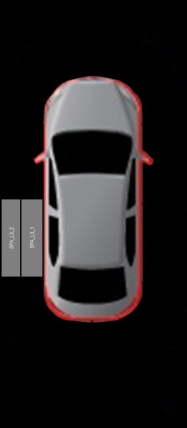

CAMERA-FUR-REQ-131042/C-Park Distance Control (PDC) Signal list - [SidePrkSnsR3_D_Stat]

Signal Received By Infotainment | Signal Parameters | Affected Display Position | Sample HMI  (Reference Only)
[SidePrkSnsR3_D_Stat] | State Encoded:  $0: Off  $1: Zone1  $2: Zone2  $3: Zone3  $4: Zone4  $5: Zone5  $6: Zone6  $7: Zone7  $8: Zone8  $9: Zone9  $A: Zone10  $B: Zone11  $C: Zone12  $D: NoObjectInSector  $E: NotFullyScannedYet  $F: NotUsed | SPA_R3_1  SPA_R3_2  OUTLINE | 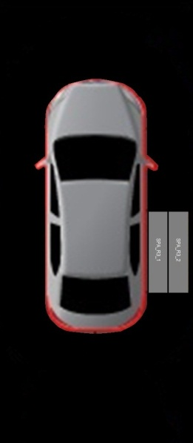

CAMERA-FUR-REQ-131043/C-Park Distance Control (PDC) Signal list - [SidePrkSnsL4_D_Stat]

Signal Received By Infotainment | Signal Parameters | Affected Display Position | Sample HMI  (Reference Only)
[SidePrkSnsL4_D_Stat] | State Encoded:  $0: Off  $1: Zone1  $2: Zone2  $3: Zone3  $4: Zone4  $5: Zone5  $6: Zone6  $7: Zone7  $8: Zone8  $9: Zone9  $A: Zone10  $B: Zone11  $C: Zone12  $D: NoObjectInSector  $E: NotFullyScannedYet  $F: NotUsed | SPA_L4_1  SPA_L4_2  OUTLINE | 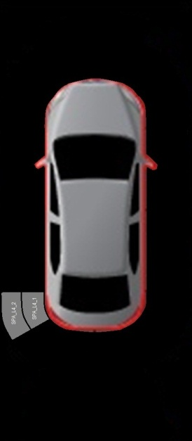

CAMERA-FUR-REQ-131044/C-Park Distance Control (PDC) Signal list - [SidePrkSnsR4_D_Stat]

Signal Received By Infotainment | Signal Parameters | Affected Display Position | Sample HMI  (Reference Only)
[SidePrkSnsR4_D_Stat] | State Encoded:  $0: Off  $1: Zone1  $2: Zone2  $3: Zone3  $4: Zone4  $5: Zone5  $6: Zone6  $7: Zone7  $8: Zone8  $9: Zone9  $A: Zone10  $B: Zone11  $C: Zone12  $D: NoObjectInSector  $E: NotFullyScannedYet  $F: NotUsed | SPA_R4_1  SPA_R4_2  OUTLINE | 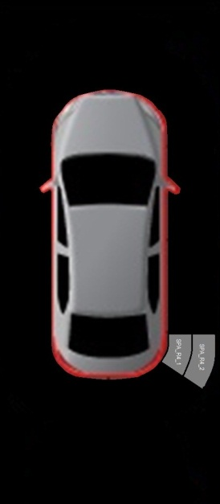

Park Distance Control (PDC) Signal Processing

Individual positionals are controlled as per the following state tables. Preconditions for arriving at these tables are in the arbitration section.

CAMERA-FUR-REQ-130461/E-Park Distance Control (PDC) Signal Processing - Positionals RPA_OL_1, RPA_OL_2, RPA_OL_3

PDCDisp | PrkAidMsgTxt_D_Rq | PrkAidSnsRlCrnr_D_Stat | RPA_OL_1 | RPA_OL_2 | RPA_OL_3
TRUE | != 0xC || 0x8 ||  0xD || 0xF | 0x0 (Off) | Inactive | Inactive | Inactive
TRUE | != 0xC || 0x8 ||  0xD || 0xF | 0x1 (Zone_1) | On-Warn | On-Nostat | On-Nostat
TRUE | != 0xC || 0x8 ||  0xD || 0xF | 0x2 (Zone_2) | On-Idle | On-Warn | On-Nostat
TRUE | != 0xC || 0x8 ||  0xD || 0xF | 0x3 (Zone_3) | On-Idle | On-Warn | On-Nostat
TRUE | != 0xC || 0x8 ||  0xD || 0xF | 0x4 (Zone_4) | On-Idle | On-Idle | On-Warn
TRUE | != 0xC || 0x8 ||  0xD || 0xF | 0x5 (Zone_5) | On-Idle | On-Idle | On-Idle
TRUE | != 0xC || 0x8 ||  0xD || 0xF | 0x6 (Zone_6) | On-Idle | On-Idle | On-Idle
TRUE | != 0xC || 0x8 ||  0xD || 0xF | 0x7 (Zone_7) | On-Idle | On-Idle | On-Idle
TRUE | != 0xC || 0x8 ||  0xD || 0xF | 0x8 (Zone_8) | On-Idle | On-Idle | On-Idle
TRUE | != 0xC || 0x8 ||  0xD || 0xF | 0x9 (Zone_9) | On-Idle | On-Idle | On-Idle
TRUE | != 0xC || 0x8 ||  0xD || 0xF | 0xA (Zone_10) | On-Idle | On-Idle | On-Idle
TRUE | != 0xC || 0x8 ||  0xD || 0xF | 0xB (Zone_11) | On-Idle | On-Idle | On-Idle
TRUE | != 0xC || 0x8 ||  0xD || 0xF | 0xC (Zone_12) | On-Idle | On-Idle | On-Idle
TRUE | != 0xC || 0x8 ||  0xD || 0xF | 0xD (Zone_13) | On-Idle | On-Idle | On-Idle
TRUE | != 0xC || 0x8 ||  0xD || 0xF | 0xE (Zone_14) | On-Idle | On-Idle | On-Idle
TRUE | != 0xC || 0x8 ||  0xD || 0xF | 0xF (Zone_15) | On-Idle | On-Idle | On-Idle
TRUE | = 0xC || 0x8 | X | On-Trailer
TRUE | = 0xD || 0xF | 0x1 (Zone_1) | On-Blkd | On-Nostat | On-Nostat
TRUE | = 0xD || 0xF | 0x0 (Off) | On-Nostat | On-Nostat | On-Nostat
All Other Cases |  |  | Inactive | Inactive | Inactive
For definition of “On-Warn,” “On-Idle,” “On-Nostat,” “Inactive” and “On-Trailer” reference Graphical Position Definition.
Park Distance Control (PDC) Positional RPA_OL_x

CAMERA-FUR-REQ-130463/E-Park Distance Control (PDC) Signal Processing - Positionals RPA_IL_1, RPA_IL_2, RPA_IL_3, RPA_IL_4, RPA_IL_5, RPA_IL_6

PDCDisp | PrkAidMsgTxt_D_Rq | PrkAidSnsRlCntr_D_Stat | RPA_IL_1 | RPA_IL_2 | RPA_IL_3 | RPA_IL_4 | RPA_IL_5 | RPA_IL_6
TRUE | != 0xC || 0x8 || 0xD || 0xF | 0x0 (Off) | Inactive | Inactive | Inactive | Inactive | Inactive | Inactive
TRUE | != 0xC || 0x8 || 0xD || 0xF | 0x1 (Zone_1) | On-Warn | On-Nostat | On-Nostat | On-Nostat | On-Nostat | On-Nostat
TRUE | != 0xC || 0x8 || 0xD || 0xF | 0x2 (Zone_2) | On-Idle | On-Warn | On-Nostat | On-Nostat | On-Nostat | On-Nostat
TRUE | != 0xC || 0x8 || 0xD || 0xF | 0x3 (Zone_3) | On-Idle | On-Warn | On-Nostat | On-Nostat | On-Nostat | On-Nostat
TRUE | != 0xC || 0x8 || 0xD || 0xF | 0x4 (Zone_4) | On-Idle | On-Idle | On-Warn | On-Nostat | On-Nostat | On-Nostat
TRUE | != 0xC || 0x8 || 0xD || 0xF | 0x5 (Zone_5) | On-Idle | On-Idle | On-Warn | On-Nostat | On-Nostat | On-Nostat
TRUE | != 0xC || 0x8 || 0xD || 0xF | 0x6 (Zone_6) | On-Idle | On-Idle | On-Idle | On-Warn | On-Nostat | On-Nostat
TRUE | != 0xC || 0x8 || 0xD || 0xF | 0x7 (Zone_7) | On-Idle | On-Idle | On-Idle | On-Warn | On-Nostat | On-Nostat
TRUE | != 0xC || 0x8 || 0xD || 0xF | 0x8 (Zone_8) | On-Idle | On-Idle | On-Idle | On-Idle | On-Warn | On-Nostat
TRUE | != 0xC || 0x8 || 0xD || 0xF | 0x9 (Zone_9) | On-Idle | On-Idle | On-Idle | On-Idle | On-Warn | On-Nostat
TRUE | != 0xC || 0x8 || 0xD || 0xF | 0xA (Zone_10) | On-Idle | On-Idle | On-Idle | On-Idle | On-Idle | On-Warn
TRUE | != 0xC || 0x8 || 0xD || 0xF | 0xB (Zone_11) | On-Idle | On-Idle | On-Idle | On-Idle | On-Idle | On-Warn
TRUE | != 0xC || 0x8 || 0xD || 0xF | 0xC (Zone_12) | On-Idle | On-Idle | On-Idle | On-Idle | On-Idle | On-Idle
TRUE | != 0xC || 0x8 || 0xD || 0xF | 0xD (Zone_13) | On-Idle | On-Idle | On-Idle | On-Idle | On-Idle | On-Idle
TRUE | != 0xC || 0x8 || 0xD || 0xF | 0xE (Zone_14) | On-Idle | On-Idle | On-Idle | On-Idle | On-Idle | On-Idle
TRUE | != 0xC || 0x8 || 0xD || 0xF | 0xF (Zone_15) | On-Idle | On-Idle | On-Idle | On-Idle | On-Idle | On-Idle
TRUE | = 0xC  || 0x8 | X | On-Trailer | On-Trailer | On-Trailer | On-Trailer | On-Trailer | On-Trailer
TRUE | = 0xD || 0xF | 0x1 (Zone_1) | On-Blkd | On-Nostat | On-Nostat | On-Nostat | On-Nostat | On-Nostat
TRUE | = 0xD || 0xF | 0x0 (Off) | On-Nostat | On-Nostat | On-Nostat | On-Nostat | On-Nostat | On-Nostat
All Other Cases |  |  | Inactive | Inactive | Inactive | Inactive | Inactive | Inactive
- For definition of “On-Warn,” “On-Idle,” “On-Nostat,” “Inactive” and “On-Trailer” reference Graphical Position Definition.
Park Distance Control (PDC) Positional RPA_IL_x

CAMERA-FUR-REQ-130464/E-Park Distance Control (PDC) Signal Processing - Positionals RPA_IR_1, RPA_IR_2, RPA_IR_3, RPA_IR_4, RPA_IR_5, RPA_IR_6

PDCDisp | PrkAidMsgTxt_D_Rq | PrkAidSnsRrCntr_D_Stat | RPA_IR_1 | RPA_IR_2 | RPA_IR_3 | RPA_IR_4 | RPA_IR_5 | RPA_IR_6
TRUE | != 0xC || 0x8 || 0xD || 0xF | 0x0 (Off) | Inactive | Inactive | Inactive | Inactive | Inactive | Inactive
TRUE | != 0xC || 0x8 || 0xD || 0xF | 0x1 (Zone_1) | On-Warn | On-Nostat | On-Nostat | On-Nostat | On-Nostat | On-Nostat
TRUE | != 0xC || 0x8 || 0xD || 0xF | 0x2 (Zone_2) | On-Idle | On-Warn | On-Nostat | On-Nostat | On-Nostat | On-Nostat
TRUE | != 0xC || 0x8 || 0xD || 0xF | 0x3 (Zone_3) | On-Idle | On-Warn | On-Nostat | On-Nostat | On-Nostat | On-Nostat
TRUE | != 0xC || 0x8 || 0xD || 0xF | 0x4 (Zone_4) | On-Idle | On-Idle | On-Warn | On-Nostat | On-Nostat | On-Nostat
TRUE | != 0xC || 0x8 || 0xD || 0xF | 0x5 (Zone_5) | On-Idle | On-Idle | On-Warn | On-Nostat | On-Nostat | On-Nostat
TRUE | != 0xC || 0x8 || 0xD || 0xF | 0x6 (Zone_6) | On-Idle | On-Idle | On-Idle | On-Warn | On-Nostat | On-Nostat
TRUE | != 0xC || 0x8 || 0xD || 0xF | 0x7 (Zone_7) | On-Idle | On-Idle | On-Idle | On-Warn | On-Nostat | On-Nostat
TRUE | != 0xC || 0x8 || 0xD || 0xF | 0x8 (Zone_8) | On-Idle | On-Idle | On-Idle | On-Idle | On-Warn | On-Nostat
TRUE | != 0xC || 0x8 || 0xD || 0xF | 0x9 (Zone_9) | On-Idle | On-Idle | On-Idle | On-Idle | On-Warn | On-Nostat
TRUE | != 0xC || 0x8 || 0xD || 0xF | 0xA (Zone_10) | On-Idle | On-Idle | On-Idle | On-Idle | On-Idle | On-Warn
TRUE | != 0xC || 0x8 || 0xD || 0xF | 0xB (Zone_11) | On-Idle | On-Idle | On-Idle | On-Idle | On-Idle | On-Warn
TRUE | != 0xC || 0x8 || 0xD || 0xF | 0xC (Zone_12) | On-Idle | On-Idle | On-Idle | On-Idle | On-Idle | On-Idle
TRUE | != 0xC || 0x8 || 0xD || 0xF | 0xD (Zone_13) | On-Idle | On-Idle | On-Idle | On-Idle | On-Idle | On-Idle
TRUE | != 0xC || 0x8 || 0xD || 0xF | 0xE (Zone_14) | On-Idle | On-Idle | On-Idle | On-Idle | On-Idle | On-Idle
TRUE | != 0xC || 0x8 || 0xD || 0xF | 0xF (Zone_15) | On-Idle | On-Idle | On-Idle | On-Idle | On-Idle | On-Idle
TRUE | = 0xC || 0x8 | X | On-Trailer | On-Trailer | On-Trailer | On-Trailer | On-Trailer | On-Trailer
TRUE | = 0xD || 0xF | 0x1 (Zone_1) | On-Blkd | On-Nostat | On-Nostat | On-Nostat | On-Nostat | On-Nostat
TRUE | = 0xD || 0xF | 0x0 (Off) | On-Nostat | On-Nostat | On-Nostat | On-Nostat | On-Nostat | On-Nostat
All Other Cases |  |  | Inactive | Inactive | Inactive | Inactive | Inactive | Inactive
- For definition of “On-Warn,” “On-Idle,” “On-Nostat,” “Inactive” and “On-Trailer” reference Graphical Position Definition.
Park Distance Control (PDC) Positional RPA_IR_x

CAMERA-FUR-REQ-130467/E-Park Distance Control (PDC) Signal Processing - Positionals RPA_OR_1, RPA_OR_2, RPA_OR_3

PDCDisp | PrkAidMsgTxt_D_Rq | PrkAidSnsRrCrnr_D_Stat | RPA_OR_1 | RPA_OR_2 | RPA_OR_3
TRUE | !=0xC || 0x8 ||  0xD || 0xF | 0x0 (Off) | Inactive | Inactive | Inactive
TRUE | !=0xC || 0x8 ||  0xD || 0xF | 0x1 (Zone_1) | On-Warn | On-Nostat | On-Nostat
TRUE | !=0xC || 0x8 ||  0xD || 0xF | 0x2 (Zone_2) | On-Idle | On-Warn | On-Nostat
TRUE | !=0xC || 0x8 ||  0xD || 0xF | 0x3 (Zone_3) | On-Idle | On-Warn | On-Nostat
TRUE | !=0xC || 0x8 ||  0xD || 0xF | 0x4 (Zone_4) | On-Idle | On-Idle | On-Warn
TRUE | !=0xC || 0x8 ||  0xD || 0xF | 0x5 (Zone_5) | On-Idle | On-Idle | On-Idle
TRUE | !=0xC || 0x8 ||  0xD || 0xF | 0x6 (Zone_6) | On-Idle | On-Idle | On-Idle
TRUE | !=0xC || 0x8 ||  0xD || 0xF | 0x7 (Zone_7) | On-Idle | On-Idle | On-Idle
TRUE | !=0xC || 0x8 ||  0xD || 0xF | 0x8 (Zone_8) | On-Idle | On-Idle | On-Idle
TRUE | !=0xC || 0x8 ||  0xD || 0xF | 0x9 (Zone_9) | On-Idle | On-Idle | On-Idle
TRUE | !=0xC || 0x8 ||  0xD || 0xF | 0xA (Zone_10) | On-Idle | On-Idle | On-Idle
TRUE | !=0xC || 0x8 ||  0xD || 0xF | 0xB (Zone_11) | On-Idle | On-Idle | On-Idle
TRUE | !=0xC || 0x8 ||  0xD || 0xF | 0xC (Zone_12) | On-Idle | On-Idle | On-Idle
TRUE | !=0xC || 0x8 ||  0xD || 0xF | 0xD (Zone_13) | On-Idle | On-Idle | On-Idle
TRUE | !=0xC || 0x8 ||  0xD || 0xF | 0xE (Zone_14) | On-Idle | On-Idle | On-Idle
TRUE | !=0xC || 0x8 ||  0xD || 0xF | 0xF (Zone_15) | On-Idle | On-Idle | On-Idle
TRUE | = 0xC || 0x8 | X | On-Trailer
TRUE | = 0xD || 0xF | 0x1 (Zone_1) | On-Blkd | On-Nostat | On-Nostat
TRUE | = 0xD || 0xF | 0x0 (Off) | On-Nostat | On-Nostat | On-Nostat
All Other Cases |  |  | Inactive | Inactive | Inactive
For definition of “On-Warn,” “On-Idle,” “On-Nostat,” “Inactive” and “On-Trailer” reference Graphical Position Definition.
Park Distance Control (PDC) Positional RPA_OR_x

CAMERA-FUR-REQ-130468/E-Park Distance Control (PDC) Signal Processing - Positionals FPA_OL_1, FPA_OL_2

PDCDisp | PrkAidMsgTxt_D_Rq | PrkAidSnsFlCrnr_D_Stat | FPA_OL_1 | FPA_OL_2
TRUE | !=0xE || 0xF || 0x8 | 0x0 (Off) | Inactive | Inactive
TRUE | !=0xE || 0xF || 0x8 | 0x1 (Zone_1) | On-Warn | On-Nostat
TRUE | !=0xE || 0xF || 0x8 | 0x2 (Zone_2) | On-Idle | On-Warn
TRUE | !=0xE || 0xF || 0x8 | 0x3 (Zone_3) | On-Idle | On-Warn
TRUE | !=0xE || 0xF || 0x8 | 0x4 (Zone_4) | On-Idle | On-Idle
TRUE | !=0xE || 0xF || 0x8 | 0x5 (Zone_5) | On-Idle | On-Idle
TRUE | !=0xE || 0xF || 0x8 | 0x6 (Zone_6) | On-Idle | On-Idle
TRUE | !=0xE || 0xF || 0x8 | 0x7 (Zone_7) | On-Idle | On-Idle
TRUE | !=0xE || 0xF || 0x8 | 0x8 (Zone_8) | On-Idle | On-Idle
TRUE | !=0xE || 0xF || 0x8 | 0x9 (Zone_9) | On-Idle | On-Idle
TRUE | !=0xE || 0xF || 0x8 | 0xA (Zone_10) | On-Idle | On-Idle
TRUE | !=0xE || 0xF || 0x8 | 0xB (Zone_11) | On-Idle | On-Idle
TRUE | !=0xE || 0xF || 0x8 | 0xC (Zone_12) | On-Idle | On-Idle
TRUE | !=0xE || 0xF || 0x8 | 0xD (Zone_13) | On-Idle | On-Idle
TRUE | !=0xE || 0xF || 0x8 | 0xE (Zone_14) | On-Idle | On-Idle
TRUE | !=0xE || 0xF || 0x8 | 0xF (Zone_15) | On-Idle | On-Idle
TRUE | = 0xE || 0xF || 0x8 | 0x1 (Zone_1) | On-Blkd | On-Nostat
TRUE | = 0xE || 0xF || 0x8 | 0x0 (Off) | On-Nostat | On-Nostat
All Other Cases |  |  | Inactive | Inactive
- For definition of “On-Warn,” “On-Idle,” “On-Nostat,” “Inactive” and “On-Trailer” reference Graphical Position Definition.
Park Distance Control (PDC) Positional RPA_IR_x

CAMERA-FUR-REQ-130469/E-Park Distance Control (PDC) Signal Processing - Positionals FPA_IL_1, FPA_IL_2, FPA_IL_3

PDCDisp | PrkAidMsgTxt_D_Rq | PrkAidSnsFlCntr_D_Stat | FPA_IL_1 | FPA_IL_2 | FPA_IL_3
TRUE | !=0xE || 0xF || 0x8 | 0x0 (Off) | Inactive | Inactive | Inactive
TRUE | !=0xE || 0xF || 0x8 | 0x1 (Zone_1) | On-Warn | On-Nostat | On-Nostat
TRUE | !=0xE || 0xF || 0x8 | 0x2 (Zone_2) | On-Idle | On-Warn | On-Nostat
TRUE | !=0xE || 0xF || 0x8 | 0x3 (Zone_3) | On-Idle | On-Warn | On-Nostat
TRUE | !=0xE || 0xF || 0x8 | 0x4 (Zone_4) | On-Idle | On-Idle | On-Warn
TRUE | !=0xE || 0xF || 0x8 | 0x5 (Zone_5) | On-Idle | On-Idle | On-Warn
TRUE | !=0xE || 0xF || 0x8 | 0x6 (Zone_6) | On-Idle | On-Idle | On-Idle
TRUE | !=0xE || 0xF || 0x8 | 0x7 (Zone_7) | On-Idle | On-Idle | On-Idle
TRUE | !=0xE || 0xF || 0x8 | 0x8 (Zone_8) | On-Idle | On-Idle | On-Idle
TRUE | !=0xE || 0xF || 0x8 | 0x9 (Zone_9) | On-Idle | On-Idle | On-Idle
TRUE | !=0xE || 0xF || 0x8 | 0xA (Zone_10) | On-Idle | On-Idle | On-Idle
TRUE | !=0xE || 0xF || 0x8 | 0xB (Zone_11) | On-Idle | On-Idle | On-Idle
TRUE | !=0xE || 0xF || 0x8 | 0xC (Zone_12) | On-Idle | On-Idle | On-Idle
TRUE | !=0xE || 0xF || 0x8 | 0xD (Zone_13) | On-Idle | On-Idle | On-Idle
TRUE | !=0xE || 0xF || 0x8 | 0xE (Zone_14) | On-Idle | On-Idle | On-Idle
TRUE | !=0xE || 0xF || 0x8 | 0xF (Zone_15) | On-Idle | On-Idle | On-Idle
TRUE | = 0xE || 0xF || 0x8 | 0x1 (Zone_1) | On-Blkd | On-Nostat | On-Nostat
TRUE | = 0xE || 0xF || 0x8 | 0x0 (Off) | On-Nostat | On-Nostat | On-Nostat
All Other Cases |  |  | Inactive | Inactive | Inactive
- For definition of “On-Warn,” “On-Idle,” “On-Nostat,” “Inactive” and “On-Trailer” reference Graphical Position Definition.
Park Distance Control (PDC) Positional FPA_Il_x

CAMERA-FUR-REQ-130470/E-Park Distance Control (PDC) Signal Processing - Positionals FPA_IR_1, FPA_IR_2, FPA_IR_3

PDCDisp | PrkAidMsgTxt_D_Rq | PrkAidSnsFrCntr_D_Stat | FPA_IR_1 | FPA_IR_2 | FPA_IR_3
TRUE | !=0xE || 0xF || 0x8 | 0x0 (Off) | Inactive | Inactive | Inactive
TRUE | !=0xE || 0xF || 0x8 | 0x1 (Zone_1) | On-Warn | On-Nostat | On-Nostat
TRUE | !=0xE || 0xF || 0x8 | 0x2 (Zone_2) | On-Idle | On-Warn | On-Nostat
TRUE | !=0xE || 0xF || 0x8 | 0x3 (Zone_3) | On-Idle | On-Warn | On-Nostat
TRUE | !=0xE || 0xF || 0x8 | 0x4 (Zone_4) | On-Idle | On-Idle | On-Warn
TRUE | !=0xE || 0xF || 0x8 | 0x5 (Zone_5) | On-Idle | On-Idle | On-Warn
TRUE | !=0xE || 0xF || 0x8 | 0x6 (Zone_6) | On-Idle | On-Idle | On-Idle
TRUE | !=0xE || 0xF || 0x8 | 0x7 (Zone_7) | On-Idle | On-Idle | On-Idle
TRUE | !=0xE || 0xF || 0x8 | 0x8 (Zone_8) | On-Idle | On-Idle | On-Idle
TRUE | !=0xE || 0xF || 0x8 | 0x9 (Zone_9) | On-Idle | On-Idle | On-Idle
TRUE | !=0xE || 0xF || 0x8 | 0xA (Zone_10) | On-Idle | On-Idle | On-Idle
TRUE | !=0xE || 0xF || 0x8 | 0xB (Zone_11) | On-Idle | On-Idle | On-Idle
TRUE | !=0xE || 0xF || 0x8 | 0xC (Zone_12) | On-Idle | On-Idle | On-Idle
TRUE | !=0xE || 0xF || 0x8 | 0xD (Zone_13) | On-Idle | On-Idle | On-Idle
TRUE | !=0xE || 0xF || 0x8 | 0xE (Zone_14) | On-Idle | On-Idle | On-Idle
TRUE | !=0xE || 0xF || 0x8 | 0xF (Zone_15) | On-Idle | On-Idle | On-Idle
TRUE | = 0xE || 0xF || 0x8 | 0x1 (Zone_1) | On-Blkd | On-Nostat | On-Nostat
TRUE | = 0xE || 0xF || 0x8 | 0x0 (Off) | On-Nostat | On-Nostat | On-Nostat
All Other Cases |  |  | Inactive | Inactive | Inactive
- For definition of “On-Warn,” “On-Idle,” “On-Nostat,” “Inactive” and “On-Trailer” reference Graphical Position Definition.
Park Distance Control (PDC) Positional FPA_IR_x

CAMERA-FUR-REQ-130472/E-Park Distance Control (PDC) Signal Processing - Positionals FPA_OR_1, FPA_OR_2

PDCDisp | PrkAidMsgTxt_D_Rq | PrkAidSnsFrCrnr_D_Stat | FPA_OR_1 | FPA_OR_2
TRUE | !=0xE || 0xF || 0x8 | 0x0 (Off) | Inactive | Inactive
TRUE | !=0xE || 0xF || 0x8 | 0x1 (Zone_1) | On-Warn | On-Nostat
TRUE | !=0xE || 0xF || 0x8 | 0x2 (Zone_2) | On-Idle | On-Warn
TRUE | !=0xE || 0xF || 0x8 | 0x3 (Zone_3) | On-Idle | On-Warn
TRUE | !=0xE || 0xF || 0x8 | 0x4 (Zone_4) | On-Idle | On-Idle
TRUE | !=0xE || 0xF || 0x8 | 0x5 (Zone_5) | On-Idle | On-Idle
TRUE | !=0xE || 0xF || 0x8 | 0x6 (Zone_6) | On-Idle | On-Idle
TRUE | !=0xE || 0xF || 0x8 | 0x7 (Zone_7) | On-Idle | On-Idle
TRUE | !=0xE || 0xF || 0x8 | 0x8 (Zone_8) | On-Idle | On-Idle
TRUE | !=0xE || 0xF || 0x8 | 0x9 (Zone_9) | On-Idle | On-Idle
TRUE | !=0xE || 0xF || 0x8 | 0xA (Zone_10) | On-Idle | On-Idle
TRUE | !=0xE || 0xF || 0x8 | 0xB (Zone_11) | On-Idle | On-Idle
TRUE | !=0xE || 0xF || 0x8 | 0xC (Zone_12) | On-Idle | On-Idle
TRUE | !=0xE || 0xF || 0x8 | 0xD (Zone_13) | On-Idle | On-Idle
TRUE | !=0xE || 0xF || 0x8 | 0xE (Zone_14) | On-Idle | On-Idle
TRUE | !=0xE || 0xF || 0x8 | 0xF (Zone_15) | On-Idle | On-Idle
TRUE | = 0xE || 0xF || 0x8 | 0x1 (Zone_1) | On-Blkd | On-Nostat
TRUE | = 0xE || 0xF || 0x8 | 0x0 (Off) | On-Nostat | On-Nostat
All Other Cases |  |  | Inactive | Inactive
- For definition of “On-Warn,” “On-Idle,” “On-Nostat,” “Inactive” and “On-Trailer” reference Graphical Position Definition.
Park Distance Control (PDC) Positional FPA_OR_x

CAMERA-FUR-REQ-130474/G-Park Distance Control (PDC) Signal Processing - Positionals SPA_L1_1, SPA_L1_2

PDCDisp | PrkAidMsgTxt_D_Rq | SidePrkSnsL1_D_Stat | SPA_L1_1 | SPA_L1_2
TRUE | !=0xE || 0xF || 0x8 | 0x0 (Off) | Inactive | Inactive
TRUE | !=0xE || 0xF || 0x8 | 0x1 (Zone_1) | On-Warn | On-Nostat
TRUE | !=0xE || 0xF || 0x8 | 0x2 (Zone_2) | On-Warn | On-Nostat
TRUE | !=0xE || 0xF || 0x8 | 0x3 (Zone_3) | On-Warn | On-Nostat
TRUE | !=0xE || 0xF || 0x8 | 0x4 (Zone_4) | On-Warn | On-Nostat
TRUE | !=0xE || 0xF || 0x8 | 0x5 (Zone_5) | On-Idle | On-Warn
TRUE | !=0xE || 0xF || 0x8 | 0x6 (Zone_6) | On-Idle | On-Warn
TRUE | !=0xE || 0xF || 0x8 | 0x7 (Zone_7) | On-Idle | On-Warn
TRUE | !=0xE || 0xF || 0x8 | 0x8 (Zone_8) | On-Idle | On-Warn
TRUE | !=0xE || 0xF || 0x8 | 0x9 (Zone_9) | On-Idle | On-Idle
TRUE | !=0xE || 0xF || 0x8 | 0xA (Zone_10) | On-Idle | On-Idle
TRUE | !=0xE || 0xF || 0x8 | 0xB (Zone_11) | On-Idle | On-Idle
TRUE | !=0xE || 0xF || 0x8 | 0xC (Zone_12) | On-Idle | On-Idle
TRUE | !=0xE || 0xF || 0x8 | 0xD (NoObjectInSector) | On-Idle | On-Idle
TRUE | !=0xE || 0xF || 0x8 | 0xE (NotFullyScannedYet) | Inactive | Inactive
TRUE | !=0xE || 0xF || 0x8 | 0xF (NotUsed) | Inactive | Inactive
TRUE | = 0xE || 0xF  || 0x8 | 0x1 (Zone_1) | On-Blkd | On-Nostat
TRUE | = 0xE || 0xF  || 0x8 | 0x0 (Off) | On-Nostat | On-Nostat
All Other Cases |  |  | Inactive | Inactive
X = Don’t Care
For definition of “On-Warn,” “On-Idle,” “On-Nostat,” “Inactive” and “On-Trailer” reference Graphical Position Definition.
Park Distance Control (PDC) Positional FPA_L1_x

CAMERA-FUR-REQ-130475/G-Park Distance Control (PDC) Signal Processing - Positionals SPA_R1_1, SPA_R1_2

PDCDisp | PrkAidMsgTxt_D_Rq | SidePrkSnsR1_D_Stat | SPA_R1_1 | SPA_R1_2
TRUE | !=0xE || 0xF || 0x8 | 0x0 (Off) | Inactive | Inactive
TRUE | !=0xE || 0xF || 0x8 | 0x1 (Zone_1) | On-Warn | On-Nostat
TRUE | !=0xE || 0xF || 0x8 | 0x2 (Zone_2) | On-Warn | On-Nostat
TRUE | !=0xE || 0xF || 0x8 | 0x3 (Zone_3) | On-Warn | On-Nostat
TRUE | !=0xE || 0xF || 0x8 | 0x4 (Zone_4) | On-Warn | On-Nostat
TRUE | !=0xE || 0xF || 0x8 | 0x5 (Zone_5) | On-Idle | On-Warn
TRUE | !=0xE || 0xF || 0x8 | 0x6 (Zone_6) | On-Idle | On-Warn
TRUE | !=0xE || 0xF || 0x8 | 0x7 (Zone_7) | On-Idle | On-Warn
TRUE | !=0xE || 0xF || 0x8 | 0x8 (Zone_8) | On-Idle | On-Warn
TRUE | !=0xE || 0xF || 0x8 | 0x9 (Zone_9) | On-Idle | On-Idle
TRUE | !=0xE || 0xF || 0x8 | 0xA (Zone_10) | On-Idle | On-Idle
TRUE | !=0xE || 0xF || 0x8 | 0xB (Zone_11) | On-Idle | On-Idle
TRUE | !=0xE || 0xF || 0x8 | 0xC (Zone_12) | On-Idle | On-Idle
TRUE | !=0xE || 0xF || 0x8 | 0xD (NoObjectInSector) | On-Idle | On-Idle
TRUE | !=0xE || 0xF || 0x8 | 0xE (NotFullyScannedYet) | Inactive | Inactive
TRUE | !=0xE || 0xF || 0x8 | 0xF (NotUsed) | Inactive | Inactive
TRUE | = 0xE || 0xF  || 0x8 | 0x1 (Zone_1) | On-Blkd | On-Nostat
TRUE | = 0xE || 0xF  || 0x8 | 0x0 (Off) | On-Nostat | On-Nostat
All Other Cases |  |  | Inactive | Inactive
X = Don’t Care
For definition of “On-Warn,” “On-Idle,” “On-Nostat,” “Inactive” and “On-Trailer” reference Graphical Position Definition.
Park Distance Control (PDC) Positional FPA_R1_x

CAMERA-FUR-REQ-130476/F-Park Distance Control (PDC) Signal Processing - Positionals SPA_L2_1, SPA_L2_2

PDCDisp | PrkAidMsgTxt_D_Rq | SidePrkSnsL2_D_Stat | SPA_L2_1 | SPA_L2_2
TRUE | X | 0x0 (Off) | Inactive | Inactive
TRUE | X | 0x1 (Zone_1) | On-Warn | On-Nostat
TRUE | X | 0x2 (Zone_2) | On-Warn | On-Nostat
TRUE | X | 0x3 (Zone_3) | On-Warn | On-Nostat
TRUE | X | 0x4 (Zone_4) | On-Warn | On-Nostat
TRUE | X | 0x5 (Zone_5) | On-Idle | On-Warn
TRUE | X | 0x6 (Zone_6) | On-Idle | On-Warn
TRUE | X | 0x7 (Zone_7) | On-Idle | On-Warn
TRUE | X | 0x8 (Zone_8) | On-Idle | On-Warn
TRUE | X | 0x9 (Zone_9) | On-Idle | On-Idle
TRUE | X | 0xA (Zone_10) | On-Idle | On-Idle
TRUE | X | 0xB (Zone_11) | On-Idle | On-Idle
TRUE | X | 0xC (Zone_12) | On-Idle | On-Idle
TRUE | X | 0xD (NoObjectInSector) | On-Idle | On-Idle
TRUE | X | 0xE (NotFullyScannedYet) | Inactive | Inactive
TRUE | X | 0xF (NotUsed) | Inactive | Inactive
All Other Cases |  |  | Inactive | Inactive
- For definition of “On-Warn,” “On-Idle,” “On-Nostat,” “Inactive” and “On-Trailer” reference Graphical Position Definition.
Park Distance Control (PDC) Positional FPA_L2_x

CAMERA-FUR-REQ-130477/F-Park Distance Control (PDC) Signal Processing - Positionals SPA_R2_1, SPA_R2_2

PDCDisp | PrkAidMsgTxt_D_Rq | SidePrkSnsR2_D_Stat | SPA_R2_1 | SPA_R2_2
TRUE | X | 0x0 (Off) | Inactive | Inactive
TRUE | X | 0x1 (Zone_1) | On-Warn | On-Nostat
TRUE | X | 0x2 (Zone_2) | On-Warn | On-Nostat
TRUE | X | 0x3 (Zone_3) | On-Warn | On-Nostat
TRUE | X | 0x4 (Zone_4) | On-Warn | On-Nostat
TRUE | X | 0x5 (Zone_5) | On-Idle | On-Warn
TRUE | X | 0x6 (Zone_6) | On-Idle | On-Warn
TRUE | X | 0x7 (Zone_7) | On-Idle | On-Warn
TRUE | X | 0x8 (Zone_8) | On-Idle | On-Warn
TRUE | X | 0x9 (Zone_9) | On-Idle | On-Idle
TRUE | X | 0xA (Zone_10) | On-Idle | On-Idle
TRUE | X | 0xB (Zone_11) | On-Idle | On-Idle
TRUE | X | 0xC (Zone_12) | On-Idle | On-Idle
TRUE | X | 0xD (NoObjectInSector) | On-Idle | On-Idle
TRUE | X | 0xE (NotFullyScannedYet) | Inactive | Inactive
TRUE | X | 0xF (NotFullyScannedYet) | Inactive | Inactive
All Other Cases |  |  | Inactive | Inactive
For definition of “On-Warn,” “On-Idle,” “On-Nostat,” “Inactive” and “On-Trailer” reference Graphical Position Definition.
Park Distance Control (PDC) Positional FPA_R2_x

CAMERA-FUR-REQ-130478/F-Park Distance Control (PDC) Signal Processing - Positionals SPA_L3_1, SPA_L3_2

PDCDisp | PrkAidMsgTxt_D_Rq | SidePrkSnsL3_D_Stat | SPA_L3_1 | SPA_L3_2
TRUE | X | 0x0 (Off) | Inactive | Inactive
TRUE | X | 0x1 (Zone_1) | On-Warn | On-Nostat
TRUE | X | 0x2 (Zone_2) | On-Warn | On-Nostat
TRUE | X | 0x3 (Zone_3) | On-Warn | On-Nostat
TRUE | X | 0x4 (Zone_4) | On-Warn | On-Nostat
TRUE | X | 0x5 (Zone_5) | On-Idle | On-Warn
TRUE | X | 0x6 (Zone_6) | On-Idle | On-Warn
TRUE | X | 0x7 (Zone_7) | On-Idle | On-Warn
TRUE | X | 0x8 (Zone_8) | On-Idle | On-Warn
TRUE | X | 0x9 (Zone_9) | On-Idle | On-Idle
TRUE | X | 0xA (Zone_10) | On-Idle | On-Idle
TRUE | X | 0xB (Zone_11) | On-Idle | On-Idle
TRUE | X | 0xC (Zone_12) | On-Idle | On-Idle
TRUE | X | 0xD (NoObjectInSector) | On-Idle | On-Idle
TRUE | X | 0xE (NotFullyScannedYet) | Inactive | Inactive
TRUE | X | 0xF (NotUsed) | Inactive | Inactive
All Other Cases |  |  | Inactive | Inactive
For definition of “On-Warn,” “On-Idle,” “On-Nostat,” “Inactive” and “On-Trailer” reference Graphical Position Definition.
Park Distance Control (PDC) Positional FPA_L3_x

CAMERA-FUR-REQ-130479/F-Park Distance Control (PDC) Signal Processing - Positionals SPA_R3_1, SPA_R3_2

PDCDisp | PrkAidMsgTxt_D_Rq | SidePrkSnsR3_D_Stat | SPA_R3_1 | SPA_R3_2
TRUE | X | 0x0 (Off) | Inactive | Inactive
TRUE | X | 0x1 (Zone_1) | On-Warn | On-Nostat
TRUE | X | 0x2 (Zone_2) | On-Warn | On-Nostat
TRUE | X | 0x3 (Zone_3) | On-Warn | On-Nostat
TRUE | X | 0x4 (Zone_4) | On-Warn | On-Nostat
TRUE | X | 0x5 (Zone_5) | On-Idle | On-Warn
TRUE | X | 0x6 (Zone_6) | On-Idle | On-Warn
TRUE | X | 0x7 (Zone_7) | On-Idle | On-Warn
TRUE | X | 0x8 (Zone_8) | On-Idle | On-Warn
TRUE | X | 0x9 (Zone_9) | On-Idle | On-Idle
TRUE | X | 0xA (Zone_10) | On-Idle | On-Idle
TRUE | X | 0xB (Zone_11) | On-Idle | On-Idle
TRUE | X | 0xC (Zone_12) | On-Idle | On-Idle
TRUE | X | 0xD (NoObjectInSector) | On-Idle | On-Idle
TRUE | X | 0xE (NotFullyScannedYet) | Inactive | Inactive
TRUE | X | 0xF (NotUsed) | Inactive | Inactive
All Other Cases |  |  | Inactive | Inactive
For definition of “On-Warn,” “On-Idle,” “On-Nostat,” “Inactive” and “On-Trailer” reference Graphical Position Definition.
Park Distance Control (PDC) Positional FPA_R3_x

CAMERA-FUR-REQ-130480/F-Park Distance Control (PDC) Signal Processing - Positionals SPA_L4_1, SPA_L4_2

PDCDisp | PrkAidMsgTxt_D_Rq | SidePrkSnsL4_D_Stat | SPA_L4_1 | SPA_L4_2
TRUE | !=0xD || 0xF | 0x0 (Off) | Inactive | Inactive
TRUE | !=0xD || 0xF | 0x1 (Zone_1) | On-Warn | On-Nostat
TRUE | !=0xD || 0xF | 0x2 (Zone_2) | On-Warn | On-Nostat
TRUE | !=0xD || 0xF | 0x3 (Zone_3) | On-Warn | On-Nostat
TRUE | !=0xD || 0xF | 0x4 (Zone_4) | On-Warn | On-Nostat
TRUE | !=0xD || 0xF | 0x5 (Zone_5) | On-Idle | On-Warn
TRUE | !=0xD || 0xF | 0x6 (Zone_6) | On-Idle | On-Warn
TRUE | !=0xD || 0xF | 0x7 (Zone_7) | On-Idle | On-Warn
TRUE | !=0xD || 0xF | 0x8 (Zone_8) | On-Idle | On-Warn
TRUE | !=0xD || 0xF | 0x9 (Zone_9) | On-Idle | On-Idle
TRUE | !=0xD || 0xF | 0xA (Zone_10) | On-Idle | On-Idle
TRUE | !=0xD || 0xF | 0xB (Zone_11) | On-Idle | On-Idle
TRUE | !=0xD || 0xF | 0xC (Zone_12) | On-Idle | On-Idle
TRUE | !=0xD || 0xF | 0xD (NoObjectInSector) | On-Idle | On-Idle
TRUE | !=0xD || 0xF | 0xE (NotFullyScannedYet) | Inactive | Inactive
TRUE | !=0xD || 0xF | 0xF (NotUsed) | Inactive | Inactive
TRUE | =0xD || 0xF | 0x1 (Zone_1) | On-Blkd | On-Nostat
TRUE | =0xD || 0xF | 0x0 (Off) | On-Nostat | On-Nostat
All Other Cases |  |  | Inactive | Inactive
For definition of “On-Warn,” “On-Idle,” “On-Nostat,” “Inactive” and “On-Trailer” reference Graphical Position Definition.
Park Distance Control (PDC) Positional FPA_L4_x

CAMERA-FUR-REQ-130481/F-Park Distance Control (PDC) Signal Processing - Positionals SPA_R4_1, SPA_R4_2

PDCDisp | PrkAidMsgTxt_D_Rq | SidePrkSnsR4_D_Stat | SPA_R4_1 | SPA_R4_2
TRUE | !=0xD || 0xF | 0x0 (Off) | Inactive | Inactive
TRUE | !=0xD || 0xF | 0x1 (Zone_1) | On-Warn | On-Nostat
TRUE | !=0xD || 0xF | 0x2 (Zone_2) | On-Warn | On-Nostat
TRUE | !=0xD || 0xF | 0x3 (Zone_3) | On-Warn | On-Nostat
TRUE | !=0xD || 0xF | 0x4 (Zone_4) | On-Warn | On-Nostat
TRUE | !=0xD || 0xF | 0x5 (Zone_5) | On-Idle | On-Warn
TRUE | !=0xD || 0xF | 0x6 (Zone_6) | On-Idle | On-Warn
TRUE | !=0xD || 0xF | 0x7 (Zone_7) | On-Idle | On-Warn
TRUE | !=0xD || 0xF | 0x8 (Zone_8) | On-Idle | On-Warn
TRUE | !=0xD || 0xF | 0x9 (Zone_9) | On-Idle | On-Idle
TRUE | !=0xD || 0xF | 0xA (Zone_10) | On-Idle | On-Idle
TRUE | !=0xD || 0xF | 0xB (Zone_11) | On-Idle | On-Idle
TRUE | !=0xD || 0xF | 0xC (Zone_12) | On-Idle | On-Idle
TRUE | !=0xD || 0xF | 0xD (NoObjectInSector) | On-Idle | On-Idle
TRUE | !=0xD || 0xF | 0xE (NotFullyScannedYet) | Inactive | Inactive
TRUE | !=0xD || 0xF | 0xF (NotUsed) | Inactive | Inactive
TRUE | = 0xD || 0xF | 0x1 (Zone_1) | On-Blkd | On-Nostat
TRUE | = 0xD || 0xF | 0x0 (Off) | On-Nostat | On-Nostat
All Other Cases |  |  | Inactive | Inactive
For definition of “On-Warn,” “On-Idle,” “On-Nostat,” “Inactive” and “On-Trailer” reference Graphical Position Definition.
Park Distance Control (PDC) Positional FPA_R4_x

CAMERA-FUR-REQ-130483/F-Park Distance Control (PDC) Signal Processing - Positional OUTLINE

PDCDisp | PrkAidMsgTxt_D_Rq | PrkAidSnsRlCrnr_D_Stat | PrkAidSnsRlCntr_D_Stat | PrkAidSnsRrCntr_D_Stat | PrkAidSnsRrCrnr_D_Stat | PrkAidSnsFlCrnr_D_Stat | PrkAidSnsFlCntr_D_Stat | PrkAidSnsFrCntr_D_Stat | PrkAidSnsFrCrnr_D_Stat | SidePrkSnsL1_D_Stat | SidePrkSnsR1_D_Stat | SidePrkSnsL2_D_Stat | SidePrkSnsR2_D_Stat | SidePrkSnsL3_D_Stat | SidePrkSnsR3_D_Stat | SidePrkSnsL4_D_Stat | SidePrkSnsR4_D_Stat | OUTLINE
TRUE | X | 0x1 | X | X | X | X | X | X | X | X | X | X | X | X | X | X | X | On-Warn
TRUE | X | X | 0x1 | X | X | X | X | X | X | X | X | X | X | X | X | X | X | On-Warn
TRUE | X | X | X | 0x1 | X | X | X | X | X | X | X | X | X | X | X | X | X | On-Warn
TRUE | X | X | X | X | 0x1 | X | X | X | X | X | X | X | X | X | X | X | X | On-Warn
TRUE | X | X | X | X | X | 0x1 | X | X | X | X | X | X | X | X | X | X | X | On-Warn
TRUE | X | X | X | X | X | X | 0x1 | X | X | X | X | X | X | X | X | X | X | On-Warn
TRUE | X | X | X | X | X | X | X | 0x1 | X | X | X | X | X | X | X | X | X | On-Warn
TRUE | X | X | X | X | X | X | X | X | 0x1 | X | X | X | X | X | X | X | X | On-Warn
TRUE | X | X | X | X | X | X | X | X | X | 0x1-4 | X | X | X | X | X | X | X | On-Warn
TRUE | X | X | X | X | X | X | X | X | X | X | 0x1-4 | X | X | X | X | X | X | On-Warn
TRUE | X | X | X | X | X | X | X | X | X | X | X | 0x1-4 | X | X | X | X | X | On-Warn
TRUE | X | X | X | X | X | X | X | X | X | X | X | X | 0x1-4 | X | X | X | X | On-Warn
TRUE | X | X | X | X | X | X | X | X | X | X | X | X | X | 0x1-4 | X | X | X | On-Warn
TRUE | X | X | X | X | X | X | X | X | X | X | X | X | X | X | 0x1-4 | X | X | On-Warn
TRUE | X | X | X | X | X | X | X | X | X | X | X | X | X | X | X | 0x1-4 | X | On-Warn
TRUE | X | X | X | X | X | X | X | X | X | X | X | X | X | X | X | X | 0x1-4 | On-Warn
All Other Cases |  |  |  |  |  |  |  |  |  |  |  |  |  |  |  |  |  | Inactive
X = Don’t Care, (0x1-4) is an abbreviation which means (0x1||0x2||0x3||0x4)
For definition of “On-Warn,” “On-Idle,” “On-Nostat,” “Inactive” and “On-Trailer” reference Graphical Position Definition.
Park Distance Control (PDC) Positional OUTLINE

Visual Park Aid Graphic - Visual Driving tube

CAMERA-FUR-REQ-197149/A-Visual Park Aid Graphic - Visual Driving Tube General Requirements 1
When the vehicle is equipped with Park Aid (PCD_Cfg=TRUE) and non-camera PDC is active (FVCDisp=false, RVCDisp=false, PDCDisp=true) the infotainment system shall show the vehicle’s driving path illustrated on top of the VPA graphic in the center stack display.
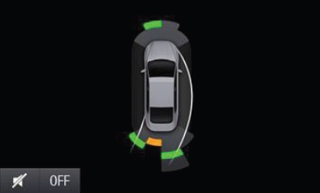
Base Park Aid visual driving tube concept.

CAMERA-FUR-REQ-197150/A-Visual Park Aid Graphic - Visual Driving Tube General Requirements 2
The infotainment system shall contain a method 2 configuation variable which is capable of configuring on and off the BPA driving tube feature. This configuration option should be internal to the infotainment system and shall not be available to driver.
Note: The intent of this requirement is to allow the disabling of the visual driving tube feature when the vehicle is RPA-only (4-channel) or when the parking aid system is otherwise not capable of providing this functionality.

CAMERA-FUR-REQ-197151/B-Visual Park Aid Graphic - Visual Driving Tube General Requirements 3
The vehicle driving path shall depend on the vehicle’s driving direction provided by the Parking Aid System. When the vehicle is traveling forward, [PrkAidDrvDir_D_Stat]=”ForwardNegative” the driving path illustration shall extend towards the front and left side of the vehicle.
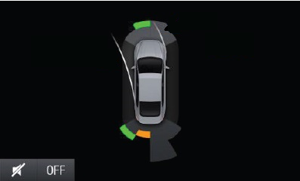
Forward visual driving tube concept.

CAMERA-FUR-REQ-197152/B-Visual Park Aid Graphic - Visual Driving Tube General Requirements 4
When the vehicle is traveling rearwards, [PrkAidDrvDir_D_Stat]=”BackwardNegative” the driving path illustration shall project towards the rear and left side of the vehicle.
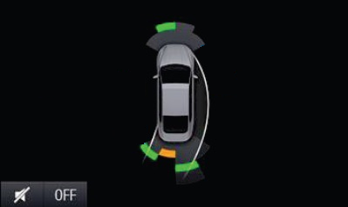
Rearward visual driving tube concept.

CAMERA-FUR-REQ-250050/A-Visual Park Aid Graphic - Visual Driving Tube General Requirements 4.1
When the vehicle is traveling forwards, [PrkAidDrvDir_D_Stat]=”ForwardPositive” the driving path illustration shall project towards the front and right side of the vehicle.
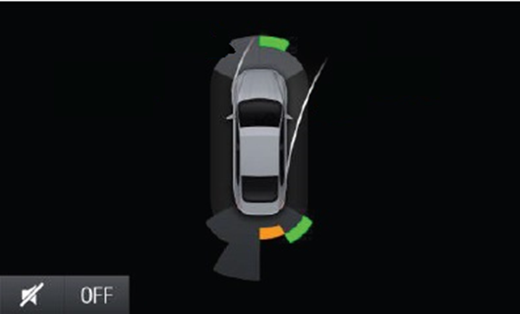

CAMERA-FUR-REQ-250051/A-Visual Park Aid Graphic - Visual Driving Tube General Requirements 4.2
When the vehicle is traveling rearwards, [PrkAidDrvDir_D_Stat]=”BackwardPositive” the driving path illustration shall project towards the rear and right side of the vehicle.
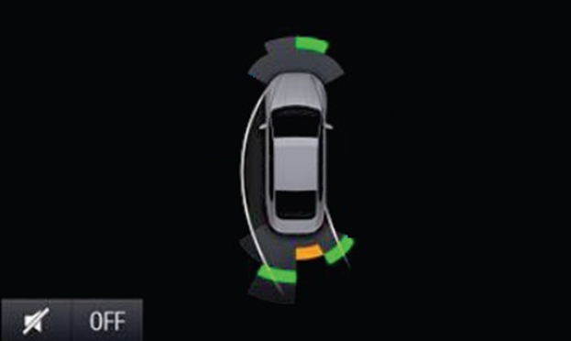

CAMERA-FUR-REQ-250052/A-Visual Park Aid Graphic - Visual Driving Tube General Requirements 4.3
When [PrkAidDrvDir_D_Stat]=”DirectionNotKnown” the driving path illustration overlay shall not be displayed.
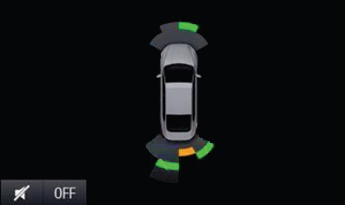

CAMERA-FUR-REQ-197153/A-Visual Park Aid Graphic - Visual Driving Tube General Requirements 5
The infotainment system shall build the BPA visual driving tube feature by representing two curves/lines along the sides of the vehicle. These curves shall illustrate the vehicle’s driving path and shall vary upon the receipt of the vehicle’s turning radius information transmitted by the Parking Aid System.

CAMERA-FUR-REQ-197155/B-Visual Park Aid Graphic - Visual Driving Tube General Requirements 6
To build the driving tube curves/lines the infotainment system display shall create 2 dynamic semi-circles, one for the right curve/line and another for the left curve/line; the radius of these semi-circles shall be adjusted upon the request of the parking aid system signals “PrkAidRdiusLeft_L_Dsply” and “PrkAidRdiusRight_L_Dsply”.

CAMERA-FUR-REQ-197156/B-Visual Park Aid Graphic - Visual Driving Tube General Requirements 7
The turning radius provided with the “PrkAidRdiusLeft_L_Dsply” signal shall correspond to the left side driving tube curve. The turning radius provided with the “PrkAidRdiusRight_L_Dsply” signal shall correspond to the right side driving tube curve.
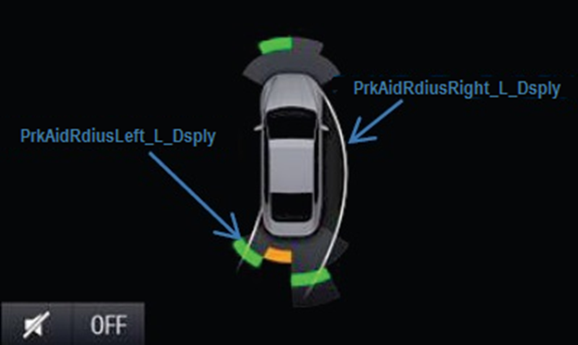
Parking Aid System signals for visual driving tube.

CAMERA-FUR-REQ-197157/B-Visual Park Aid Graphic - Visual Driving Tube General Requirements 8
When the vehicle is traveling forward [PrkAidDrvDir_D_Stat]=”ForwardPositive” or “ForwardNegative” with a straight steering wheel angle [PrkAidRdiusLeft_L_Dsply] = [PrkAidRdiusRight_L_Dsply] = “0”, the infotainment system shall draw two straight parallel lines along the side of the vehicle with starting points in ends of the rear wheel axle, as shown in the illustration provided below. The position of these points in the infotainment display shall be tunable in order to adjust the VPA graphic for different vehicle types, i.e. sedan, suv, pick-up truck.
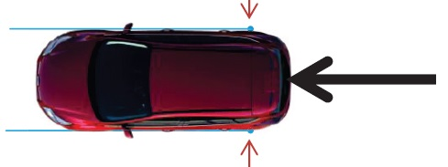
BPA visual driving tube concept for vehicle traveling forward w/straight steering wheel.

CAMERA-FUR-REQ-197158/B-Visual Park Aid Graphic - Visual Driving Tube General Requirements 9
When the vehicle is traveling rearward [PrkAidDrvDir_D_Stat]=”RearwardPositive” or “RearwardNegative” with a straight steering wheel angle [PrkAidRdiusLeft_L_Dsply] = [PrkAidRdiusRight_L_Dsply] = “0”, the infotainment system shall draw two straight parallel lines along the side of the vehicle with starting points in the outer most points of the front end of the vehicle. The position of these points in the infotainment display shall be tunable in order to adjust the VPA graphic for different vehicle types, i.e. sedan, suv, pick-up truck.
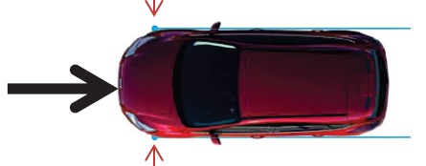
BPA visual driving tube concept for vehicle traveling rearward w/straight steering wheel.

CAMERA-FUR-REQ-197159/B-Visual Park Aid Graphic - Visual Driving Tube General Requirements 10
When the vehicle is traveling forward [PrkAidDrvDir_D_Stat]=”ForwardNegative” with a steering wheel angle turned towards the left side [PrkAidRdiusLeft_L_Dsply] OR [PrkAidRdiusRight_L_Dsply] != “0” && negative value (-), the starting point of the driving tube left curve shall be the end of the rear wheel axle, and the starting point of the driving tube right curve shall be the outer most point of the front end of the vehicle as shown in the illustration below. These points shall be used as points of tangency to build the dynamic semi-circles corresponding to the vehicle’s driving path as detailed in later requirements of this specification. The position of these points in the infotainment display shall be tunable in order to adjust the VPA graphic for different vehicle types, i.e. sedan, suv, pick-up truck.
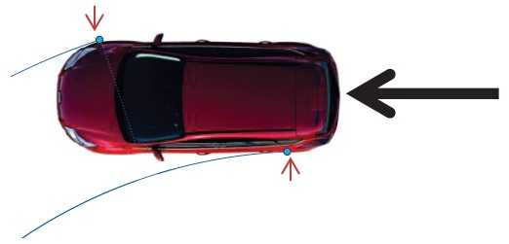
BPA visual driving tube concept for vehicle traveling forward w/steering wheel turned left.

CAMERA-FUR-REQ-197160/B-Visual Park Aid Graphic - Visual Driving Tube General Requirements 11
When the vehicle is traveling forward [PrkAidDrvDir_D_Stat]=”ForwardNegative” with a steering wheel angle turned to the right side [PrkAidRdiusLeft_L_Dsply] OR [PrkAidRdiusRight_L_Dsply] != “0” && positive value (+), the starting point of the driving tube right curve shall be the end of the rear wheel axle, and the starting point of the driving tube left curve shall be the outer most point of the front end of the vehicle as shown in the illustration below. These points shall be used as points of tangency to build the dynamic semi-circles corresponding to the vehicle’s driving path as detailed in later requirements of this specification. The position of these points in the infotainment display shall be tunable in order to adjust the VPA graphic for different vehicle types, i.e. sedan, suv, pick-up truck.
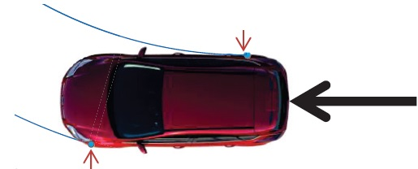
BPA visual driving tube concept for vehicle traveling forward w/steering wheel turned right.

CAMERA-FUR-REQ-197161/B-Visual Park Aid Graphic - Visual Driving Tube General Requirements 12
When the vehicle is traveling rearward [PrkAidDrvDir_D_Stat]=”RearwardNegative” with a steering wheel angle turned to the left side [PrkAidRdiusLeft_L_Dsply] OR [PrkAidRdiusRight_L_Dsply] != “0” && negative value (-), the starting point of the driving tube left curve shall be the end of the rear wheel axle, and the starting point of the driving tube right curve shall be the outer most point of the front end of the vehicle as shown in the illustration below. These points shall be used as points of tangency to build the dynamic semi-circles corresponding to the vehicle’s driving path as detailed in later requirements of this specification. The position of these points in the infotainment display shall be tunable in order to adjust the VPA graphic for different vehicle types, i.e. sedan, suv, pick-up truck.
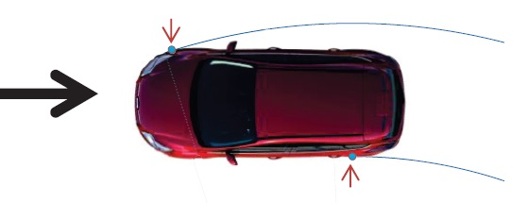
BPA visual driving tube concept for vehicle traveling rearward w/steering wheel turned left.

CAMERA-FUR-REQ-197162/B-Visual Park Aid Graphic - Visual Driving Tube General Requirements 13
When the vehicle is traveling rearward [PrkAidDrvDir_D_Stat]=”RearwardPositive” with a steering wheel angle turned to the right side [PrkAidRdiusLeft_L_Dsply] OR [PrkAidRdiusRight_L_Dsply] != “0” && positive value (+), the starting point of the driving tube right curve shall be the end of the rear wheel axle, and the starting point of the driving tube left curve shall be the outer most point of the front end of the vehicle as shown in the illustration below. These points shall be used as points of tangency to build the dynamic semi-circles corresponding to the vehicle’s driving path as detailed in later requirements of this specification. The position of these points in the infotainment display shall be tunable in order to adjust the VPA graphic for different vehicle types, i.e. sedan, suv, pick-up truck.
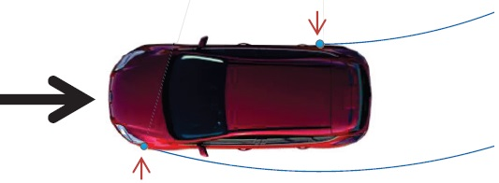
BPA visual driving tube concept for vehicle traveling rearward w/steering wheel turned right.

CAMERA-FUR-REQ-197163/A-Visual Park Aid Graphic - Visual Driving Tube General Requirements 14
The semi-circles created to simulate the vehicle’s path shall have as points of tangency the driving tube curve starting points defined in requirements listed above. The center/origin of the driving tube semi-circles shall be common and its position shall dynamically vary upon the turning radius provided by the parking aid system along the vehicle’s rear axle axis/plane. Please see the illustrations provided below for further detail, note how the position of center of the semi-circles varies upon different turning radius defined.
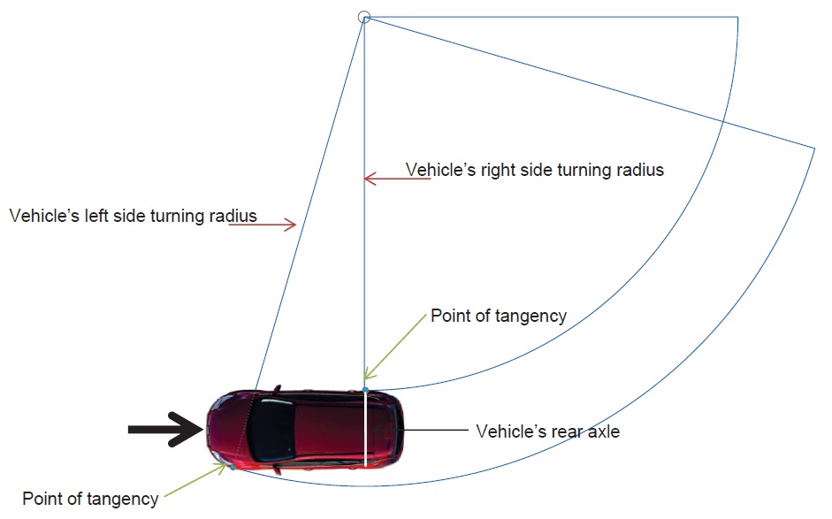
Vehicle turning radius traveling rearward with steering wheel angle slightly turned to the right side.

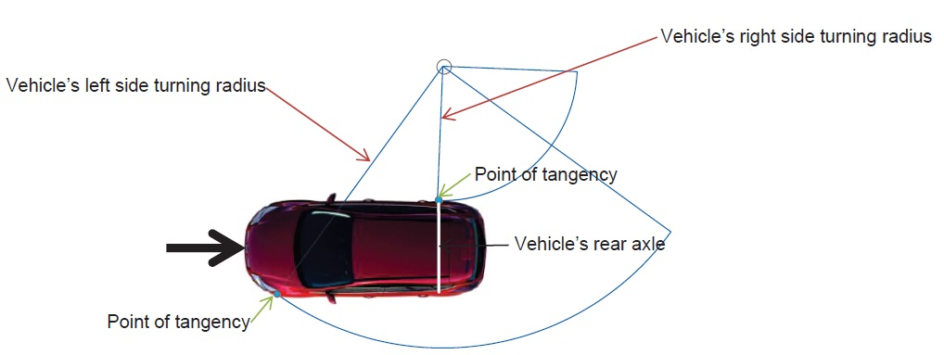
Vehicle turning radius traveling rearward with steering wheel angle fully turned to the right side.

CAMERA-FUR-REQ-197164/A-Visual Park Aid Graphic - Visual Driving Tube General Requirements 15
When the turning radius provided by the Parking Aid System is positive the centre of the driving tube semi-circles shall be located to the right side of the vehicle.
Note: This means the vehicle is turning in clockwise direction.
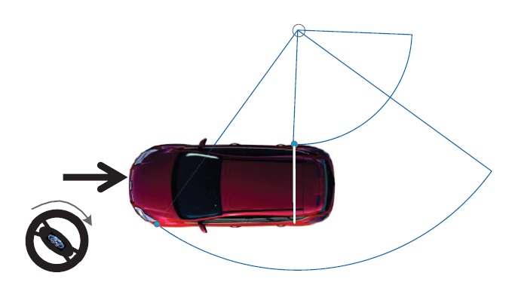
Positive turning radius, steering wheel turned towards the right side of the vehicle.

CAMERA-FUR-REQ-197165/A-Visual Park Aid Graphic - Visual Driving Tube General Requirements 16
When the turning radius provided by the Parking Aid System is negative, the centre of the driving tube semi-circles shall be located to the left side of the vehicle. As shown in illustration provided below.
Note: This means the vehicle is turning in counterclockwise direction.
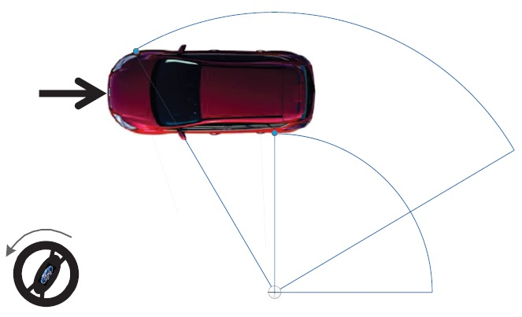
Negative turning radius, steering wheel turned towards the left side of the vehicle.

CAMERA-FUR-REQ-197166/A-Visual Park Aid Graphic - Visual Driving Tube General Requirements 17
The BPA visual driving tube curves/lines shall extend to cover the VPA field of view sectors when the vehicle is driving straight or turning as shown in the illustrations provided below. Please note that the length of the rear driving tube curves/lines is smaller than the front driving tube curves/lines, this variance is created due to the different sector field of view coverage.
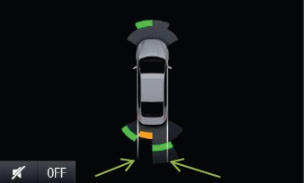
BPA rear visual driving tube curve/line length straight steering wheel.

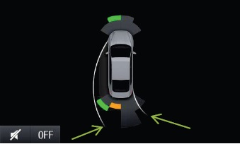
BPA rear visual driving tube curve/line length turned steering wheel.

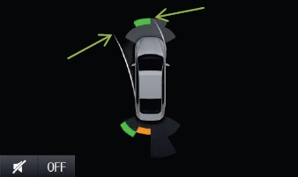
BPA front visual driving tube curve/line length turned steering wheel.

CAMERA-FUR-REQ-197167/A-Visual Park Aid Graphic - Visual Driving Tube General Requirements 18
The color of the BPA visual driving tube curves/lines shall be implemented such that allows the driver to visualize the vehicle’s driving path as per the illustrations provided below. It shall not conflict with the existing VPA visual warning colors, i.e. amber, green or red.
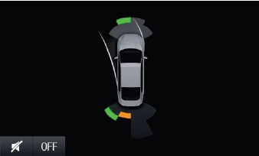
BPA visual driving tube nighttime curve/line color concept.

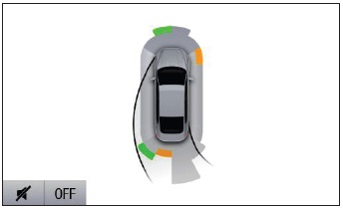
BPA visual driving tube daytime curve/line color concept.

Base Parking Aid Display Deactivation Interface

Base Parking Aid display Deactivation Function

CAMERA-FUR-REQ-130487/D-Base Parking Aid display Deactivation General Requirements 1
The infotainment display shall provide either a user-selectable menu option for visual parking aids OR an HMI-defined user interface called the “close-option” which shall remove the PDC overlay from the screen. Subsequent requirements in this section apply to the second option, the “close-option.”

CAMERA-FUR-REQ-131045/B-Base Parking Aid display Deactivation General Requirements 2
The close-option logic shall be contained entirely within the Infotainment ECU. No close-option status indication is required to be returned to the Park Aid ECU.

CAMERA-FUR-REQ-131046/B-Base Parking Aid display Deactivation General Requirements 3
The close-option logic shall operate with no discernable flicker and shall be seamlessly integrated into the overall HMI ECU screen arbitration algorithm.

CAMERA-FUR-REQ-131047/B-Base Parking Aid display Deactivation General Requirements 4
If the driver has used the close-option to switch off the BPA screen and [PDCScrReq] toggles from “True” to “False” to “True”, the close-option shall reset and the BPA screen shall be shown as per previous requirements.
Note:
An example of this would be a driver closing the BPA screen because he or she is aware of the obstacle present; then later during the same ignition cycle, another obstacle is detected. The driver must again be notified when this next obstacle is detected.

CAMERA-FUR-REQ-131048/B-Base Parking Aid display Deactivation General Requirements 5
If the driver has used the close-option to switch off the BPA screen [GearPosHMI transitions from (Not ReverseReverse) or from (ReverseNot Reverse), the close-option shall reset and the BPA screen shall be shown as per previous requirements.
Note:
An example of this would be a driver closing the BPA screen because he or she is aware of the obstacle present; then changes gears and the obstacle is still detected. The driver must again be notified since the driving conditions have changed.

CAMERA-FUR-REQ-131049/B-Base Parking Aid display Deactivation General Requirements 6
[BPA_Close] is an internal parameter that is used by the HMI ECU to track whether the close option is active (true) or inactive (false).

CAMERA-FUR-REQ-131051/D-Base Parking Aid display Deactivation Function-BPA Close Option Logic
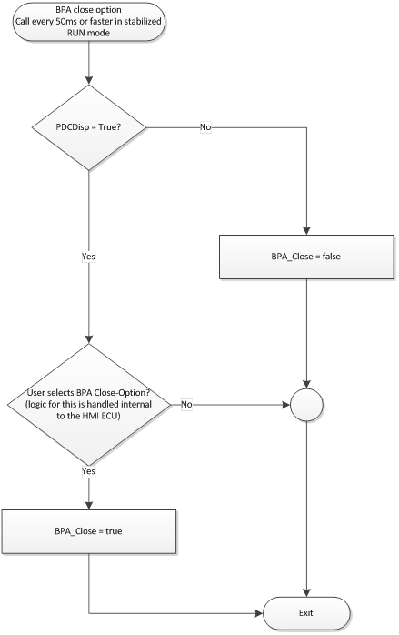
BPA Close Option Logic

CAMERA-FUR-REQ-161354/A-Reverse Video Camera with Active Park Assist (APA) and Park Distance Control (PDC) - Positional ParkPilot
As per Active Park Assist (APA) Signal Interface

CAMERA-FUR-REQ-130503/K-Active Park Assist (APA) Signal Processing - Positional ParkPilot
8” (or equivalent) displays
Operational Mode | Parking Assistance (Cfg) | [ApaSys_D_Stat] | [ApaSteScanMde_D_Stat] | [ApaActvSide2_D_Stat] | [ApaMde_D_Stat] | [ApaSelSapp_D_Stat] | [ApaSelPpa_D_Stat] | [ApaSelPoa_D_Stat] | [ApaScan_D_Stat] | [ApaLongCtl_D_RqDrv] | [ApaGearShif_D_RqDrv] | [ApaSteWhl_D_RqDrv] | [ApaAcsy_D_RqDrv] | [ApaTrgtDist_D_Stat] † | [ApaMsgTxt_D_Rq] ‡ | [PrkAidMsgTxt_D_Rq] | Display HMI_{/REF#}
Run  (as per Operational Modes and Voltage Range Definition) | 0xA |0xB | X | X | X | X | X | X | X | X | X | X | X | X | X | X | 0x1 | 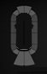  Follow Base Park Aid Signal Interface_{/083}
Run  (as per Operational Modes and Voltage Range Definition) | 0xA |0xB | X | X | X | X | X | X | X | X | X | X | X | X | X | X | 0x2
Run  (as per Operational Modes and Voltage Range Definition) | 0xA |0xB | X | X | X | X | X | X | X | X | X | X | X | X | X | X | 0x5
Run  (as per Operational Modes and Voltage Range Definition) | 0xA |0xB | X | X | X | X | X | X | X | X | X | X | X | X | X | X | 0x8
Run  (as per Operational Modes and Voltage Range Definition) | 0xA |0xB | X | X | X | X | X | X | X | X | X | X | X | X | X | X | 0x9
Run  (as per Operational Modes and Voltage Range Definition) | 0xA |0xB | X | X | X | X | X | X | X | X | X | X | X | X | X | X | 0xA
Run  (as per Operational Modes and Voltage Range Definition) | 0xA |0xB | X | X | X | X | X | X | X | X | X | X | X | X | X | X | 0xC
Run  (as per Operational Modes and Voltage Range Definition) | 0xA |0xB | X | X | X | X | X | X | X | X | X | X | X | X | X | X | 0xD
Run  (as per Operational Modes and Voltage Range Definition) | 0xA |0xB | X | X | X | X | X | X | X | X | X | X | X | X | X | X | 0xE
Run  (as per Operational Modes and Voltage Range Definition) | 0xA |0xB | X | X | X | X | X | X | X | X | X | X | X | X | X | X | 0xF
Run  (as per Operational Modes and Voltage Range Definition) | All Other Cases |  |  |  |  |  |  |  |  |  |  |  |  |  |  |  | Blank (Do not show ParkPilot)

Active Park Assist (APA) Positional ParkPilot
† - Only if supported by the implementing program as per REQ-130570. If not supported but required by signal processing tables, treat as data 0x0.
‡ - Only if supported by the implementing program as per REQ-130570. If not supported but required by signal processing tables, treat as data 0x1.

4” displays
Operational Mode | [ApaSys_D_Stat] | [ApaSteScanMde_D_Stat] | [ApaActvSide2_D_Stat] | [ApaMde_D_Stat] | [ApaSelSapp_D_Stat] | [ApaSelPpa_D_Stat] | [ApaSelPoa_D_Stat] | [ApaScan_D_Stat] | [ApaLongCtl_D_RqDrv] | [ApaGearShif_D_RqDrv] | [ApaSteWhl_D_RqDrv] | [ApaAcsy_D_RqDrv] | [PrkAidMsgTxt_D_Rq] | Display HMI_{/REF#}
Run  (as per Operational Modes and Voltage Range Definition) | X | X | X | X | X | X | X | X | X | X | X | X | 0x1 | Follow Base Park Aid Signal Interface_{/083}
Run  (as per Operational Modes and Voltage Range Definition) | X | X | X | X | X | X | X | X | X | X | X | X | 0x2
Run  (as per Operational Modes and Voltage Range Definition) | X | X | X | X | X | X | X | X | X | X | X | X | 0x5
Run  (as per Operational Modes and Voltage Range Definition) | X | X | X | X | X | X | X | X | X | X | X | X | 0x8
Run  (as per Operational Modes and Voltage Range Definition) | X | X | X | X | X | X | X | X | X | X | X | X | 0x9
Run  (as per Operational Modes and Voltage Range Definition) | X | X | X | X | X | X | X | X | X | X | X | X | 0xA
Run  (as per Operational Modes and Voltage Range Definition) | X | X | X | X | X | X | X | X | X | X | X | X | 0xC
Run  (as per Operational Modes and Voltage Range Definition) | X | X | X | X | X | X | X | X | X | X | X | X | 0xD
Run  (as per Operational Modes and Voltage Range Definition) | X | X | X | X | X | X | X | X | X | X | X | X | 0xE
Run  (as per Operational Modes and Voltage Range Definition) | X | X | X | X | X | X | X | X | X | X | X | X | 0xF
Run  (as per Operational Modes and Voltage Range Definition) | All Other Cases |  |  |  |  |  |  |  |  |  |  |  |  | Blank (Do not show ParkPilot)
4” supports semi-assisted park (SAP) only, configuration Parking Assistance_Cfg is not required.

Functional Definition

VPAv1-FUN-REQ-130706/A-Enable/Disable Visual Park Assist

Use Cases

VPAv1-UC-REQ-014399/A-Enable Visual Park Assist (TcSE ROIN-289855)

Actors | Vehicle Occupant
Pre-conditions | The infotainment system is powered on.  The ignition status is Run/Start.  The Visual Park Assist system is disabled.
Scenario Description | The user enables the Visual Park Assist (VPA) system via hard switch interface.
Post-conditions | The VPA system is enabled by the VisualParkAssistServer.
List of Exception Use Cases | NA
Interfaces | Dedicated Hard Button  Vehicle System Interface

VPAv1-UC-REQ-014400/A-Disable Visual Park Assist (TcSE ROIN-289856)

Actors | Vehicle Occupant
Pre-conditions | The infotainment system is powered on.  The ignition status is Run/Start.  The Visual Park Assist system is enabled.
Scenario Description | The user disables the Visual Park Assist (VPA) system via hard switch interface.
Post-conditions | The VPA system is disabled by the VisualParkAssistServer.
List of Exception Use Cases | NA
Interfaces | Dedicated Hard Button  Vehicle System Interface

White Box View

Activity Diagrams

VPAv1-ACT-REQ-014396/A-Enable/Disable Visual Park Assist (TcSE ROIN-283929-1)
Linked Elements
VPAv1-SD-REQ-014401/A-Enable/Disable Visual Park Assist Via Switch (TcSE ROIN-283909-1)
VPAv1-SD-REQ-014430/A-Enable/Disable Rear Visual Park Assist (TcSE ROIN-283902-1)
VPAv1-SD-REQ-014429/A-Enable/Disable Front Visual Park Assist (TcSE ROIN-283888-1)
Activity Diagram

Sequence Diagrams

VPAv1-SD-REQ-014401/A-Enable/Disable Visual Park Assist Via Switch (TcSE ROIN-283909-1)
Scenarios
Normal Usage
The user enables or disables the full (front and rear) visual park assist system via hard switch interface.

Constraints
Pre-condition
Enable:
The full visual park assist system is disabled.
Disable:
The full visual park assist system is enabled.

Post-condition
Enable:
The full visual park assist system is enabled.
Disable:
The full visual park assist system is disabled.

Sequence Diagram

VPAv1-FUN-REQ-130707/B-Display Visual Park Assist

Requirements

REQ-131084/B-VPA Displays Definition Requirement
VPA HMI displays are dependent on the encoding of the ParkAidSensorFront_St, ParkAidSensorRear_St, ParkAidSensorSide_St and VisualParkAssist_St signals.

REQ-131002/B-VPA Logic Names and CAN Signal Names Translation Table

Logic Name |  | CAN Signal Name
ParkAidSensorFront_St | FrontLeftCenter | PrkAidSnsFlCntr_D_Stat
ParkAidSensorFront_St | FrontRightCenter | PrkAidSnsFlCntr_D_Stat
ParkAidSensorFront_St | FrontLeftCorner | PrkAidSnsFlCrnr_D_Stat
ParkAidSensorFront_St | FrontRightCorner | PrkAidSnsFrCrnr_D_Stat
ParkAidSensorFront_St | FrontLeftSide | NA to VPA
ParkAidSensorFront_St | FrontRightSide | NA to VPA
ParkAidSensorRear_St | RearLeftCenter | PrkAidSnsRlCntr_D_Stat
ParkAidSensorRear_St | RearRightCenter | PrkAidSnsRrCntr_D_Stat
ParkAidSensorRear_St | RearLeftCorner | PrkAidSnsRlCrnr_D_Stat
ParkAidSensorRear_St | RearRightCorner | PrkAidSnsRrCrnr_D_Stat
ParkAidSensorRear_St | RearLeftSide | N/A to VPA
ParkAidSensorRear_St | RearRightSide | N/A to VPA
ParkAidSensorSide_St | RightSideSector1 | SidePrkSnsR1_D_Stat
ParkAidSensorSide_St | RightSideSector2 | SidePrkSnsR2_D_Stat
ParkAidSensorSide_St | RightSideSector3 | SidePrkSnsR3_D_Stat
ParkAidSensorSide_St | RightSideSector4 | SidePrkSnsR4_D_Stat
ParkAidSensorSide_St | LeftSideSector1 | SidePrkSnsL1_D_Stat
ParkAidSensorSide_St | LeftSideSector2 | SidePrkSnsL2_D_Stat
ParkAidSensorSide_St | LeftSideSector3 | SidePrkSnsL3_D_Stat
ParkAidSensorSide_St | LeftSideSector4 | SidePrkSnsL4_D_Stat
VisualParkAssist_St |  | PrkAidMsgTxt_D_Rq

Use Cases

VPAv1-UC-REQ-014424/B-Display Visual Park Assist (TcSE ROIN-289863)
Linked Elements
VPAv1-HMI-REQ-014405/A-Display Visual Park Assist When Camera Image Is Not Available (TcSE ROIN-294140-1)
VPAv1-HMI-REQ-014406/A-Display Visual Park Assist When Camera Image Is Available (TcSE ROIN-294141-1)
VPAv1-HMI-REQ-014407/A-Active Park Assist Override Of Visual Park Assist (TcSE ROIN-294142-2)
VPAv1-HMI-REQ-014408/A-VPA Display when Gear position changes: "Reverse to Non-Reverse" or "non-Reverse to non-Reverse" (TcSE ROIN-294143-2)
VPAv1-HMI-REQ-014409/A-Visual Park Assist Display When Gear Position Changes from Non-reverse to Reverse (TcSE ROIN-294144-1)
VPAv1-HMI-REQ-014411/A-Disable VPA overlay from vehicle camera screen. (TcSE ROIN-294146-1)
VPAv1-HMI-REQ-014412/A-Multi-camera View Override of Visual Park Assist (TcSE ROIN-294147-2)
VPAv1-HMI-REQ-014413/A-4 or 6 Channel Park Aid Conditions for Not Displaying VPA Graphic (TcSE ROIN-294148-1)
VPAv1-HMI-REQ-014414/A-4 or 6 Channel Park Aid Conditions for Displaying VPA Graphic Fault (TcSE ROIN-294149-1)
VPAv1-HMI-REQ-014415/A-4 or 6 Channel Park Aid VPA Graphic Type (TcSE ROIN-294150-1)
VPAv1-HMI-REQ-014417/A-8, 10, or 12 Channel Park Aid conditions for not displaying VPA graphic (TcSE ROIN-294152-1)
VPAv1-HMI-REQ-014418/A-8, 10, or 12 Channel Park Aid Conditions for Displaying VPA Graphic Fault (TcSE ROIN-294153-1)
VPAv1-HMI-REQ-014419/A-8, 10, or 12 Channel Park Aid VPA Graphic Type (TcSE ROIN-294154-1)
VPAv1-HMI-REQ-014420/A-8, 10, or 12 channel Park Aid VPA Graphic Type (TcSE ROIN-294155-1)
VPAv1-HMI-REQ-014421/A-8, 10, or 12 channel Park Aid VPA Graphic Type (TcSE ROIN-294156-1)
VPAv1-HMI-REQ-014422/A-8, 10, or 12 channel Park Aid VPA Graphic Type (TcSE ROIN-294157-1)

Actors | Vehicle Occupant
Pre-conditions | The infotainment system is powered on.  The ignition status is Run/Start.
Scenario Description | The vehicle system indicates Visual Park Assist (VPA) is enabled and an indication should be provided to the user.
Post-conditions | The VPA information is displayed to the user according to HMI requirements.
List of Exception Use Cases | NA
Interfaces | G-HMI  Vehicle System Interface

VPAv1-UC-REQ-014425/A-Cancel Display of Visual Park Assist (TcSE ROIN-293590)
Linked Elements
VPAv1-HMI-REQ-014416/A-4 or 6 Channel Park Aid VPA Graphic Closure Conditions (TcSE ROIN-294151-2)
VPAv1-HMI-REQ-014423/A-8, 10, or 12 Channel Park Aid VPA Graphic Closure Conditions (TcSE ROIN-294158-2)

Actors | Vehicle Occupant
Pre-conditions | The infotainment system is powered on.  The ignition status is Run/Start.  The Visual Park Assist information is displayed to the user.
Scenario Description | The user closes the Visual Park Assist (VPA) graphic via HMI interface.
Post-conditions | The VPA information is no longer displayed to the user.
List of Exception Use Cases | NA
Interfaces | G-HMI  Vehicle System Interface

White Box View

Activity Diagrams

VPAv1-ACT-REQ-014397/A-Display Visual Park Assist (TcSE ROIN-283933-2)
Linked Elements
VPAv1-SD-REQ-014426/A-Display Visual Park Assist (TcSE ROIN-283895-2)
Activity Diagram

Sequence Diagrams

VPAv1-SD-REQ-014426/A-Display Visual Park Assist (TcSE ROIN-283895-2)
Scenarios
Normal Usage
The system displays the visual park assist graphic to the user.

Please refer to table in the requirement number 196898 for a list of all signals affecting the displays in sequence diagram.
Constraints
Pre-condition
The infotainment system is active.

Post-condition
The visual park assist graphic is displayed to the user via the HMI interface.

Sequence Diagram

Appendix: Reference Documents

Reference # | Document Title
1 | A59_SYNC Gen II Notifications and Alerts
2 | A36a_SHMI Driver Assist - RVC-FlankGuard
3 | A36c_PDC_distance_bar_signal_mapping_PAMtoHMI
4
5

